SMART STUDENTS PROJECT MANUAL

|  |  |  |  |  |
| --- | --- | --- | --- | --- |
|  | | IS 376 Senior Capstone |  | |
|  | |  |  |  |  | | --- | --- | --- | --- | |  | John Ress  Project Manager  Testing Manager |  | Lorena Rojas  Webmaster | |  | John Kalady  Systems Programmer  Testing Manager |  | Andy Reyes  Interface Manager | |  | Anna Terzian  Designer  Presentation Manager |  | Denise Maldia  Video Manager  Planner | |  | Sayraj Kazi  Implementation Manager |  | Jay Miller  Documentation Manager  Security Manager | |  | Zunair Khan  Requirements Manager | Smart Students | | | | |  |

Contents

Project Overview 7

1.1 Overview 7

1.2 Business Mission 7

1.3 Business Objective 7

2. Business Plan 8

2.1 Target Market 8

2.2 Differentiated Product 8

2.3 SWOT Analysis 9

2.4 Competitive Analysis Chart 9

2.5 Competitive Analysis Quadrant 10

2.6 Customer Acquisition Channels 11

Requirements 11

1.1 Functional Requirements 11

2 Technical Requirements 19

3. Due Diligence 22

3.1 Key Competitors and Features 22

3.1.1 22

3.1.2 22

3.1.3 23

3.2 Differentiated Product 23

4. Assumptions 23

5. Constraints 23

5.1 Constraint Table 23

6. Risk Management 24

6.1 Risk Mitigation Table 24

7. Stakeholders 25

7.1 Development Team 25

7.2 Customer Representative Team 25

7.3 Clients 25

8. Project group management requirements 25

8.1 Management Strategy 26

8.2 Conflict Resolution 26

8.3 Proactive Tasks of the Management Team 26

8.3.1 26

8.3.2 26

8.4 Progress Reports 27

8.4.1 27

8.4.2 27

8.4.3 27

8.4.4 27

8.5 Accountability Model 27

8.6 Acknowledgement Model 28

8.7 Agenda Management 28

9. Project roles specification requirements 28

9.1 Project Manager 28

9.2 Remote Collaboration Manager 28

9.3 Planner 29

9.4 Systems Programmer 29

9.5 Presentation Manager 29

9.6 Designer 29

9.7 Requirements Manager 29

9.8 Implementation Manager 29

9.9 Documentation Manager 30

9.10 Security Manager 30

9.11 Video Manager 30

9.12 Testing Manager 30

9.13 Interface/HCI Manager 30

9.14 Webmaster 31

10. Client / Developer management 31

11. Project planning requirements 32

12. Scope Change Management 33

12.1 Original Scope 33

12.2 Scope Change 34

13. Project Phases 34

14. User Profile Requirements 34

14.1 End user 34

14.2 Business Admin 34

14.3 Customer Service Agent 34

14.4 Developer 35

15. Testing Requirements Testing Documentation 35

1 Register/Login 39

2 Ticket System 43

4 General Usability 47

5 User Account DB Functionality 49

6 Search Functionality Testing 51

15. Documentation Requirements 53

15.1 User Documentation 53

15.2 Group Documentation 53

15.4 Technical Maintenance Documentation 54

15.5 Code Documentation 54

Design 54

1 Original Design Demo Document 54

2 Major Module Descriptions 57

2.1 Account Database 57

2.2 Search Algorithm 57

2.3 Chatbot 57

2.4Ticket System 57

2. Data Flow and Workflow Diagrams 57

2.1 DFD Diagram 57

2.2 General User Workflow 59

2.3 Business Workflow 60

2.4 Anonymous User Search Workflow 60

2.5 Chatbot Workflow Diagram 61

Planning 62

1 Microsoft Teams 62

1.1 Group communication 62

1.2 Tasks and Deadlines 63

1.3 File Sharing 64

2. Gantt Chart 65

3. Individual Task Chart 66

4. Meeting Agendas 71

4.1 Friday April 8, 2022, Group Meeting Agenda 71

4.2 Wednesday April 13, 2022, Group Meeting Agenda 73

4.3 Sunday April 17, 2022, Group Meeting Agenda 74

4.4 Wednesday April 20, 2022, Group Meeting Agenda 75

4.5 Sunday May 8, 2022 Group Meeting 76

4.6 Monday May 11, 2022 Group Meeting 76

4.7 Wednesday, May 18, 2022 Group Meeting 77

4.8 Wednesday May 25, 2022 Group Meeting Agenda 78

Frontend Site 80

1 Website Screenshots 80

1.1 Index Page 80

1.2 Login Page 80

1.3 Business Login 81

1.4 FAQs Page 82

1.5 Customer Directory 84

1.6 Comments Page 85

1.7 Create a Ticket Page 85

1.8 Business Directory Page 86

1.9 Business Directory with Chat Box Open 87

1.10 Comments Page 87

1.11 Create a Ticket Page 88

1.12 Chatbot 89

Coding Documentation 90

1 Summary 90

Google OAuth 90

2 Main Method 90

3 Configuration Files 93

Front End Code 95

/Comments 96

/User Dash Board 96

/Landing page 98

/ FAQ page 99

/User Login 100

/Business Login 100

/results page 101

/Submit a ticket Page 102

/layout user dashboard 103

layouts business dashboard 106

/ Standard 109

4 Routing 113

/Google OAuth Route 114

/Comments Page Route 114

/User Dashboard Route 114

/FAQ Page Route 115

/Landing Page Route 115

/Login Page Route 115

/Business Login Route 115

/Post Ticket Method 116

/Results Page Route 116

/New Ticket Page Route 117

5 Models/MiddleWare 117

/Ticket 118

/Links 118

6 Ticket Manager Page 118

Packages used within Node.js 119

119

Manager Main Runnable Function for Display 120

The Manager’s ticket visualizer 120

The Crud Functionality for the page (for Display) 122

Manager Crud Functionality(For Backend) 123

To Visualize New Tickets 123

Routing for the manager 124

Lastly For the connection to the Database 125

Time logs 126

Johnny Kalady 126

Sayraj Kazi 129

Zunair Khan 131

John Rees 132

Andy Reyes 136

Denise Maldia 137

Jay Miller 139

Lorena Rojas 142

Anna Terzian 144

# Project Overview

## 1.1 Overview

OneHelp is an online helpdesk service that seamlessly directs all end users toward common solutions for troubleshooting desktops and mobile devices. The service also provides end users with convenient methods and options of navigating end users to third-party business support.

## 1.2 Business Mission

 Our goal at OneHelp is to provide the end user, both from businesses and general end users, a seamless method of connecting to support without having to scour through unfiltered search engine results or navigating through rabbit holes to find methods of reaching business support. This includes providing customers and users a bridge of connection to business support departments using an optimized search algorithm and a reliable chatbot that provides quick answers for the most urgent technology-related inquiries.

## 1.3 Business Objective

OneHelp is aimed at building and maintaining partnerships with client enterprises and that may not have established methods of providing direct support to their customers. OneHelp works to provide the solution of connection with our methods to seamlessly connect the end user with the support that they need. In providing this “middleman” service, OneHelp works to reduce overhead costs of businesses that may not be able to maintain their own inhouse support department. OneHelp also aims to provide this seamless method of delivering support without sacrificing any quality of communication and support between the customer and the business.

# 2. Business Plan

## 2.1 Target Market

Our target market comprises of people who may not be as technology savvy as those who use technology on a regular basis as well as those who often use technology as a part of their daily lives. This includes the general end user who may only use their computer for email as well as business end users who regularly use their computers for work-related tasks and need immediate support solutions. The platform works to provide seamless navigation between the end user and support channels, ranging from support solutions for business categories, like grocery and travel for general end users, as well as business end user support regarding FAQ solutions that may be useful in troubleshooting their work devices. OneHelp’s target market at this time are small technology companies that may not have large-scale structures that can be managed to provide support for their customer base. OneHelp aids in this case to provide the bridge between the client and the business in offering methods of connection, ranging from common FAQs solutions to navigating end users directly to the business support page(s).

## 2.2 Differentiated Product

Our product consists of a chatbot that will later be integrated with the clients’ own webpage. If someone wishes to log in to our website, they will also have the option to use a search bar to search for the criteria of items they have questions about. Our ticket generator is also a tool used to ensure that users’ questions will be answered by customer service representatives in an efficient manner.

## 2.3 SWOT Analysis

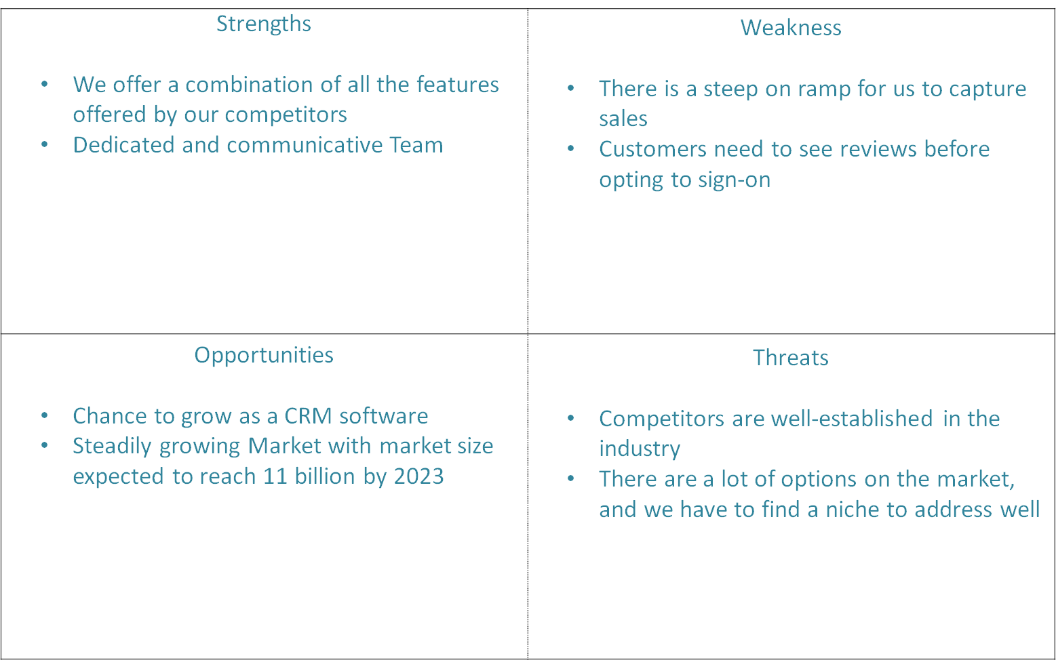

## 2.4 Competitive Analysis Chart

The market for global helpdesk automation is expected to reach $11 billion by 2023.

|  |  |  |  |  |  |  |
| --- | --- | --- | --- | --- | --- | --- |
| Feature | OneHelp | Zendesk | HelpScout | HappyFox | Freshdesk | Crisp |
| Chatbot | ü | X | ü | X | ü | ü |
| Search Bar | ü | ü | X | X | ü | ü |
| Ticket Generator | ü | ü | X | ü | ü | X |
| Client-side widget | F | ü | ü | X | X | X |
| Customer Representative Chat | ü | ü | X | X | X | ü |
| Data Analytics and Tracking | F | ü | ü | ü | ü | ü |

ü = Implemented X = Not included F = Future planning

## 2.5 Competitive Analysis Quadrant

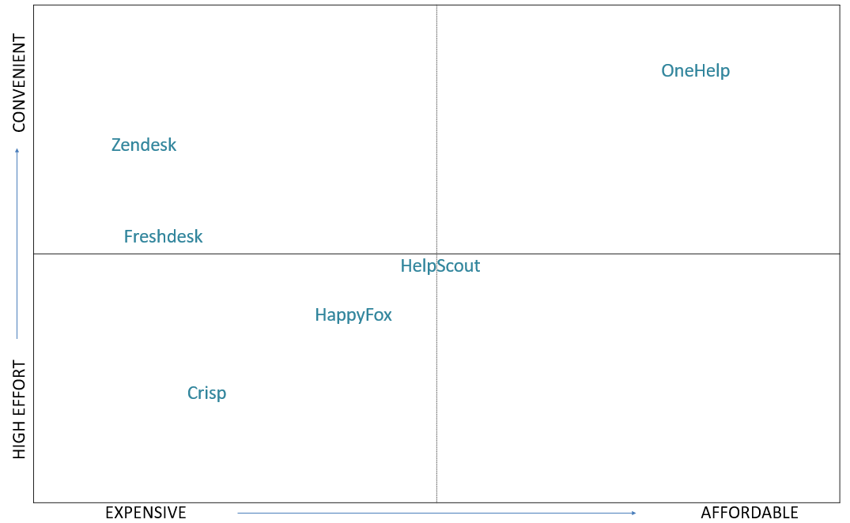

## 2.6 Customer Acquisition Channels

We will appeal to users directly by using online advertisements on google ads and facebook ads. Other than that, we will have a sales department to gain clients that would like to use our services for their products.

2.7 Customer Sign-Up Swimlane

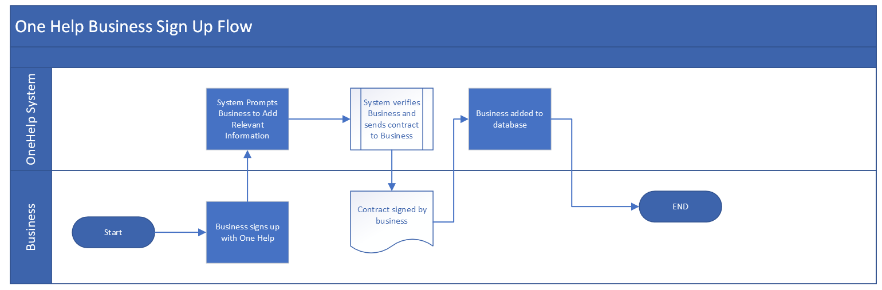

# Requirements

# 1.1 Functional Requirements

|  |  |  |  |  |  |  |  |
| --- | --- | --- | --- | --- | --- | --- | --- |
| No. | Revision | Requirement Description | Bad client attack | Bad dev attack | Approval Status | Sign-off | |
| 1.1 User Requirements | | | | | | | |
| 1.1.1 | 0 | User can register | User enters invalid email address | Email is incorrect and password is weak | NO | NOT APPROVED  John Ress  4/18/22 | |
| 1.1.1 | 1 | If a user enters a valid email address which is verified in the database, and a strong password, they can register an account | N/A | N/A | YES | APPROVED  John Ress  4/18/22 | |
| 1.1.2 | 0 | User should be able to delete their account | Consumes too many resources and users can create unlimited accounts | Remove command is sent, but account is not deleted from database | NO | NOT APPROVED  John Ress  4/18/22 | |
| 1.1.2 | 1 | Users must submit a request to support to terminate their accounts | N/A | N/A | YES | APPROVED  John Ress  4/18/22 | |
| 1.1.3 | 0 | User can login | User is unable to connect to the web site login | Valid email and pass are created but not stored | NO | NOT APPROVED  John Ress  4/18/22 | |
| 1.1.3 | 1 | Prerequisite that the user may access the website from a general client and should therefore be able to register for an account | N/A | N/A | YES | APPROVED  John Ress  4/18/22 | |
| 1.1.4 | 0 | User can generate a ticket | User does not know how to submit a ticket | Ticket is generated but not logged by the system | NO | NOT APPROVED  John Ress  4/18/22 | |
| 1.1.4 | 1 | User can generate a ticket through methods provided by website, including chatbot and working with representative | User still does not know where to look | N/A | NO | NOT APPROVED  John Ress  4/18/22 | |
| 1.1.4 | 2 | Users may submit tickets to OneHelp Agents by using the Chatbot conversation (provided link to ticket form) or by presenting a navigation link to land them on the Ticket Form submission page | N/A | N/A | YES | APPROVED  John Ress 4/22/22 | |
| 1.1.5 | 0 | User can search an inquiry | User searches for term not found | Search algorithm inaccurate/ returns useless results | NO | NOT APPROVED  John Ress  4/18/22 | |
| 1.1.5 | 1 | User can search an inquiry and results provide feedback accordingly (i.e. “not found” or “found 3 matches”) | N/A | N/A | YES | APPROVED  John Ress  4/18/22 | |
| 1.1.6 | 0 | Users may click on home button to navigate to the home page of the website | User cannot find the home button | Button does not work | NO | NOT APPROVED  John Ress  4/18/22 | |
| 1.1.6 | 1 | Users may click on the home button, while the code for the button functionality has been verified and that the button is immediately visible to the user, to allow navigation to the site home page | N/A | N/A | YES | APPROVED  John Ress  4/19/22 | |
| 1.1.7 | 0 | User can click a category to navigate to the business support page | User is unable to find a category easily or immediately | Categories are not defined | NO | NOT APPROVED  John Ress  4/19/22 | |
| 1.1.7 | 1 | User may click on the business category while navigation options are immediately visible and labeled accordingly | N/A | N/A | YES | APPROVED  John Ress  4/19/22 | |
| 1.1.8 | 0 | Users may navigate to different pages from their home page | User is not presented with immediate navigation options and descriptions or unaware of where to navigate | User cannot leave home page | NO | NOT APPROVED  John Ress | |
| 1.1.8 | 1 | User has the option of navigating to different site pages via the use of navigation buttons that have had code verified to assure functionality and provides captions if user hovers over the button to provide navigation description | N/A | N/A | YES | APPROVED  John Ress  4/19/22 | |
| 1.1.9 | 0 | Users can set their notifications to be enabled or disabled | Users prefer to enable specific notifications | User preference is not acknowledged by system and has no effect on default notification functionality | NO | NOT APPROVED  John Ress  4/19/22 | |
| 1.1.9 | 1 | Users can configure their notifications for the chatbot or ticket updates while logged in to the website and user decision to enable or disable notifications is verified on backend | N/A | N/A | YES | APPROVED  John Ress  4/19/22 | |
| 1.2.1 | 0 | Users can select whether they prefer to be notified through email or not | Specific types of notifications must be identified | User still receives emails from application | NO | NOT APPROVED  John Ress  4/19/22 | |
| 1.2.1 | 1 | Users have the option of configuring, (enable or disable), email notifications for ticket updates and pass is made to backend to ensure that notifications are managed accordingly (whether the user has enabled or disabled notifications) | N/A | N/A | YES | APPROVED  John Ress  4/19/22 | |
| 1.2.2 | 0 | Users need to be able to have their questions answered within a day | Users do not have any guarantee that their queries will be answered within a reasonable time frame | Application does not relay tickets to businesses efficiently | NO | NOT APPROVED  John Ress  4/19/22 | |
| 1.2.2 | 1 | SLA includes assurance of the following statuses have a first response within the respective time frames: Urgent tickets – 1 hour, High – 4 hours, Medium – 24 hours, Low – 48 hours. The SLA must also ensure that any tickets or queries are routed accordingly to third party businesses while also providing the end user with a method to contact third-party businesses directly within 1-3 business days | N/A | N/A | YES | APPROVED  John Ress  4/19/22 | |
| 1.2 Client Requirements | | | | | | | |
| 1.2.1 | 0 | Client can register their company | Any entity may register as a business user | Email is incorrect, weak password | NO | NOT APPROVED  John Ress  4/19/22 | |
| 1.2.1 | 1 | Client must create account with a verified business email domain address and a strong password | N/A | N/A | YES | APPROVED  John Ress  4/19/22 | |
| 1.2.2 | 0 | Client can get verified | Invalid credentials are accepted by the system | Business verification failed due to invalid email address | NO | NOT APPROVED  John Ress  4/20/22 | |
| 1.2.2 | 1 | Client email address is verified via server connection upon login | N/A | N/A | YES | APPROVED  John Ress  4/20/22 | |
| 1.2.3 | 0 | Client can opt in or out to have questions regarding their products answered | Third-party business does not provide any means of organizing documentation to provide to end user through OneHelp | N/A | NO | NOT APPROVED  John Ress  4/20/22 | |
| 1.2.3 | 1 | Clint can opt in or out to have OneHelp provide articles and FAQs on the third-party business’ behalf | N/A | N/A | YES | APPROVED  John Ress  4/20/22 | |
| 1.2.4 | 0 | Client can submit a question to a OneHelp agent for further assistance | Client is unable to locate methods or navigate respectively to find support from agent | Application cannot establish connection between user and rep | NO | NOT APPROVED  John Ress  4/20/22 | |
| 1.2.4 | 1 | Client is provided with navigation links and an option to create a ticket to further their inquiry with a OneHelp Agent | N/A | N/A | YES | APPROVED  John Ress  4/20/22 | |
| 1.3 Agent Requirements | | | | | | | |
| 1.3.1 | 0 | Agent is notified when a ticket is generated | Agent does not know where to view the notification | Ticket is logged, but system fails to notify agent | NO | NOT APPROVED  John Ress  4/20/22 | |
| 1.3.1 | 1 | Agent is notified via their registered email address that a new ticket has been received by the system | N/A | N/A | YES | APPROVED  John Ress  4/20/22 | |
| 1.3.2 | 0 | Agent can sign up as an agent | Any actor may create an agent account and pose as a OneHelp Agent | Any actor may create an agent account and pose as a OneHelp Agent | NO | NOT APPROVED  John Ress  4/21/22 | |
| 1.3.2 | 1 | Existing agent or systems administrator will manually update the system database to create new login for new agent(s) | N/A | N/A | YES | APPROVED  John Ress  4/20/22 | |
| 1.3.3 | 0 | Agent can login using a verified email address and with a strong password | N/A | N/A | YES | APPROVED  John Ress  4/20/22 | |
| 1.3.4 | 0 | Agent can view new tickets in their dashboard | Agent does not have ability to manage their views and differentiate tickets | Agent is unable to view new tickets assigned to them due to lack of configurability | NO | NOT APPROVED  John Ress  4/20/22 | |
| 1.3.4 | 1 | Agent is provided settings and system configuration options to customize and organize their dashboards, allowing for custom views and methods of managing tickets | N/A | N/A | YES | APPROVED  John Ress  4/20/22 | |
| 1.3.5 | 0 | Agent can be assigned tickets based on their roles, as defined by the system database backend | N/A | N/A | YES | APPROVED  John Ress  4/20/22 | |
| 1.3.6 | 0 | Agent is provided the option to review tickets before being assigned to them – system will not immediately assign a ticket until an agent has reviewed | N/A | N/A | YES | APPROVED  John Ress  4/20/22 | |
| 1.3.7 | 0 | Urgent tickets and tickets that have not met SLA will be assigned in a round-robin fashion if no first response has been provided | N/A | N/A | YES | APPROVED  John Ress  4/20/22 | |
| 1.4 User Account Database | | | | | | |
| 1.4.1 | 0 | Account Login needs to be stored in user account database | User wants to search anonymously | Created logins are lost | NO | NOT APPROVED  John Ress  4/21/22 |
| 1.4.1 | 1 | All user accounts are stored in the user account database table and managed separately from other databases to ensure accuracy and organization of accounts | N/A | N/A | YES | APPROVED  John Ress  4/21/22 |
| 1.4.2 | 0 | User data including history needs to be stored | There is not a central location of viewing information | History is not stored | NO | NOT APPROVED  John Ress  4/21/22 |
| 1.4.2 | 1 | User Data, including history of queries and recent activity, is stored in the back-end database system – (for future scaling) | N/A | N/A | YES | APPROVED  John Ress  4/21/22 |
| 1.4.3 | 0 | User accounts should be stored in a database which will not affect performance if the number of accounts increases. | Specific methods are not used to ensure the security of sensitive information | Account database is oversaturated and slows down overall functionality | NO | NOT APPROVED  John Ress  4/21/22 |
| 1.4.3 | 1 | User accounts are stored and managed by the back-end database system along with instilling security protocols to ensure the security of sensitive information, including HTTPS and SSL protocols | N/A | N/A | YES | APPROVED  John Ress  4/21/22 |
| 1.4.4 | 0 | User Traffic needs to be tracked and stored | There is no way for an agent or client to view the traffic | User traffic is measured but not stored | NO | NOT APPROVED  John Ress  4/21/22 |
| 1.4.4 | 1 | User traffic is stored and tracked using the connection to the back-end database system | N/A | N/A | YES | APPROVED  John Ress  4/21/22 |
| 1.5 Business Account Database | | | | | | |
| 1.5.1 | 0 | All user accounts are stored in the business user account database and managed separately from other databases to ensure accuracy and organization of accounts | N/A | N/A | YES | APPROVED  John Ress  4/21/22 |
| 1.5.2 | 0 | User Data, including history of queries and recent activity, is stored in the back-end database system – (for future scaling) | N/A | N/A | YES | APPROVED  John Ress  4/21/22 |
| 1.5.3 | 0 | Business profiles need to be updated | No method provided to update business accounts or specific information | No ability listed to update information |  | NOT APPROVED  John Ress  4/21/22 |
| 1.5.3 | 1 | Business profiles are updated and maintained by the Systems Administrator and updated as needed through direct communication between the Systems Administrator and the Business-end representative using secure communication channels agreed upon by both parties | N/A | N/A | YES | APPROVED  John Ress  4/21/22 |
| 1.5.4 | 0 | Track usage metrics for businesses to determinate plans for scalability and forecasting using data analytics tools – i.e. Tableau | N/A | N/A | YES | APPROVED  John Ress  4/21/22 |
| 1.6 Search Algorithm | | | | | | |
| 1.6.1 | 0 | Recognize user inputs (single word, phrases or direct questions) and JavaScript match cases of keywords with common FAQs provided from the back-end database | N/A | N/A | YES | APPROVED  John Ress  4/21/22 |
| 1.6.2 | 0 | Returned results have term-frequency saturation with consideration of document length function included in search algorithm code | N/A | N/A | YES | APPROVED  John Ress  4/21/22 |
| 1.6.3 | 0 | Returned results should have inverse-document frequency function included in search algorithm code | N/A | N/A | YES | APPROVED  John Ress  4/21/22 |
| 1.6.4 | 0 | Forecasting/ Scalability solutions to enhance search depth and accuracy – enhanced performance by adding language detection capability function to translate inquiries universally | N/A | N/A | YES | APPROVED  John Ress  4/21/22 |
| 1.6.5 | 0 | Documents should be scored based on matching elements | No technical method of determining document scores | Documents are not scored and returned in random order | NO | NOT APPROVED  John Ress  4/21/22 |
| 1.6.5 | 1 | Documents are scored by the search algorithm based on matching keywords using the BM25 equation | N/A | N/A | YES | APPROVED  John Ress  4/21/22 |
| 1.7 Chatbot | | | | | | |
| 1.7.1 | 0 | Chatbot opens conversation with end-user with a greeting – i.e. “How may I help?” when user lands on Chatbot page or begins conversation with Chatbot from web application | N/A | N/A | YES | APPROVED  John Ress  4/21/22 |
| 1.7.2 | 0 | Chatbot provides immediate resources, such as FAQs and Links to resources that provide general and immediate solutions to the end-user based on the inquiry. The database will work to match keywords to provide the best results to common issues based on the inquiry | N/A | N/A | YES | APPROVED  John Ress  4/21/22 |
| 1.7.3 | 0 | Chatbot provides end user with resource navigation link to Ticket form page for further assistance from a OneHelp representative | N/A | N/A | YES | APPROVED  John Ress  4/22/22 | |
| 1.8 Ticket System | | | | | | |
| 1.8.1 | 0 | Store tickets from general and business end users in ticket database based on tickets submitted to OneHelp and enable administrative access to permitted personnel | N/A | N/A | YES | APPROVED  John Ress  4/21/22 |
| 1.8.2 | 0 | Database maintains record of number of tickets received, ticket statuses, and provides front-end configurability for agents to organize tickets according to status | N/A | N/A | YES | APPROVED  John Ress  4/21/22 |
| 1.8.3 | 0 | Agents are required to accurately maintain ticket statuses via coordination with other agents and SLA | N/A | N/A | YES | APPROVED  John Ress  4/21/22 | |
| 1.8.4 | 0 | Third-party business client tickets are stored within the Ticket Database business ticket table and respective administrators from third-party business clients are permitted managed access to ticket table | N/A | N/A | YES | APPROVED  John Ress  4/21/22 |

# 2 Technical Requirements

|  |  |  |  |  |  |  |
| --- | --- | --- | --- | --- | --- | --- |
| Number | Revision | Requirement Description | Bad client attack | Bad dev attack | Approved? | Sign-off name |
| 2.1 Response Time | | | | | | |
| 2.1.1 | 0 | Hosting service managing website resources adequately mitigates traffic volumes and may be scaled up accordingly in respect to laid out plans | N/A | N/A | YES | APPROVED  John Ress  4/21/22 |
| 2.1.2 | 0 | The time it takes for the server to provide clients with resolved pages should be within reasonable buffer times (within 30 seconds) | N/A | N/A | YES | APPROVED  John Ress  4/21/22 |
| 2.1.3 | 0 | The time between the user sending a request and the website updating based on the request must be low | Website page takes too long to load | Search algorithm functionality underperforms and delivers inadequate response times | NO | NOT APPROVED John Ress  4/21/22 |
| 2.1.4 | 1 | The server-side code includes effective functions to enable efficient delivery of results in respect to the user interaction with the website’s offered methods of interaction | N/A | N/A | YES | APPROVED  John Ress  4/21/22 |
| 2.1.5 | 0 | The number and size of assets must load within reasonable render times to the client | No reasonable render time is referenced | The asset does not load | NO | NOT APPROVED  John Ress  4/21/22 |
| 2.1.5 | 1 | The number and size of assets must load within reasonable render times to the client (within 30 seconds of buffer time) and plan for contingency by implementing “lazy loading method” | N/A | N/A | YES | APPROVED  John ress  4/21/22 |
| 3.2 System Dependability and Performance/ Usability | | | | | | |
| 2.2.1 | 0 | SLA ensures 85% downtime for end user accessibility to system resources -using AMI method offered from AWS to backup and clone instances | N/A | N/A | YES | APPROVED  John Ress  4/21/22 |
| 2.2.2 | 0 | SLA ensures agent support will be available from 9am-5pm CST during business days | N/A | N/A | YES | APPROVED  John Ress  4/21/22 |
| 2.2.3 | 0 | If page does not resolve for client, end user is redirected to a 404 Error page to indicate conflict in connection to website page | N/A | N/A | YES | APPROVED  John Ress  4/21/22 |
| 3.3 Maintainability | | | | | | |
| 2.3.1 | 0 | A clean and consistent coding standard must be maintained with the implementation of eslint – patching | N/A | Excluding most recent updates may cause functionality issues | NO | NOT APPROVED  John Ress  4/22/22 |
| 2.3.1 | 1 | A clean and consistent coding standard must be maintained with the implementation of eslint – patching while Systems administrators implement version parameters to ensure patch reliability | N/A | N/A | YES | APPROVED  John Ress  4/22/22 |
| 2.3.2 | 0 | There should be minimal redundancy within code classes and reviewed within the development team periodically | N/A | N/A | YES | APPROVED  John Ress  4/22/22 |
| 2.3.3 | 0 | Class and function names should be descriptive and readable and include comments | N/ A | N/ A | YES | APPROVED  John Ress  4/22/22 |
| 2.3.4 | 0 | Each method should be pascal case and variables should be camel case and be used for a single objective | N/ A | N/ A | YES | APPROVED  John Ress  4/22/22 |
| 2.3.5 | 0 | Commonly used Types and Interfaces should be declared in a separate (.ts) file | N/A | N/A | YES | APPROVED  John Ress  4/22/22 |
| 2.3.6 | 0 | There should be minimal use of inline styling used in at least 10 instances of the code base | N/A | N/A | YES | APPROVED  John Ress  4/22/22 |
| 2.3.7 | 0 | Files should be decoupled, organized methodically, and run independently of on another | N/A | N/A | YES | APPROVED  John Ress  4/22/22 |
| 2.3.8 | 0 | Unused code should be reviewed for possible revision and reimplemented for further use | N/A | N/A | YES | APPROVED  John Ress  4/22/22 |
| 3.4 Security | | | | | | |
| 2.4.1 | 0 | Access Controls must be implemented | Access controls are not defined accurately or at all | Access controls are not properly assigned | NO | NOT APPROVED  John Ress  4/22/22 |
| 2.4.1 | 1 | Access control protocols must be implemented and readily available for agents. Access controls will be assigned according to roles and verified through system logs | N/A | N/A | YES | APPROVED  John Ress  4/22/22 |
| 2.4.2 | 0 | End user and business password strings will be encrypted using Google’s encryption method of 0Auth Authentication method using AES-256-bit encryption | N/A | N/A | YES | APPROVED  John Ress  4/22/22 |
| 2.4.3 | 0 | General end user accounts will be stored in a separate database from the Business database and will be encrypted through Google 0Auth authentication method | N/A | N/A | YES | APPROVED  John Ress  4/22/22 |
| 2.4.4 | 0 | Business accounts must be secured by method of identity verification through email verification and 0auth methods implemented on the server-side configuration | N/A | N/A | YES | APPROVED  John Ress  4/22/22 |
| 2.4.5 | 0 | End user data is encrypted using public key, (private key held in Database) in transactions between client and server endpoints hosted on node.js backend server utilizing express module(s) | N/A | N/A | YES | APPROVED  John Ress  4/22/22 |
| 2.4.6 | 0 | Domain verification used to verify business domains on server-side. Businesses register with OneHelp representatives to manually update database to include the respective business domain | N/A | N/A | YES | APPROVED  John Ress  4/22/22 |
| 2.4.7 | 0 | Dedicated PayPal business account for OneHelp in which all transactions may be handled and a general ledger may be managed by PayPal and accessed seamlessly through the service while also not storing any transaction information on the website | N/A | N/A | YES | APPROVED  John Ress  4/22/22 |
| 2.4.8 | 0 | Website instances will be maintained through load-balancing methods to manage traffic flows and several back up methods using AMI through AWS to implement new instances for recovery, as needed | N/A | N/A | YES | APPROVED  John Ress  4/22/22 |

# 3. Due Diligence

## 3.1 Key Competitors and Features

3.1.1 Zendesk

* Help Center
* Knowledge base
* Online community
* Customer portal
* Reporting and analytics
* App Integrations

3.1.2 HelpScout:

* Widget on clients’ websites

3.1.3 HappyFox:

* Convert email, phone, chat and web requests into tickets and keep them organized
* Metrics Tracking and Data Analytics

## 3.2 Differentiated Product

We will have a lower cost service for middle and smaller enterprises if they choose our second-tier service. Our service will ensure a high volume of enterprises so that we will be compensated for lower margins. We will incorporate the online customer portal with access to customer representatives for our users. A chatbot will also be implemented for users to interact with before ticket is generated. If not, users can choose to generate a ticket directly.

# 4. Assumptions

4.1 Users must know the basics of using computers and search.

4.2 Clients must have documentation or manuals for their products, either for users or for, customer service representatives.

4.3 Customer Service Agents must know how to use a basic chat feature

# 5. Constraints

## 5.1 Constraint Table

|  |  |  |
| --- | --- | --- |
| Constraint | Impact | Strategy |
| Cost of development should be low/zero before seed funding round | May affect performance as resources | Use open-source software solutions, Use AWS (low cost) and React library |
| User is not well-versed in basic computer usage | Users’ needs are not met, Question is not answered | Demo video for user must be on the landing page  User interface must be simple enough that user is not overwhelmed |
| Agent is not skilled enough to be a customer service representative | User’s questions are not answered satisfactorily, user leaves bad review, business reputation falls | Agent can be screened based on skill level and customer service experience  Agent can be trained through a series of interactive videos with quizzes at the end of each module  Agent can be given a script based on the question being asked |

# 6. Risk Management

## 6.1 Risk Mitigation Table

|  |  |  |
| --- | --- | --- |
| Specific Risk | Potential Impact | Mitigation strategy |
| Lower than predicted conversion rate | Lower profit margin/ negative ROI/ Loss | Minimize costs by using opensource software and minimize storage required by using AWS |
| User accounts are hacked | Emails and passwords are leaked | User and Client accounts are stored in separate databases  The server-side databases are encrypted using 256-bit encryption offered by AWS  The user passwords are 128-bit encrypted on the frontend using modulo algorithm |
| Chatbot is unhelpful | Customer deletes their account  Customer gives negative review | Chatbot must prompt the user for additional information  If user’s problem is still unresolved, chatbot should prompt the user to give feedback which the development team should evaluate |
| New technology is released that outdates current version of software being used to host site instances | The OneHelp system becomes difficult to and costly to update and maintain | Use well-maintained libraries with well-documented |
| Database storage limit reached | No new users are able to create accounts  No new clients are able make accounts  Website may crash | Load balancing will be used implemented using AWS Elastic Load Balancing service |
| AWS server crashes | The website will crash | Datto will be used to back up the website |

# 7. Stakeholders

## 7.1 Development Team

The development team is responsible for the development of the system from start to finish. They will be responsible for the maintainability of the code as well. The development team will be held responsible if the code does not meet the requirements.

## 7.2 Customer Representative Team

The customer representative team is responsible for helping end-users with their queries when they use OneHelp. They should be professional and well-versed in IT principles so that they can help customers based on whichever product they need help with.

## 7.3 Clients

Clients will be the businesses that sign up with OneHelp. We will provide their front-facing customer service. They will have to agree with the SLA before being onboarded as clients.

# 8. Project group management requirements

## 8.1 Management Strategy

The management strategy of the Smart Students group has a foundation beginning in communication. This includes the use of Microsoft Teams Channel communications as well as one-to-one direct messaging between group members to coordinate tasks, activities, and delegation of resources. The Microsoft Teams software also allows for planning modules to set deadlines and manage task progress among group members. The communication channels serve to keep group members updated on relevant information. Files are managed using Microsoft Teams’ connection to Microsoft SharePoint file-storage services. The Smart Students group mandates a weekly group meeting. Those who are unable to attend meetings are required to review content, such as meeting recordings, prior to meeting with other group members to complete adjacent work or prior to task deadlines, as needed.

## 8.2 Conflict Resolution

Conflicts that arise within the group should be immediately brought up confidentially with the Project Manager and dealt with privately between the Project Manager and the involved parties. Any following actions are taken on behalf of the Project Manager, and the mediator, typically the Planner accordingly to ensure that any conflicts are resolved appropriately.

## 8.3 Proactive Tasks of the Management Team

8.3.1 Polling for problems

- On weekly basis, Smart Students will conduct polls and surveys through the use of the Microsoft teams service to gauge group member’s engagement. Polls will include queries to group member feelings regarding tasks, working with other group members, and changes to schedules. Additionally, the polls and surveys will work to help identify anyone struggling in the group as well as any who have questions or concerns regarding any relevant matters within the group. The Project Manager will be required to follow up with individuals via the use of Teams messaging service or directly in one-on-one meetings to verify group member engagement.

8.3.2 Schedule slippage/serendipity predictions:

* If the communication team fails to receive notification of any failures to meet criteria prior to a deadline in a timely manner, the management team may uptake certain measures to ensure that the criteria is met. This includes allocation of resources and planning contingency measures.
* The management and communication teams will coordinate to evaluate the task(s) required for completion and the time required to complete the task(s). The teams will work to acquire and delegate the necessary resources in order to meet the task criteria within the respective deadline.
* Ensuring the documentation of actions taken in order to complete tasks i.e. programming comments. Group members will also be required to update their planner tasks accordingly with what steps they took in order to resolve any conflicts that they may encounter within their realm of responsibility.

- Assessments of prioritized responsibilities are measured and based on dependencies referenced in the Gantt Chart. If a task cannot be completed and is not a dependency, the planner will delegate to ensure the task will be completed by the respective deadline. Further delegation of the non-dependency task will be taken up by the project manager to determine if the task will be dropped. If a task cannot be completed and is a dependency, the planner and project manager will work together to delegate the dependency task to ensure the task will be properly completed by the respective deadline. Finally, the communication and management team will hold a brief meeting to discuss how the slippage happened and to implement a plan to ensure a slippage will not occur again.

## 8.4 Progress Reports

8.4.1 Every week, there should be one mandatory weekly group meeting based on availability.

8.4.2 Project Management Teams will remain in contact with subgroups and individual group members using Microsoft Teams direct messaging to keep updated of progress

8.4.3 Microsoft Teams Channels will be used to prompt group members to stay on task.

8.4.4 The Project Manager and Planner will run meetings and receive progress reports about all tasks currently assigned to subgroups.

## 8.5 Accountability Model

In case of group members’ absence from optional group meetings, the management team is responsible for recording the meeting and maintaining the minutes of the meeting to update the entire group using Microsoft Teams. In case of continued absences, the management team will meet with the group member and determine an plan off action to ensure that the group can meet all deadlines.

|  |  |
| --- | --- |
| Member | Role(s) |
| John Ress | Project Manager  Remote Collaboration Manager |
| Denise Maldia | Planner  Video Manager |
| Anna Terzian | Designer  Presentation Manager |
| Sayraj Kazi | Implementation Manager |
| Lorena Rojas | Webmaster |
| Jay Miller | Security Manager  Documentation Manager |
| John Kalady | Systems Programmer  Testing Manager |
| Andy Reyes | Interface Design and Testing |
| Zunair Khan | Requirements Manager |

## 8.6 Acknowledgement Model

Each weekly mandatory group meeting starts with a weekly stand up consisting of three talking points. These three talking points are updates on what group members are working on, any issues they ran into/getting support, and what group members are working on next. This ensures every group member is up to date with the overall group progress and gives a chance to tell group members if they need support or help with a certain task.

## 8.7 Agenda Management

For group progress and extent of the OneHelp web application, group members are to use Microsoft Teams for communication, track of due date, task delegation, and ensuring tasks are being completed. Gantt Chart and individual task chart are created and made available for view for all group members to keep track of modules and see which tasks can be done at the same time.

# 9. Project roles specification requirements

## 9.1 Project Manager

9.1.1 Must be present for all group meeting that include the enter group

9.1.2 Project manager is responsible for coordinating the future plan with the planner and make sure the deadlines are met

9.1.3 The project manager is responsible for mediating all disputes within the development team

## 9.2 Remote Collaboration Manager

9.2.1 The remote collaboration manager is responsible for all the software being used to collaborate.

9.2.2 The remote collaboration manager should make sure the project’s GitHub repositories are well-maintained and everyone knows how to use it

9.2.3 The remote collaboration manager should set up groups meeting environment

## 9.3 Planner

9.3.1 The planner is responsible for setting the deadlines and schedule for each subtask in the project

9.3.2 The planner must co-ordinate with every group member to set up meetings between groups and subgroups

9.3.3 The planner is responsible to divide deliverable into subtasks which can be finished in less than five hours.

## 9.4 Systems Programmer

9.4.1 The systems programmer is responsible for the backend module of the system.

9.4.2 The systems programmer is responsible for maintaining the AWS server for the system.

## 9.5 Presentation Manager

9.5.1 The presentation manager is responsible for communicating the project’s deliverables to the audience

9.5.2 Should collaborate with the manager and planner to ensure at least half a day buffer is left between the project due date and the project completion

9.5.3 The presentation manager is responsible for organizing all the deliverables and setting up the content of the presentation

## 9.6 Designer

9.6.1 The designer is responsible for the creating the model that will plan how the modules in the system will be linked

9.6.2 The designer will make sure that the software is abstracted and modular so that it will be easy to maintain in the future.

## 9.7 Requirements Manager

9.7.1 The Requirements Manager is responsible for creating the requirements document that will outline the entire scope of the project

9.7.2 The requirements manager is responsible for making sure all the needs of the clients are met in a way that is feasible to the development team

9.7.3 The requirements manager should communicate concerns regarding constraints and possible risks in the requirements documents

## 9.8 Implementation Manager

9.8.1 The implementation manager is responsible for ensuring that the system will be functional by the due date

9.8.2 The implementation manager is responsible for delegating all programming tasks to the team based on skill level and area of expertise.

9.8.3 The implementation manager should be available to help the team understand how to code the various modules where they may face difficulties

## 9.9 Documentation Manager

9.9.1 The documentation manager is responsible for the completion of the project manual.

9.9.2 The documentation manager is responsible for making sure the timelog is updated regularly and accurately

9.9.3 The documentation manager should make sure that the code is well-documented using clear, descriptive comments that will make it easier to maintain in the suture

9.9.4 The documentation manager is responsible for writing all documents required in the project

## 9.10 Security Manager

9.10.1 The security manager is responsible for designing the security model of the system

9.10.2 The security manager should make sure that the security model is up-to-date with the current encryption standards.

9.10.3 The security manager is responsible for testing security measure to make sure the system and data is secure.

9.10.4 The security manager should make sure a failsafe mechanism is in place in case the system is compromised.

## 9.11 Video Manager

9.11.1 The video manager is responsible for editing and compressing the video before it is due.

9.11.2 The video manager should obtain and configure the software needed to record the video.

9.11.3 The video manager should collaborate with the presentation manager to make sure the video is recorded before the due date

## 9.12 Testing Manager

9.12.1 The testing manager is responsible for collaborating with the implementation manager to make sure the code runs correctly before it is due.

9.12.2 The testing manager is responsible for planning the test needed to make sure the functionality works correctly in accordance with the requirements and design.

9.12.3 The testing manager should make sure the testing is well-documented so that it is easier to maintain the code in the future

## 9.13 Interface/HCI Manager

9.13.1 The Interface manager is responsible for the UX design of the project.

9.13.2 The interface manager should collaborate with the designer, implementation manager and testing manager to make sure that users can easily interact with the software interface.

9.13.3 The interface manager should make sure that accessibility standards are followed during the development of the interface for users that may require them

## 9.14 Webmaster

9.14.1 The webmaster is responsible for designing and maintaining the website

9.14.2 The webmaster is responsible for the frontend modules and should collaborate with the Interface manager to make sure UX requirements are met

# 10. Client / Developer management

|  |  |  |  |  |  |  |  |
| --- | --- | --- | --- | --- | --- | --- | --- |
| Number | Revision | Requirement Description | Bad client attack | Bad dev attack | Approved? | | Sign-off name |
| 10.1 | 0 | Client must sign off on all changes to the scope before implementation | N/A | Client’s demands are not feasible | | No | NOT APPROVED  ZUNAIR KHAN  4/22/22 |
| 10.1 | 1 | Client can request a change in scope of the project, and it may be implemented if deemed feasible by the development Team | N/A | N/A | | Yes | Approved  Zunair Khan  4/22/22 |
| 10.2 | 0 | Requirements Manager must mediate conflicts between clients and development team | N/A | N/A | | Yes | Approved  Zunair Khan  4/22/22 |
| 10.3 | 0 | Client must agree to SLA before onboarding | N/A | N/A | | Yes | Approved  Zunair Khan  4/22/22 |
| 10.4 | 0 | All clients must have a technical support team proficient in integrating OneHelp technology with their website if required | N/A | N/A | | Yes | Approved  Zunair Khan  4/22/22 |

# 11. Project planning requirements

|  |  |  |  |  |  |  |  |
| --- | --- | --- | --- | --- | --- | --- | --- |
| Number | Revision | Requirement Description | Bad client attack | Bad dev attack | Approved? | | Sign-off name |
| 11.1 | 0 | The planner should create a deadlines channel in Microsoft Teams to ensure deadlines are met and all tasks are completed before due dates. | N/A | N/A | | Yes | Approved  Zunair Khan  4/22/22 |
| 11.2 | 0 | The planner should divide tasks into sub-modules such that future tasks are outlined and no task should go over a five-hour time-limit. | N/A | N/A | | Yes | Approved  Zunair Khan  4/22/22 |
| 11.3 | 0 | The planner should assign Tasks to group members and sub teams based on availability | N/A | N/A | | Yes | Approved  Zunair Khan  4/22/22 |
| 11.4 | 0 | The planner is responsible for polling group members to ascertain availability using Google forms and Microsoft Teams | N/A | N/A | | Yes | Approved  Zunair Khan  4/22/22 |
| 11.5 | 0 | The planner shall create a GANTT chart to display group / subgroup schedule | N/A | N/A | | Yes | Approved  Zunair Khan  4/22/22 |
| 11.6 | 0 | The planner should make sure all tasks are assigned to at least one group member | N/A | N/A | | Yes | Approved  Zunair Khan  4/22/22 |
| 11.7 | 0 | The planner should make sure group members update timelogs and carry water document accurately | N/A | N/A | | Yes | Approved  Zunair Khan  4/22/22 |
| 11.8 | 0 | The planner should ensure that communication team is reaching out to each team member through Microsoft Teams | N/A | N/A | | Yes | Approved  Zunair Khan  4/22/22 |
| 11.9 | 0 | Before weekly group meetings, an agenda should be set by the planner, in order to check in with each group member, follow up with goals and future subgroup meetings are created | N/A | N/A | | Yes | Approved  Zunair Khan  4/22/22 |

# 12. Scope Change Management

## 12.1 Original Scope

12.1.1 General end users have trouble finding consolidated or accurate resources to troubleshoot common issues with technology or they have trouble finding solutions that are to be provided from business.

12.1.2 We will provide consolidated results that have a high probability of providing solutions to common technology issues

12.1.3 Majority of businesses do not have a customer support department – OneHelp acts as a medium/ outsourced solution to provide customers and business users with immediate solutions to common issues.

## 12.2 Scope Change

12.2.1 User may suggest or provide feedback that requires changing the scope of the system.

12.2.2 The development team in collaboration with the requirements team should calculate the feasibility of implementing the new feature request. If the change is deemed to be feasible given that it falls within the constraints of budget and time, the implementation team will move forward with development.

12.2.3 Through implementation management we will outline the possible changes to be made. Next the tasks are signed off by the design management to ensure they feasibly can fit within our design. Afterward they are split up into tasks by the planning team to be implemented by the team in small subtasks.

# 13. Project Phases

1. Requirements
2. Design
3. Test Plan
4. Implementation
5. Documentation
6. Testing
7. Maintenance

# 14. User Profile Requirements

## 14.1 End user

No skill level requirement, system exposed to end-users must be foolproof; Demo needs to be provided

## 14.2 Business Admin

Technical skill is not required; basic computer interaction skill is required; Demo for businesses should also be provided

## 14.3 Customer Service Agent

Needs to be well-versed in customer support and online communication; Professional training may be required

## 14.4 Developer

Part of the developer team responsible for the source code. Needs to understand all aspects of the code or have enough skills to learn through documentation

# 15. Testing Requirements Testing Documentation

This section documents the testing implementation and functionality in informal format as enterprise to the functionality of our working system.

Given the three types of testing, we will implement testing on different aspects of our code to ensure usability and user friendliness. (three types of testing)

**Manual testing** is the most hands-on type of testing and is employed by every team at some point. Of course, in today’s fast-paced software development lifecycle, manual testing is tough to scale.

**Automated testing**uses test scripts and specialized tools to automate the process of software testing.

**Continuous testing** goes even further, applying the principles of automated testing in a scaled, continuous manner to achieve the most reliable test coverage for an enterprise. Keep reading to learn more about the differences between [automated testing vs. manual testing](https://www.perfecto.io/blog/automated-testing-vs-manual-testing-vs-continuous-testing) and how continuous testing fits in.

**The tests are separated into different categories based on functionality. Below Are the categories in table format.**

|  |  |
| --- | --- |
| **Notifications** | **0** |
| **Registering and Login** | **1** |
| **Ticket System** | **2** |
| **Main Directory** | **3** |
| **General Usability** | **4** |
| **Database Functionality** | **5** |
| **Search Functionality** | **6** |

0 Notifications

|  |  |  |  |  |  |  |
| --- | --- | --- | --- | --- | --- | --- |
| Unit Number | Unit Name | Testing Attribute | Description | Test Sample | Test Results/Comments | Sign-off and Date |
| 0.1.1 | Client can opt to have questions regarding their products answered | **Automated testing – Functional** Testing | Using unit testing we test the validity of opting in and out of talking to representatives (for users who prefer to browse the application)  Sizes: only necessary for single account – scalable to multiple accounts | Tests: Test on two separate accounts with answers turned on or off for ten questions they ask to the chatbot. If they receive or do not receive answers all 20 questions, based on their notification status, it passes. | Implemented | **Reviewed**  **Johnny Kalady**  **4/22/22** |
| 0.1.3 | Users can select whether they prefer to be notified through email or not | **Manual Testing**- Non-Functional Testing | Using Unit testing our admins automate notifications with Mockito to initiate notifications sent to the user about new platform updates and accessibility  Sizes: only necessary for single account – scalable to multiple accounts | **Test: Manual enabling visually changes the Visual switch, upon switching states the DB is updated** | Implemented | **Reviewed**  **Johnny Kalady**  **4/22/22** |
| 0.1.4 | Users need to be able to have their questions answered within a day | **Continuous testing** - Functional Testing | Using unit testing we will test the validity of opting in and out of receiving email notifications. Tested with at least three different emails | Sizes: only necessary for single account – scalable to multiple accounts | Implemented | **Reviewed**  **Johnny Kalady**  **4/22/22** |

## 1 Register/Login

|  |  |  |  |  |  |  |
| --- | --- | --- | --- | --- | --- | --- |
| Unit Number | Unit Name | Testing Attribute | Description | Test Sample | Test Results/Comments | Sign-off and Date |
| 1.4.3 | User should be able to request to delete their account | **Continuous testing – Functional** Testing | Using unit testing and Mockito we will test functions to delete user information from our system. We will test full load on this as well as partial deletes for specific user information | Test: Delete 1 account, successfully deletes the correct account, and ensures other accounts are not affect | Implemented | **Reviewed**  **Johnny Kalady**  **4/22/22** |
| 1.5.1 | User can register | **Continuous testing – Functional** Testing | Using multi-user load testing we will assess functionality with scripts that employ requests to register an account from third party locations in heavy loads. Necessarily we will need testing for special characters and length to meet standard login verification, 6 characters or more with at least one number and one special character | Test: Sign up 10 different users for our user end application. Test using login screen for verification | Implemented | **Reviewed**  **Johnny Kalady**  **4/22/22** |
| 1.5.2 | If a user enters a valid email address which is verified, they can register an account | **Automated testing – Functional** Testing | Using accessibility testing we will test the availability of usernames and password specificity on new registries. Using parameterized tests will significantly decrease time spent on login testing while ensuring functionality  Sizes: only necessary for single account – scalable to multiple accounts | Test login screen with 5 working emails and 5 fake emails. Use passwords that meet standard for three working emails and three non-working emails. Test two not standard passwords | Implemented | **Reviewed**  **Johnny Kalady**  **4/22/22** |
| 1.5.3 | Client can request to register their company | **Continuous testing – Functional** Testing | Using multi-user load testing we will assess functionality with scripts that employ requests to register an account from third party locations in lighter loads 10-20. Necessarily we will need testing for special characters and length to meet standard login verification, 6 characters or more with at least one number and one special character | Test: Register 5 new Client accounts successfully | Implemented | **Reviewed**  **Johnny Kalady**  **4/22/22** |
| 1.5.5 | Business user can sign up as an representative | **Continuous testing** – Functional Testing | Using multi-user load testing we will assess functionality with scripts that employ requests to register an account from third party locations in moderate loads 20-40. Necessarily we will need testing for special characters and length to meet standard login verification, 6 characters or more with at least one number and one special character | Test: Register 5 representative accounts, verify with login | Implemented | **Reviewed**  **Johnny Kalady**  **4/22/22** |
| 1.5.6 | Rep. can login and User can login | **Continuous testing** – Functional Testing | Using Mockito and unit testing we can automate login testing and verify any security issues plausible in our login authentication  Sizes: only necessary for single account – scalable to multiple accounts | Test: Login ten times with verified accounts, test 10 times with unverified accounts for failure | Implemented | **Reviewed**  **Johnny Kalady**  **4/22/22** |

## 2 Ticket System

|  |  |  |  |  |  |  |
| --- | --- | --- | --- | --- | --- | --- |
| Unit Number | Unit Name | Testing Attribute | Description | Test Sample | Test Results/Comments | Sign-off and Date |
| 2.1.1 | User can generate a ticket | **Automated testing – Functional** Testing | Using Mockito and parameterized testing we can specify the necessity of information and test the functionality of our server/database connection without using too much space.  Sizes: as base functionality this needs testing on high scale. Need parameterized testing on full length and nullable values | Test: Generate 10 tickets, verify the data is stored correctly and that it is visible by business end. | Implemented | **Reviewed**  **Johnny Kalady**  **4/22/22** |
| 2.1.2 | Rep. is notified when a ticket is generated | **Automated testing – Non-Functional** Testing | Using unit testing we can implement new tickets and have flags to check if representatives are notified of said new tickets are created. Testing on this needs to be verified based on specificity of ticket and which representatives can and will be notified  Sizes: only necessary for single account – scalable to multiple accounts | Test: create a new ticket and if an Rep. is not notified within ten minutes test due for failure | Implemented | **Reviewed**  **Johnny Kalady**  **4/22/22** |
| 2.2.1 | Rep. can view new tickets in their dashboard | **Manual testing – Functional** Testing | Using parameterized testing or unit testing we can generate varying amounts of tickets and visually test the accessibility of tickets from Rep. or business side directory  Sizes: need to test ten or more tickets on a single page | Test: Check whether all tickets within the DB are visible by correct Rep., dependent upon 2.1.1 and 2.1.2 | Implemented | **Reviewed**  **Johnny Kalady**  **4/22/22** |
| 2.3.1 | Rep. can be assigned tickets based on their affiliation | **Automated testing – Functional** Testing | Using parameterized unit testing we can set range of accessibility to representatives and test automatic visibility of tickets based on company/specialty certifications  Sizes: Need testing on at least ten tickets per Rep. and load bearing for representatives with rapid ticket solving | Test: generate 25 tickets with only ten applying to specified Rep., check to ensure Rep. can only view 10 | Implemented | **Reviewed**  **Johnny Kalady**  **4/22/22** |
| 2.4.1 | Rep. can view a question and review it before they choose to accept | **Manual testing** - Functional Testing | Manual testing can be implemented on Rep. end webpage for navigation functionality  Sizes: only necessary for single account – scalable to multiple accounts | Test: Manually click on ticket from representative login. Data views correctly equates a pass. Dependent on 2.1.1 and 2.2,2 | Implemented | **Reviewed**  **Johnny Kalady**  **4/22/22** |

3 Main Directory

|  |  |  |  |  |  |  |
| --- | --- | --- | --- | --- | --- | --- |
| Unit Number | Unit Name | Testing Attribute | Description | Test Sample | Test Results/Comments | Sign-off and Date |
| 3.1.1 | User can search questions | **Automated testing – Functional** Testing | Using Unit testing implementation scripts to test for possible search tag misunderstandings and connotation understandability may be used.  Sizes: only necessary for single Search – scalable to multiple Searches | Test: apply a script with 5 different searches. Results must relate to topic from searches. Three results must be provided per search. | Implemented | **Reviewed**  **Johnny Kalady**  **4/22/22** |
| 3.2.1 | User can click a category | **Manual testing – Functional** Testing | Manual testing can be implemented on user end webpage for navigation functionality  Sizes: only necessary for single account – scalable to multiple accounts | Test: manually, on user end, click on a category, minimum of three results must appear | Implemented | **Reviewed**  **Johnny Kalady**  **4/22/22** |

## 4 General Usability

|  |  |  |  |  |  |  |
| --- | --- | --- | --- | --- | --- | --- |
| Unit Number | Unit Name | Testing Attribute | Description | Test Sample | Test Results/ Comments | Sign-off and Date |
| 4.1.1 | User can click on home button | **Manual testing** – Functional Testing | Manual testing can be implemented on user end webpage for navigation functionality  Sizes: only necessary for single account – scalable to multiple accounts | Test: upon clicking home button the page will return to the home page/ directory page. Must work from all screens | Implemented | **Reviewed**  **Johnny Kalady**  **4/22/22** |
| 4.2.1 | Users can navigate to different pages from their home page | **Manual testing** – Functional Testing | Manual testing can be implemented on user end webpage for navigation functionality  Sizes: only necessary for single account – scalable to multiple accounts | Test: all links must navigate to their respective pages. Must be tried at least five times each. | Implemented | **Reviewed**  **Johnny Kalady**  **4/22/22** |
| 4.3.1 | Client can opt-in to have their questions answered by an Rep. | **Manual testing** – Functional Testing | Manual testing can be implemented on user end webpage for navigation functionality  Sizes: only necessary for single account – scalable to multiple accounts | Test: Button will update their preferences within mongo DB | Implemented | **Reviewed**  **Johnny Kalady**  **4/22/22** |

## 5 User Account DB Functionality

|  |  |  |  |  |  |  |
| --- | --- | --- | --- | --- | --- | --- |
| Unit Number | Unit Name | Testing Attribute | Description | Test Sample | Test Results/ Comments | Sign-off and Date |
| 5.1.1 | Client/ Business Data store correctly on DB | Automated Testing – Functional Testing | Automated testing can be implemented for backend functionality. Using scripts, we can perform actions client side and run checks for speed and accuracy using DB get methods. | Test: Each transaction with the mongo DB should store the data with correct encryption. With ten different transactions the data is represented in the Mongo Db with correct format. | Implemented | **Reviewed**  **Johnny Kalady**  **4/22/22** |
| 5.1.3 | User/Business DB Storage needs Scalability in respect to constant performance | Continuous Testing – Non-Functional Testing | Using test scripts with scud database methods we can test the speeds of initial get and post methods, using initial testing values we can create comparison tests that check for increase or decrease in performance | Test: Not Yet Available | Implemented | **Reviewed**  **Johnny Kalady**  **4/22/22** |
| 5.1.4 | User /Business Traffic needs to be Stored on AWS and MongoDB | Automated Testing – Non-Functional Testing | Automated testing can be implemented for backend functionality. Using scripts, we can perform actions client side and run checks for speed and accuracy using DB get methods. | Test: test 10 transactions, all should be visible from logs in mongo DB overview pages and AWS EC2 dashboard | Implemented | **Reviewed**  **Johnny Kalady**  **4/22/22** |

## 6 Search Functionality Testing

|  |  |  |  |  |  |  |
| --- | --- | --- | --- | --- | --- | --- |
| Unit Number | Unit Name | Testing Attribute | Description | Test Sample | Test Results/ Comments | Sign-off and Date |
| 6.1.1 | User Search comprehensible by Search algorithm | Automated Testing – Functional Testing | Using robust parameterized testing we shall implement test samples of user searches and test the search bar for extracting correct data from the search-bar for use in algorithm  Size: minimum 10 searches | Test: Ten searches responding with a minimum of three responses. Must pertain to at least two words in the search,  Additional Test: Test formatting- string is broken into keywords using inverse document keyword searches | Implemented | **Reviewed**  **Johnny Kalady**  **4/22/22** |
| 6.2.1 | Search returns adequate data | Automated Testing – Functional Testing | Given base parameterized tests our system will produce the correct links and info for user search. (Base examples are 6 categories planned in user directory) | Test: reliant upon 8.1.1 – Searches pertain to minimum of two words with string longer than five words. Smaller searches pertain to minimum of one word. At least ten searches are necessary to pass. | Implemented | **Reviewed**  **Johnny Kalady**  **4/22/22** |
| 6.2.2 | Search results considers document size | Automated Testing – Non-Functional Testing | Given base parameterized tests our system will produce the correct links and info for user search. (Base examples are 6 categories planned in user directory) Given results must be displayed based on size and format. Bulky files and info should be given last. Using unit testing we can test the file size of results and report average distribution with test results | Test: N/A Not implemented until further research can be done | Implemented | **Reviewed**  **Johnny Kalady**  **4/22/22** |
| 6.2.3 | Returned results should have inverse-document frequency | Automated Testing – Non-Functional Testing | Given base parameterized tests our system will produce the correct links and info for user search. (Base examples are 6 categories planned in user directory) Given results must be displayed based on size and format. Bulky files and info should be given last. Using unit testing we can test the occurrence of documents in search results and report the average distribution with test results | Tests: Results of search query return minimum 30%-word frequency within document on at least 20 of thirty searches. | Implemented | **Reviewed**  **Johnny Kalady**  **4/22/22** |

Link to testing information - <https://www.perfecto.io/resources/types-of-testing#ways>

# 15. Documentation Requirements

## 15.1 User Documentation

A manual will be provided to end users and they will also be provided with a demonstration video. Along with that, a help section will be linked from the navigation bar on the landing page.

## 15.2 Group Documentation

The group should document all the time spent on the project in the time log. Group members must also update the carry water document with their time spent on carry water tasks.

## 15.4 Technical Maintenance Documentation

Technical maintenance staff must add meaningful commit messages to the code they change that succinctly describes the changes they made and why it was necessary. In the code itself, if they change the code, they should add meaningful comments in accordance with the conventions set during development.

## 15.5 Code Documentation

The commented code must include a summary of the code’s functionality before the function declaration as well as all the parameters included in the code as well as the event parameters. Changes to the code must be well-documented in meaningful commit messages in the git repositories.

# Design

# 1 Original Design Demo Document

Make preliminary platform decisions -- hardware, software, coding languages, backup methods, code maintenance procedures, etc.

Utilizing a MERN stack

HTML, JS, TS, React, AWS, etc.

The cloud

Build prototypes as necessary to determine the correctness of the design, and the REAL user needs in practice

~~~~~~~~~~~~~~~~~~~~~~~~~~~~~~~~~~~~~~~~~~~~~~~~~~~~~~~~~~~~~~~~~~~~~~~~~~~~~~~~~~~~~~~~~~~~~~~~~~~~~~~

What are the major modules required?

User account database, Business account database, search algorithm, chat bot, ticket system, administrative management, *user review*

How do the modules relate to one another?

Two methods of login for both user and business side.

User side offers account creation and storage, can access a search bar or business directory, interaction with chatbot, service review

Business side offers account creation and storage, can organize and manage ticket requests

Administration management for developers

What is the user interface going to look like? How does one design it to be tested?

See Illustrations (produced in XD, Dreamweaver, WordPress, etc.)

Testing: Two

For each of the major modules, what is the flow of all data?

User to site to database; User to chatbot to business; Business to database to user;

Through the MERN stack, data flows front to back

What are the transition triggers?

TBD later in development

What is in the data dictionary? (Complete listing, and meaning, of all the data stored in the system.)

Database data:

User accounts

Business accounts

Ticket

Are all the technical issues handled in the design: critical sections, shared resources, timing issues, security, avoiding duplicate data, etc.?

*Programmer, Testing, Security, Implementation*

For the components of the larger modules, how to they run? What do the individual coding objects do? Is there globally shared data or memory?

TBD after initial establishment of modules

If there is a network component, how are timeouts handled? How is remote administration handled?

TBD later in development

Are databases to be used? If so, what is the normalized form of the database?

MongoDB as a document database

How is the file system handled?

Combination of Express.js(Node.js) server-side application interacting with React.js frontend JavaScript framework

How are errors reported?

*Initially: Programmer, Testing*

What are the major algorithms used? Are these well documented?

Search algorithm

Chat automation

How will the system be guaranteed to be scaled up, if this becomes necessary?

Starting with MERN stack outlines a growth possibility

Working with .Net framework

Creating with React and Typescript (JavaScript)

What special issues have to be addressed relative to the particular paradigm? E.g., for web interaction, how are cookies handled? For wireless systems, how are special/dual display formats handled?

TBD later in development

MERN STACK: 3-tier architecture

M: MongoDB (document database)

E: Express.js (Node.js web framework)

R: React.js (client-side JS framework)

N: Node.js (JS web server)

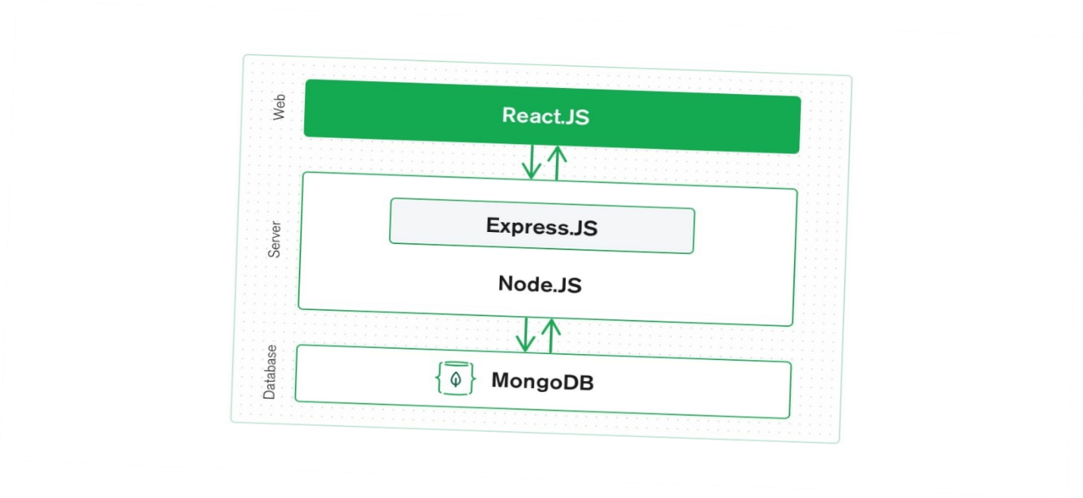

Frontend:

React can handle stateful, data-driven interfaces along with support for forms, error handling, events, etc.

Backend:

Express.js works for URL routing, handling HTTP requests and responses

Database:

Documents created by a React frontend can be sent to an Express server to be processed and stored directly in MongoDB for later retrieval and use

The MongoDB database is designed to store JSON data and is entirely built on JSON and JavaScript (e.g., cmd and query language, MQL). MongoDB Atlas allows for scability by auto-scaling the MongoDB cluster in a chosen cloud provider with ease. Express.js and React.js allows for easy communication between web and server sides and a natural flow of JSON data. Utilizing Typescript is possible as it is based off JavaScript

# 2 Major Module Descriptions

## Account Database

Using Google’s login API, users on OneHelp can create and log into accounts. Their accounts and passwords are stored in our database and are kept secure thanks to the encryption on Google’s API. Both Customers and Business users can create an account, customers can access the site’s search functionality, chatbot, and ticket creation system, while business users can access the ticket database and see, edit, or delete all tickets.

## Search Algorithm

The search algorithm takes in user input from a search bar and runs a search of the database for all keywords found in the user query. The algorithm then checks if the query corresponds to data inside the database. If no results are found, the search algorithm informs the user that there is no data related to their query. If there is data relating to the query in the database, it takes users to a page where the search results are displayed.

## 2.3 Chatbot

The chatbot is a more focused way for a user to get data from the database. The user can initiate a conversation with the chatbot by asking it a question, at which point it will give them the first link stored in the database or inform them that nothing is stored in the database to help with that problem. The chatbot then asks them if the output solved their problem, at which point they can say yes and exit the chatbot, or they can say no and the bot will offer them a link to the Create a Ticket page.

## 2.4Ticket System

The ticket system is how customers can interact with business users. There is a Create a Ticket page on the site where customers can leave their email and a description of their problem. On the business end, business users can see a list of all tickets, and edit or delete any of them. Tickets can be sorted by urgency so that they can be responded to in the proper order

# 2. Data Flow and Workflow Diagrams

## 2.1 DFD Diagram

1.1

Search Query

Email Customer with resolution

Login Credentials

Login Credentials

User

Business User

Account Login

Relevant Links

Read Customer Issues: Email + Issue+ Urgency

Write Customer Issues:

Email + Issue+ Urgency

Ask questions in text format

Smart

Students

Functionality

issues

New Information

Search Query

Supplies relevant Information based on search query

Customer issue info

Links to relevant information

Search histories and business data

Database

Business Home

Adds business information to database

Supplies ticket with chat information

Chat Bot

Problem Ticket

Search Screen

d

## 2.2 General User Workflow

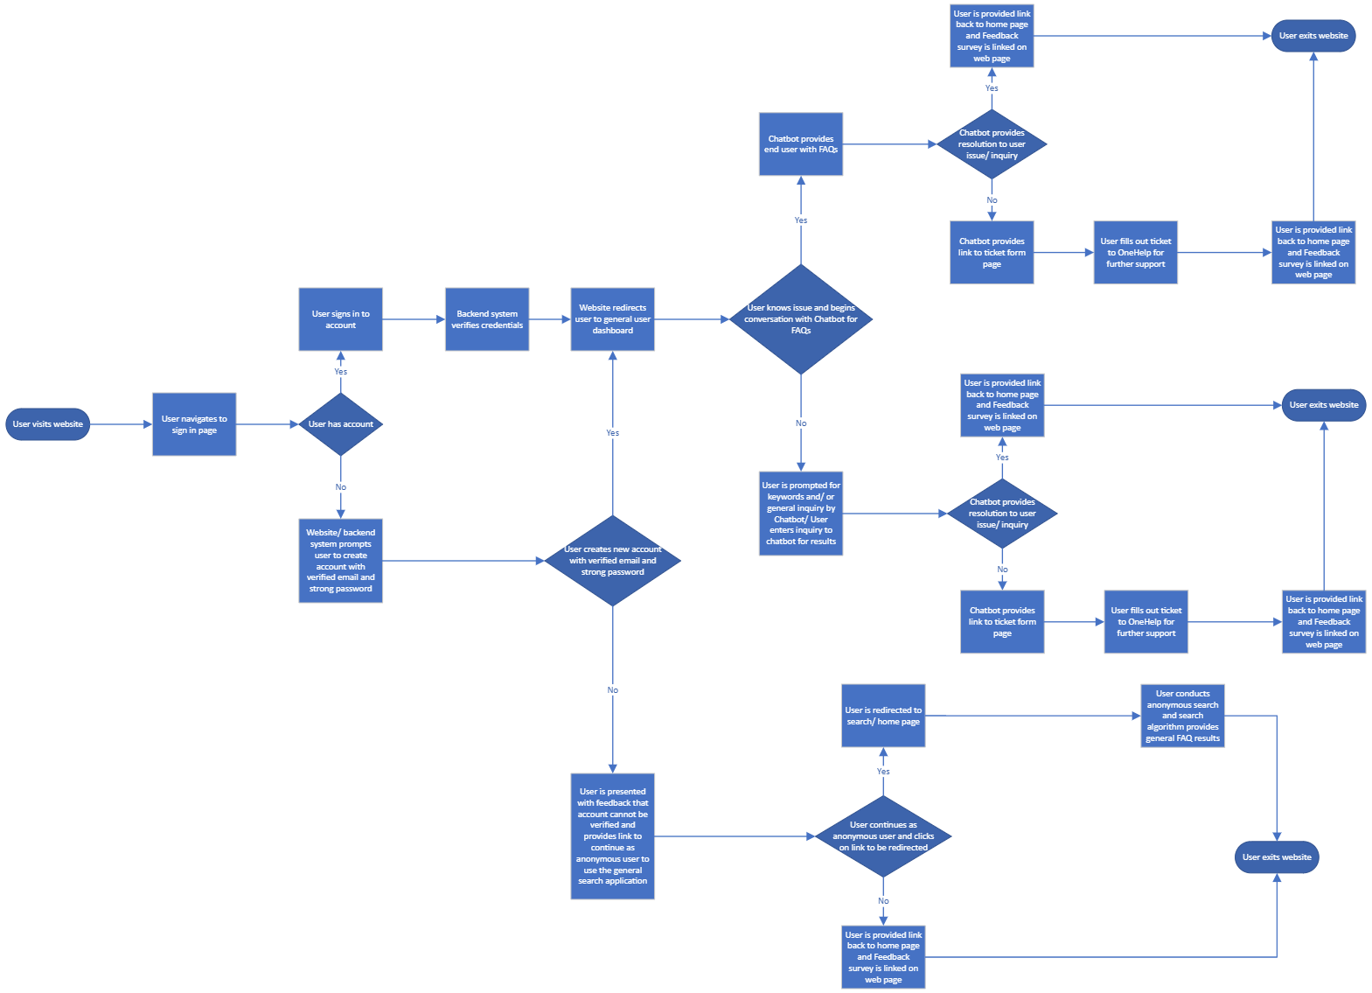

## 2.3 Business Workflow



## 2.4 Anonymous User Search Workflow

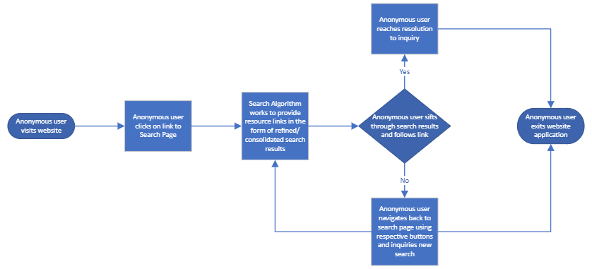

## 2.5 Chatbot Workflow Diagram

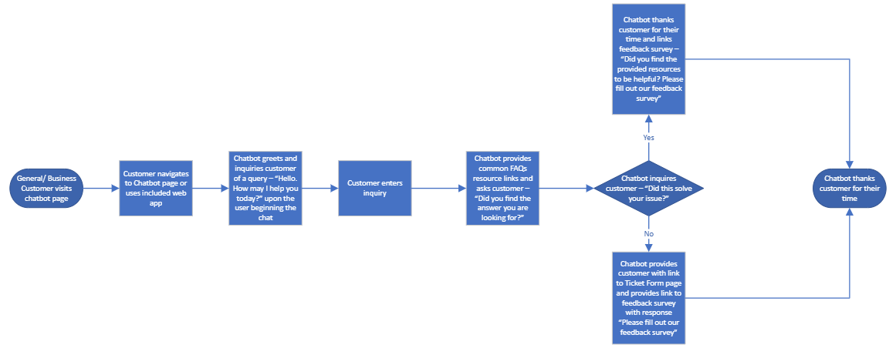

# Planning

# 1 Microsoft Teams

## Group communication

* Microsoft Teams used for communication of meetings and work needed between group members through three channels, General, Deliverables, and Schedule and Tasks

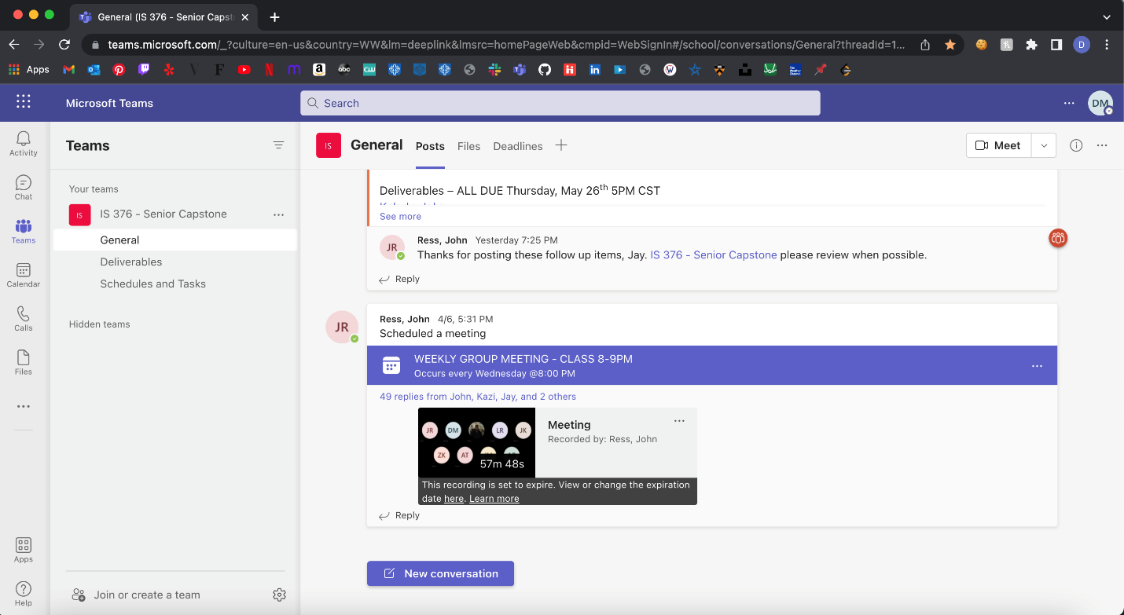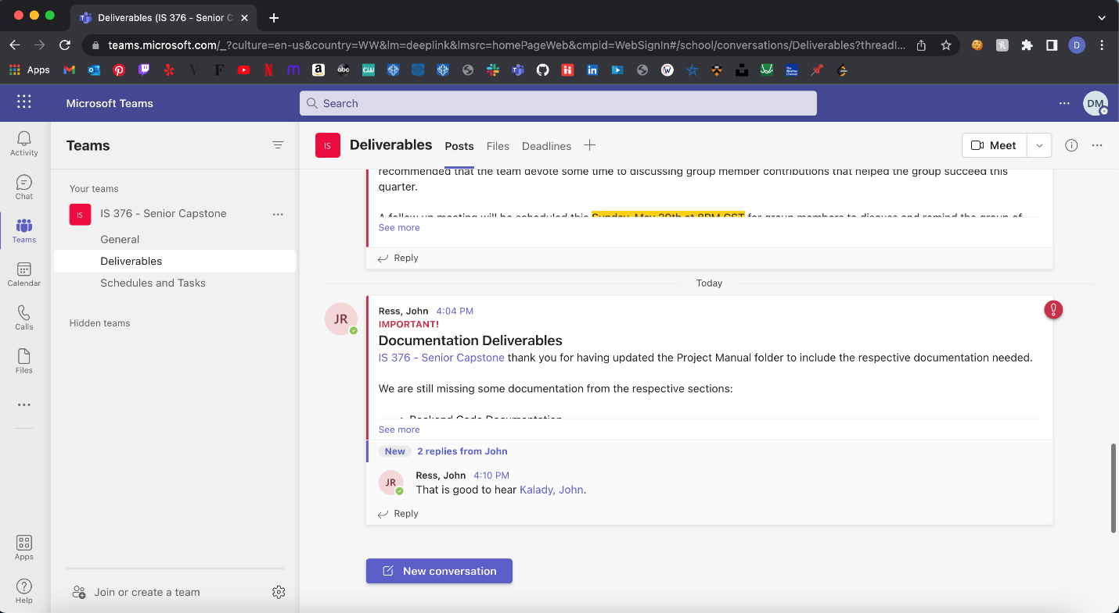

## Tasks and Deadlines

* Microsoft Teams was used to assign tasks to all members of the group, as well as deadlines for those tasks

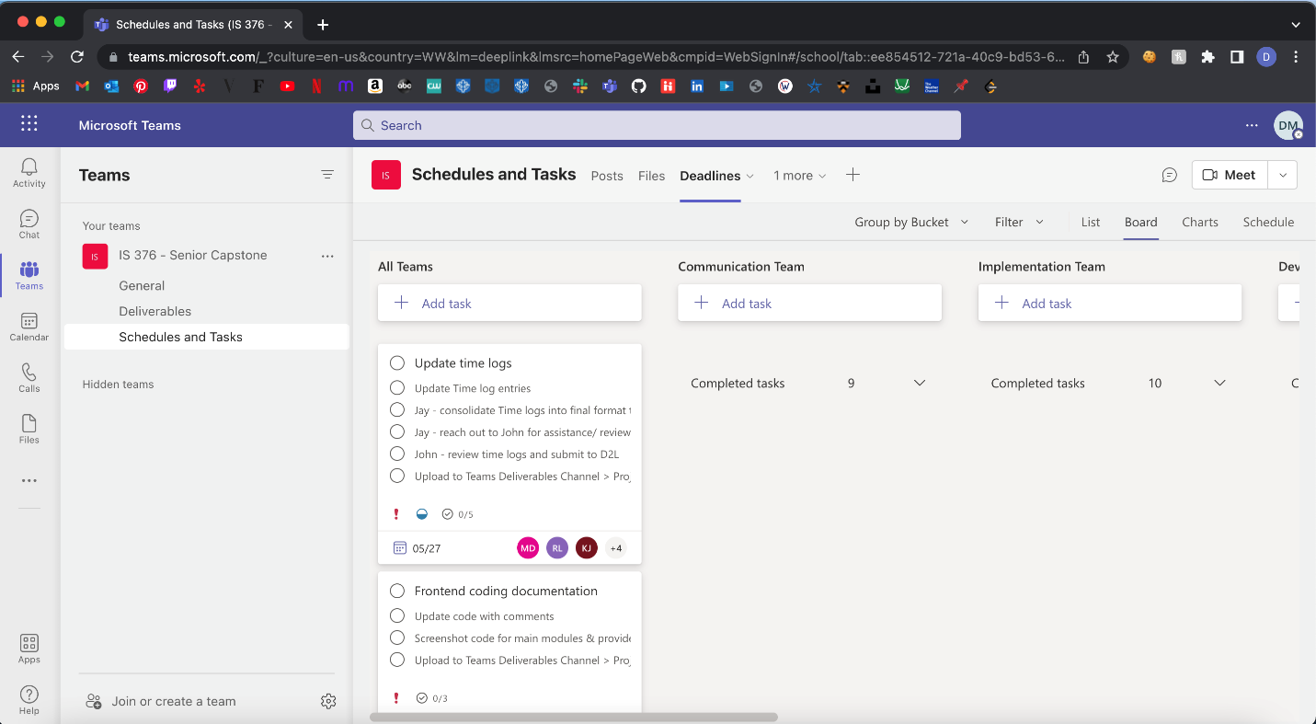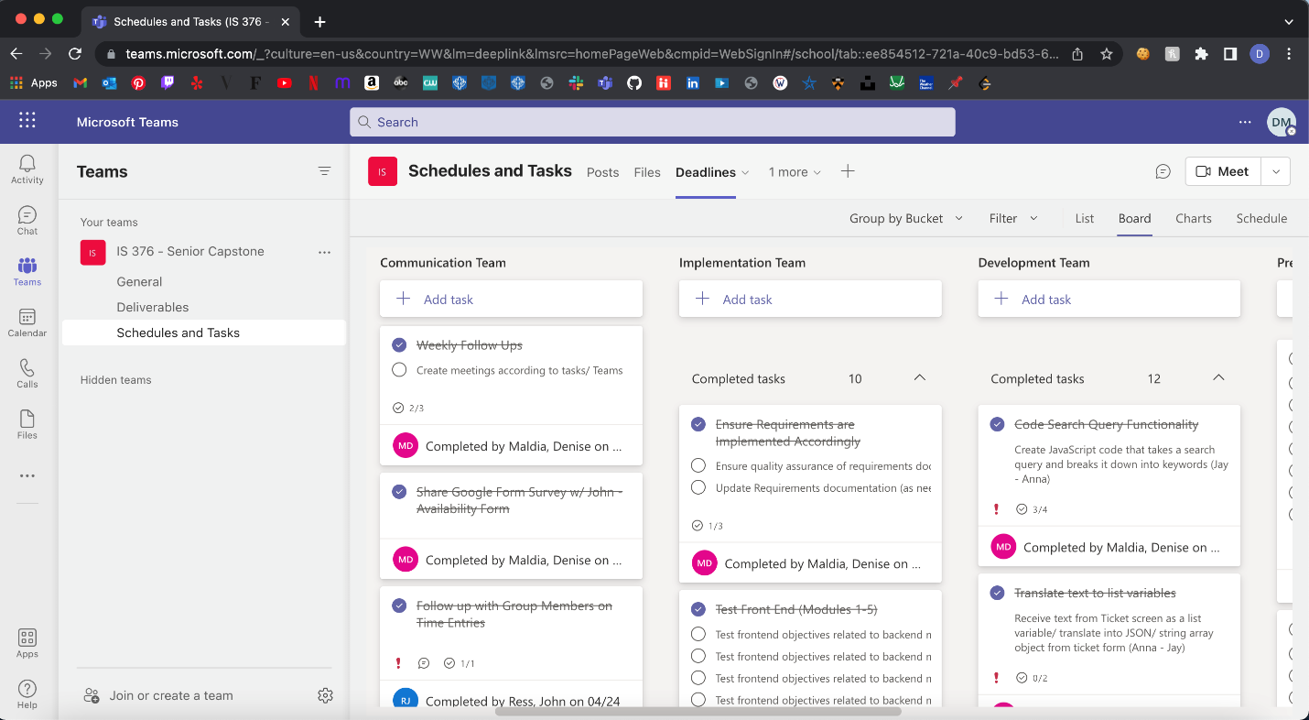

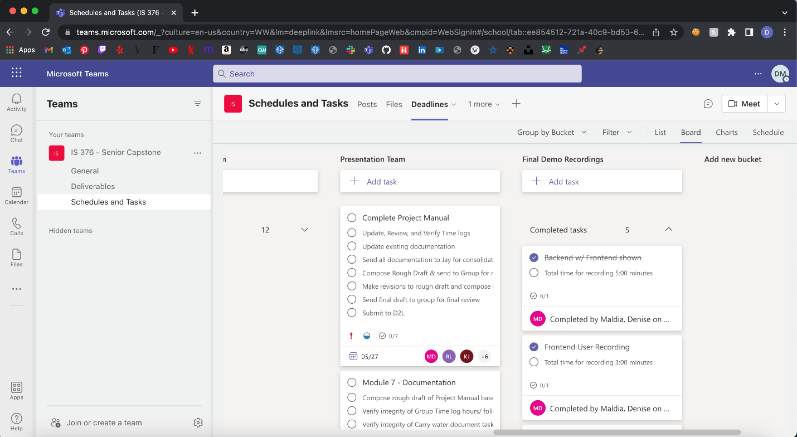

## File Sharing

* Microsoft Teams was used as the primary method of file sharing

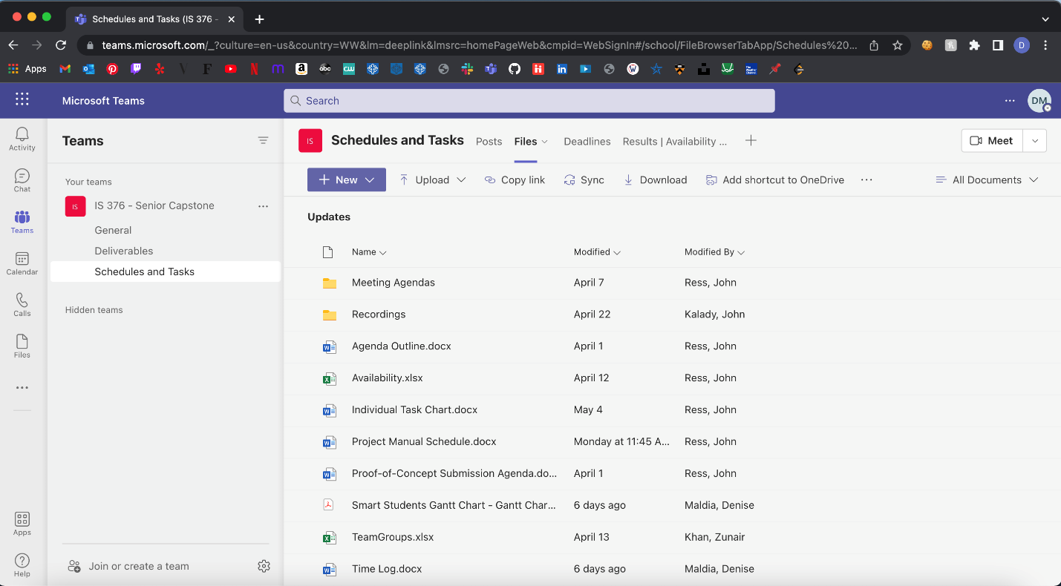

# 2. Gantt Chart

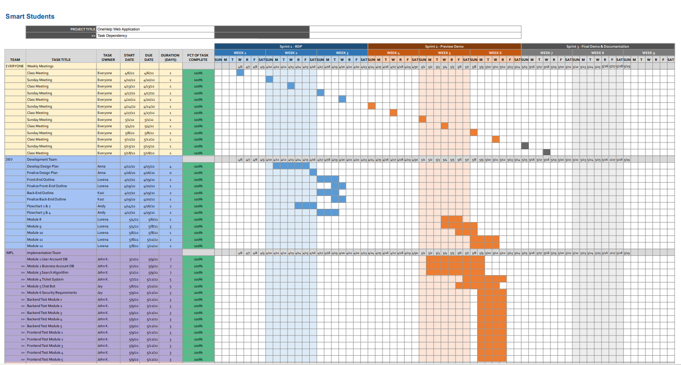

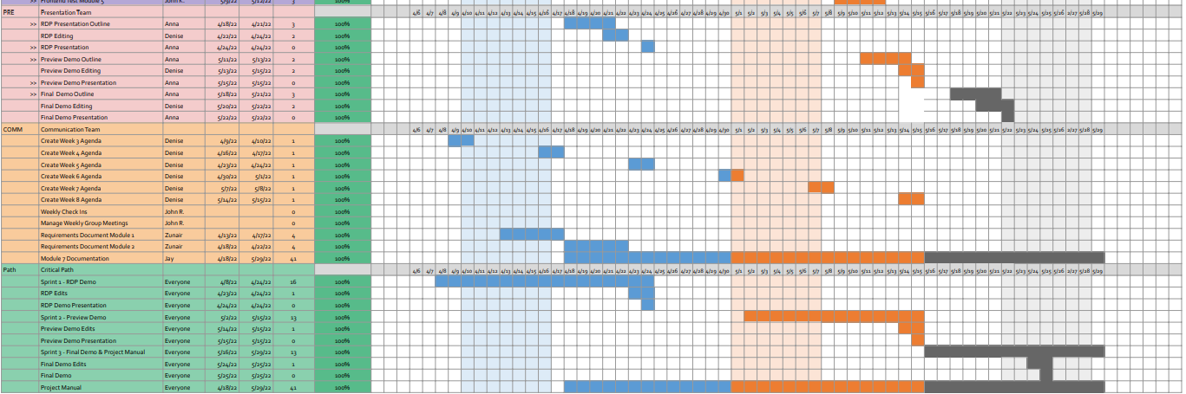

# 3. Individual Task Chart

Name: John Kalady

Role: Programmer

|  |  |  |  |
| --- | --- | --- | --- |
| Task | Description | Time (hrs.) | Completed |
| *Mod 1* | *Module 1 User Account DB* |  |  |
| Mod 1.1 | Implement username & password in MongoDB & create delete button allowing any user to delete account | 2 | Yes! Nice Job! |
| Mod 1.2 | Create account profile in MongoDB to verify member login, include security questions | 2 | Yes, superb work! |
| Mod 1.3 | Store user history, store customer ticket request in database | 2 | Yes, wonderful job! |
| Mod 1.4 | Save interactions between rep and customer from chatbot & ensure functionalities of chatbot | 3 | Yes, stellar! |
| Mod 1.5 | Integrate Node.js files to MongoDB | 2 | Yes! Nice! |
| *Mod 2* | *Module 2 Business Account DB* |  |  |
| Mod 2.1 | Implement account login specific to business user table | 2 | Yes! Good work! |
| Mod 2.2 | Verify member login, ensure integrity of email domains (i.e. @target.com) & include security questions | 2 | Yes, nice job! |
| Mod 2.3 | Store business user ticket request in database | 2 | Yes, wonderful! |
| Mod 2.4 | Ensure chatbot functionalities on business end | 2 | Yes, excellent! |
| Mod 2.5 | Integrate Node.js files to MongoDb | 2 | Yes, fantastic! |
| *Mod 3* | *Search Algorithm* |  |  |
| Mod 3.1 | Implement search algorithm | 5 | Yes, good job! |
| Mod 3.2 | Match keywords for FAQs/resources | 3 | Yes! Wonderful! |
| Mod 3.3 | Implement three key parameters → key frequency, document length, & an accuracy check | 2 | Yes! Good job! |
| Mod 3.4 | Implement machine learning for optimized search results | 3 | Yes! Wonderful! |
| *Mod 4* | *Ticket System* |  |  |
| Mod 4.1 | Create ticket and store in database | 3 | Nice work John K.! |

Name: Jay Miller

Role(s): Security Manager & Documentation

|  |  |  |  |
| --- | --- | --- | --- |
| Task | Description | Time (hrs.) | Completed |
| *Mod 5* | *Chat Bot* |  |  |
| Mod 5.1 | Generate responses to customer queries & determine conversation endpoints/branches i.e. when to redirect user | 3 | Yes! Good Job! |
| Mod 5.2 | Implement click path & create button/link for ticket form page | 2 | Yes, that’s great! |
| Mod 5.3 | Generate ticket based on user inquiry & ticket page link | 1 | Yes, excellent! |
| Mod 5.4 | Save conversation in database & implement prompt for user to start new conversation | 1 | Yes! Nice! |
| *Mod 6* | *Security Requirements* |  |  |
| Mod 6.1 | Use mernstack to secure connections between clients and servers | 2 | Yes! Nice Work! |
| Mod 6.2 | Implement encryption | 1 | Yes! Way to go! |
| Mod 6.3 | Use AWS security to handle network attack & implement required security certificates | 2 | Yes, terrific! |
| Mod 6.4 | Ensure secure data information between client and server | 1 | Yes, wonderful! |
| *Mod 7* | *Documentation* |  |  |
| Mod 7.1 | Compose the first half of the project manual | 4 | Yes! Good Job! |
| Mod 7.2 | Compose the second half of the project manual | 4 | Yes, excellent! |
| Mod 7.3 | Revise, organize, and finalize project manual | 4 | Yes, fantastic! |

Name: Lorena Rojas

Role(s): Webmaster

|  |  |  |  |
| --- | --- | --- | --- |
| Task | Description | Time (hrs.) | Completed |
| *Mod 8* | *Home Page - HTML/CSS* |  |  |
| Mod 8.1 | Create links for customer and business page | 1 | Yes, good job Lorena! |
| *Mod 9* | *Customer Login* |  |  |
| Mod 9.1 | Implement username and password boxes & create sign in/up button/link | 2 | Yes, nice work! |
| *Mod 10* | *Business Login* |  |  |
| Mod 10.1 | Implement username and password boxes & create sign in/up button/link | 2 | Yes, amazing job! |
| *Mod 11* | *Customer Directory* |  |  |
| Mod 11.1 | Create pages and links to homepage, FAQs, comments, & create a ticket | 3 | Yes! Superb! |
| Mod 11.2 | Create search bar, category links & chat box | 5 | Yes! Excellent! |
| *Mod 12* | *Business Directory* |  |  |
| Mod 12.1 | Create link to create ticket, search bar & chat box | 5 | Yes, wonderful! |

Name: Andy Reyes

Role(s): HCI Manager

|  |  |  |  |
| --- | --- | --- | --- |
| Task | Description | Time (hrs.) | Completed |
| Accessibility & Use | Ensure accessibility and use of website is up to standard | 3 | Yes, nice! |
| User account flowchart 1 | Create diagram/flowchart for user account | 4 | Yes, good job Andy! |
| Business flowchart 2 | Create diagram/flowchart for business account | 4 | Yes, nice flowchart! |
| Search Algorithm flowchart 3 | Create diagram/flowchart for search algorithm | 4 | Yes, perfect! |
| Chatbot flowchart 4 | Create diagram/flowchart for chat bot | 4 | Yes, keep up the good work! |

Name: John Kalady

Role(s): Testing Manager

|  |  |  |  |
| --- | --- | --- | --- |
| Task | Description | Time (hrs.) | Completed |
| Backend Mod 1 | Test backend Mod 1.1 - 1.5 | 2 | Yes! Good work! |
| Backend Mod 2 | Test backend Mod 2.1 - 2.5 | 2 | Yes, Nice Job! |
| Backend Mod 3 | Test backend Mod 3.1 - 3.5 | 2 | Yes! |
| Backend Mod 4 | Test backend Mod 4.1 | 2 | Yes! Superb! |
| Backend Mod 5 | Test backend Mod 5.1 - 5.5 | 2 | Yes! Nice! |
| Frontend Mod 1 | Test frontend correlated to backend Mod 1 | 2 | Yes! |
| Frontend Mod 2 | Test frontend correlated to backend Mod 2 | 2 | Yes! |
| Frontend Mod 3 | Test frontend correlated to backend Mod 3 | 2 | Yes! Good work! |
| Frontend Mod 4 | Test frontend correlated to backend Mod 4 | 2 | Yes, outstanding! |
| Frontend Mod 5 | Test frontend correlated to backend Mod 5 | 2 | Yes, fantastic! |

Name: Anna Terzian

Role(s): Presentation Manager

|  |  |  |  |
| --- | --- | --- | --- |
| Task | Description | Time (hrs.) | Completed |
| RDP Presentation Outline | Create a script for RDP presentation | 2 | Yes! Nice work! |
| RDP Presentation | Create, record, and present RDP presentation | 3 | Yes! Good Job! |
| Preview Demo Outline | Create a script for Preview Demo | 2 | Yes! Fantastic work! |
| Preview Demo Presentation | Create, record, and present Preview Demo presentation | 3 | Yes! |
| Final Demo Outline | Create a script for Final Demo presentation | 2 | Yes, excellent! |
| Final Demo Presentation | Create, record, and present Final Demo presentation | 3 | Yes! Nice! |

Name: Denise Maldia

Role(s): Planner & Video Manager

|  |  |  |  |
| --- | --- | --- | --- |
| Task | Description | Time (hrs.) | Completed |
| Updates and ensuring tasks are completed | Ensure tasks are continuously being updated through Teams and ensuring completion | * - |  |
| Weekly meetings & creating agenda | Create weekly agenda & remind team of upcoming due dates | * - |  |
| RDP Editing | Edit RDP Presentation | 5 | Yes! |
| Preview Demo Editing | Edit Preview Demo Presentation | 5 | Yes! |
| Final Demo Editing | Edit Final Demo Presentation | 5 | Yes! |

Name: Zunair Khan

Role(s): Requirements Manager

|  |  |  |  |
| --- | --- | --- | --- |
| Task | Description | Time (hrs.) | Completed |
| Requirements Document Mod 1 | Create first half of requirements document | 5 | Yes! Nice work! |
| Requirements Document Mod 5 | Create second half of requirements document | 5 | Yes! Good Job! |
| Finalize Requirements Document | Ensure quality and assurance of requirements document and piece Mod 1 and Mod 2 of requirements document | 3 | Yes, wonderful! |

Name: John Ress

Role(s): Project Manager & Remote Collaboration Manager

|  |  |  |  |
| --- | --- | --- | --- |
| Task | Description | Time (hrs.) | Completed |
| Weekly Group Meetings | Manage mandatory group meetings and Sunday group meetings | Ongoing | Yes |
| Weekly check ins | Check in with individual group members on weekly basis | Ongoing | Yes |
| Maintain Team Updates | Produce Team updates through Teams Posts and reaching assisting in group members being able to utilize communication methods effectively | Ongoing | Yes |

|  |  |
| --- | --- |
| Estimated Total Time Project Tasks | 162 hours |

## 4. Meeting Agendas

## 4.1 Friday April 8, 2022, Group Meeting Agenda

Topics of Discussion:

1. Consolidation of teams
2. Overview of RDP
3. Getting started
4. What to expect in future meetings

Consolidation of teams

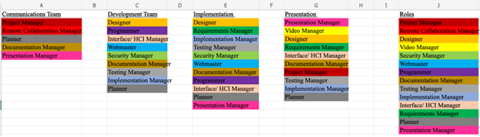

Overview of RDP

When is it due? *Sunday, April 24, 2022 at 11:30 pm*

* RDP rubric is visible on the class website
* (RECOMMENDED) Have the rubric up when working with your teams

Initial Goals

* Requirements Document
* Design Outline
* Plans moving forward/ Outline

End Goals

* Get RDP done by Saturday April 23, 2022
* Website up and Running - not yet needed to establish finalized functionality

Getting Started

Goals to Achieve by Sunday 4/10

* Communications:
* Plan out deadlines and schedules
* Create meetings & tasks
* Communicate Deadlines and updates to Team
* Development:
* Establish DB connection
* Establish connection to site portal
* Implementation:
* Outline and fortify Requirements Document
* UML diagrams/ designs
* Presentation:
* Attend meetings/ meet with Dev. and Implementation Teams to review presentation
* Begin creating PowerPoint

What to Expect in future meetings

* weekly one hour meeting (other than Wednesdays)
* weekly stand ups
* each person will…

1. update the group on what they are working on
2. any issues they ran into and if they need support
3. what you are working on next & how you are going to achieve this by the following deadline

* These updates need to be short and concise
* Ideally 5-7 minutes per person in order to be able to cover as much in the weekly group meetings & to ensure we are staying on track & not going overtime
* If there are any questions or concerns, reach out to Project Manager or Planner (no need to discuss with the whole group unless it is a whole group matter)
* IMPORTANT: your tasks is dependent on moving forward so please please do your best to treat the deadlines like hard deadlines

Links and Resources:

<https://condor.depaul.edu/~elliott/394/demos/d-rdp/>

Planning:

https://condor.depaul.edu/~elliott/394/demos/d-rdp/PlanNotesB.html

Presentation:

<https://condor.depaul.edu/~elliott/394/demos/d-rdp/PlanPresentationA.html>

<https://condor.depaul.edu/~elliott/394/demos/d-rdp/DesignPresentationB.html>

<https://condor.depaul.edu/~elliott/394/demos/d-rdp/RequirementsNotesA.html>

Design:

<https://condor.depaul.edu/~elliott/394/demos/d-rdp/design-notes.html>

## 4.2 Wednesday April 13, 2022, Group Meeting Agenda

Topics of Discussion:

1. Weekly Stand ups
2. Update on planning
3. Design - Anna
4. Evaluation Survey

Weekly Stand Ups

Everyone will…

1. Update on what you are working on
2. Any issues you ran into and if you need support/help
3. What you are working on next

** Please keep these updates concise so that everyone can go around and talk

Updates on Plan

* Focusing on big picture (overall group’s tasks)
* Separating each due date into sprints

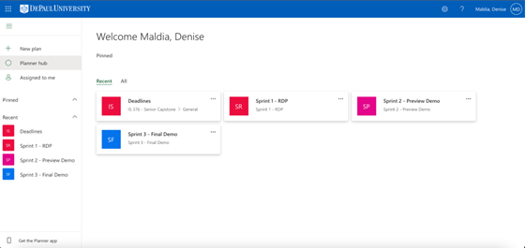

* Sprint 1 - RDP
* DUE April 24, 2022 @11:30 pm
* April 8 - April 23
* Sprint 2 - Preview Demo
* DUE May 15, 2022 @11:30pm
* April 25 - May 14
* Sprint 3 - Final Demo
* DUE May 22, 2022 @11:30pm
* May 16 - May 21

Design - Anna

* Idealized doc design
* Questions
* Requirement Matrix
* Suggest subteams & confirm feasibility & capability

Evaluation Survey

Main Issue: Communication

Other issues: Lack of Experience and Organization

## 4.3 Sunday April 17, 2022, Group Meeting Agenda

Topics of Discussion:

1. Updates from RDP managers [keep to first 30 min of meeting]
2. Requirements (10 min)
3. Design (10 min)
4. Plan (10 min)
5. Planner Tasks Updates
6. What else are we missing for RDP? / What do we need in order to complete RDP?

Requirements

* Discuss requirements document
* Questions for group regarding requirements

Design

Plan

* I have a spreadsheet with general tasks
* Share screen with everyone to briefly go over how the Gantt Chart outline is structured
* I have outline for individual tasks
* Share screen with everyone to briefly go over the structure of the individual task outline
* May share the outline with people in order for them to fill in their own tasks in chronological order and fill in description
* Leave start and end date as well as estimated time to me

## 4.4 Wednesday April 20, 2022, Group Meeting Agenda

1. Weekly stand up
2. Project Planning
3. Follow up tasks & RDP timeline
4. Group meetings before Sunday deadline
5. General Questions/Concerns

Weekly Stand Up (John)

1. Update on what you are working on
2. Any issues you ran into and if you need support/help
3. What you are working on next
4. Anna - Design Manager / Presentation Manager
5. Zunair - Requirements Manager
6. Kazi - Implementation Manager
7. John K. - Programmer / Testing Manager
8. Andy - Interface
9. Lorena - Webmaster
10. Jay - Security Manager / Documentation
11. John R. - Project Manager / Remote Collaboration Manager
12. Denise - Video Manager / Planner

Planning (Denise)

* Worked on Gantt Chart
* Focusing on individual tasks (might need to follow up with regards to individual tasks)

Follow Up Task & Outline Remaining Time Until Sunday (Denise)

* New survey will be made with updated availability in order to finalize planning
* Explain the Individual Task Outline
* Push out the document
* Working on implementation individual task
* Will reach out for other domains
* Three days to finalize the RDP
* Try to finish everything by Saturday so presentation manager and video manager have time to record and edit

Group Meetings/ Follow-ups Before Sunday Deadline (John)

* Thursday 4/21 - Design, Requirements, Planning Status
* Friday 4/22 - Final touches
* Saturday 4/23 - Submit all content to Presentation manager/ Presentation manager to record presentation and submit to Video Manager
* Sunday 4/24 - Video Manager to submit recorded presentation to Project Manager for Submission

General Questions and Concerns (Group Discussion)

* Make sure everyone leaves knowing what they have to do by Saturday
* Reassure everyone that it is not a strict deadline on Saturday but ideal deadline
* Any task completion concerns reach out to Denise
* Any other concerns reach out to John and/ or Denise

## 4.5 Sunday May 8, 2022 Group Meeting

Topics of Discussion

1. Weekly Stand up
2. Zunair - business information overview
3. Updates on tasks and delegation of tasks
4. Deliverables for this week
5. Questions/Concerns

Weekly Stand Up

1. Update on what you are working on
2. Any issues you ran into and if you need support/help
3. What you are working on next

Zunair - business information overview

Updates on tasks and delegation of tasks

Dev Team - main person John Kalady (pass it on to him)

Deliverables for the week

* Reference deadlines tab, individual task chart & Gantt Chart

Questions/Concerns

## 4.6 Monday May 11, 2022 Group Meeting

Topics of Discussion

1. Weekly Stand up
2. Make sure updating deadlines tab
3. Updates on Presentation Planning
4. Questions/Concerns for upcoming due date Friday

Weekly Stand Up

1. Update on what you are working on
2. What modules have you finished - need progress reports/ percentages
3. What modules are you working on CURRENTLY
4. What you are working on next
5. Any issues you ran into and if you need support/help → addressed at end of meeting (questions/concerns)

Update Deadlines Tab

* Dev Team
* Discuss deadlines tab → share screen and take note of what is done, what has to be done and what can be let go
* Make sure you are updating the deadlines tab as you go (understandable because of short time span it is probably not priority but try the best) and update time logs ensuring logging in within the 5 hour rule  *(DEADLINE 5/12 - Thursday 11pm CST)*

Presentation Planning Updates

* Outline broken down (refer to presentation planning outline)
* Each manager can present their domains/coordinate with Anna

## 4.7 Wednesday, May 18, 2022 Group Meeting

Topics of Discussion:

**as always save questions/comments/concerns once we get to discussion point #4 (we have plenty to cover!)

1. Smart Students Preview Demo (comments from Elliot)
2. Purple Panthers Example
3. Structure of Final Demo Presentation
4. Recommendations/Questions/Concerns - Open the floor for discussion
5. Deliverables / task delegation

Smart Students Preview Demo - Comments from Elliot (John)

* See actual ticket and chatbot functionality implemented ***
* Keep within 20 minutes
* Biggest sag was actual search and chatbot functions do not appear to be working, not aware of ticket management
* Barely met CRUD specifications
* In terms of intro → see actual design or some sophisticated new way to approach this problem that has been around and unsolved ** keep it short to identifying the problem, then show the audience how are are attempting to solve the problem
* Too much screen jumping on the code
* Teaching session when talking about code
* Show requirements document more thoroughly/ provide working example

[Purple Panthers Example](https://docs.google.com/document/d/1Ostk6sGx6kyPij5vHeeT26uGhsSBGJO6cIOjAlVjx2E/edit?usp=sharing) (John)

* What they did well
* Keeping each domain/ part concise i.e. to the point
* Showed frontend as if they were a user (teaching style)
* Showed backend with the corresponding frontend (teaching style)
* Brief business plan
* Good hand off from one person to another
* Teach don’t tell

[Structure of Final Demo](https://docs.google.com/document/u/0/d/1I0FgTg8c8iexZCHB21RXIzBQlkjLSxE1EVivaU40SG0/edit) (Denise)

Recommendations/Questions/Concerns - Open the floor (Everyone)

Deliverables / Task Delegations (John & Denise)

* Due date for all tasks is Friday, May 20, 2022 at 8 pm
* If possible earlier the better - send ASAP to enable time for reviewing before video editing
* Those who are part of presenting and recording
* Establish how to record and what to use to record - OBS DEMO (if needed)
* REQUIRED - Introduction requires video feed. No need for cameras after introduction - can just be voice over
* When downloading ensure it is .mp4 or for mac users .mov
* UPDATE YOUR TIME LOGS!!!
* Denise will update the deadlines tab and please take a look at it this final week to ensure tasks are completed and everyone knows the progress of the project

Notes for Check Ins & meetings to be set:

* Check in with Jay regarding the security model
* Push out final presentation demo plan on teams following tonight’s group meeting
* Jay, John, Kazi, Lorena meeting Thursday 6pm - 7pm
* Anna to get script and slides uploaded to Teams

Have search algorithm and chat bot on customer end

Remove search algorithm and chat bot on business end

Revise requirements document

Revise security implementation

## 4.8 Wednesday May 25, 2022 Group Meeting Agenda

Topics of Discussion:

1. Reflect on feedback from Elliot
2. Deliverables for this week
3. Questions/Concerns

Reflect of feedback from Elliot - Everyone

* Open discussion about what Elliot says

Deliverables for this week

***IMPORTANT: everyone needs to update their time logs!!

* A frozen time log will be submitted and everyone needs to ensure all their times are appropriately documented
* *If* we have extra time at the end we can have everyone go on the time log document and update accordingly

Project Manual Deliverables

* Any project manual documentation are worked with the coordination of Jay
* Use blue rhinos project manual on D2L as a reference (not to copy just an idea)
* General tasks with Project Manual
* Cover and table of contents
* Once we have all the parts and have a draft, ideally have everyone take a look at it for comments and feedback
* Have a couple of people for editing and revising the document according to group’s comments and feedbacks
* Reach out to Jay in terms of what other support/help he needs with the manual
* Individual tasks with Project Manual ( can also be seen in deadlines tab)
* Front End Documentation
* Lorena, John K. & Kazi
* Back End Documentation
* Jay, Kazi & John K.
* Security Documentation
* Jay
* Testing Documentation
* John K.
* Planning Documentation
* Denise
* Requirements/Business Documentation
* Zunair
* Implementation Documentation
* Kazi
* Design Documentation
* Anna

# Frontend Site

# 1 Website Screenshots

## 1.1 Index Page

* Links – Login Page and FAQs page
* Mission Statement

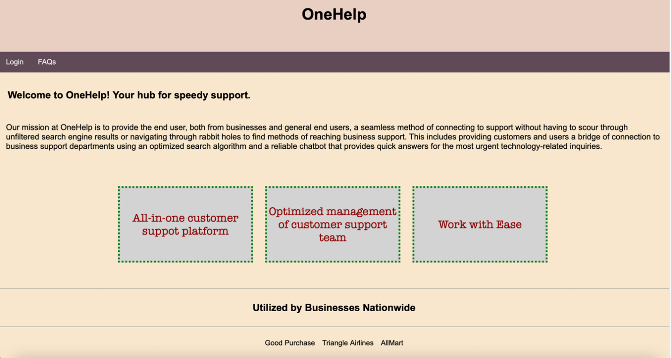

## 1.2 Login Page

* Allows user to login using google account
* Once user has logged in he/she will be redirected to either the customer or business directory

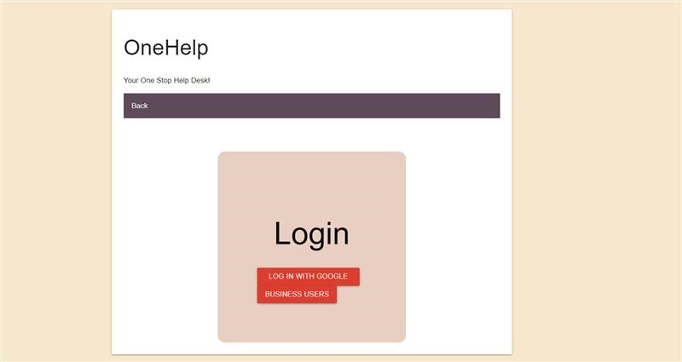

## 1.3 Business Login

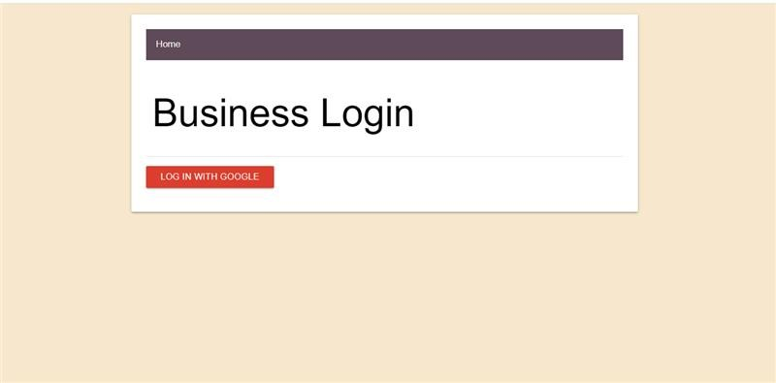

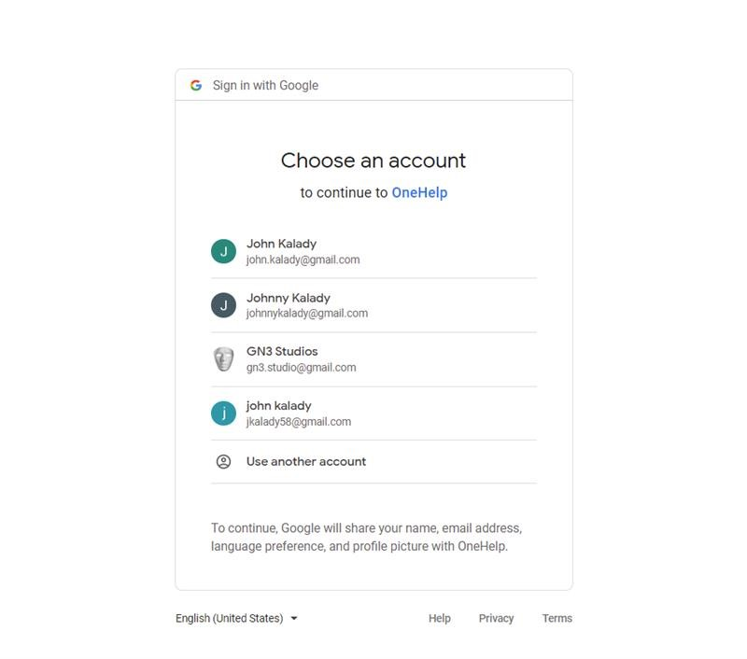

## 1.4 FAQs Page

* Provides user with different FAQ links.

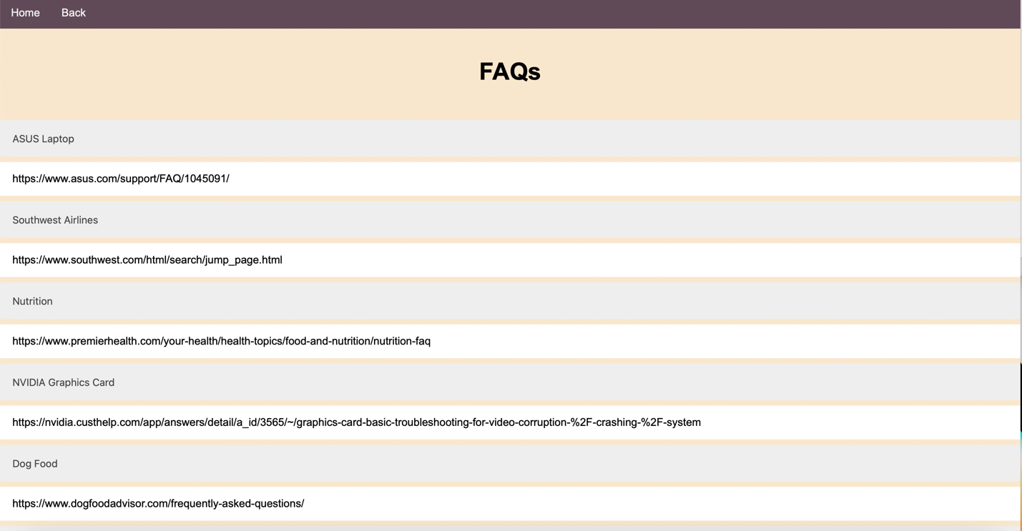

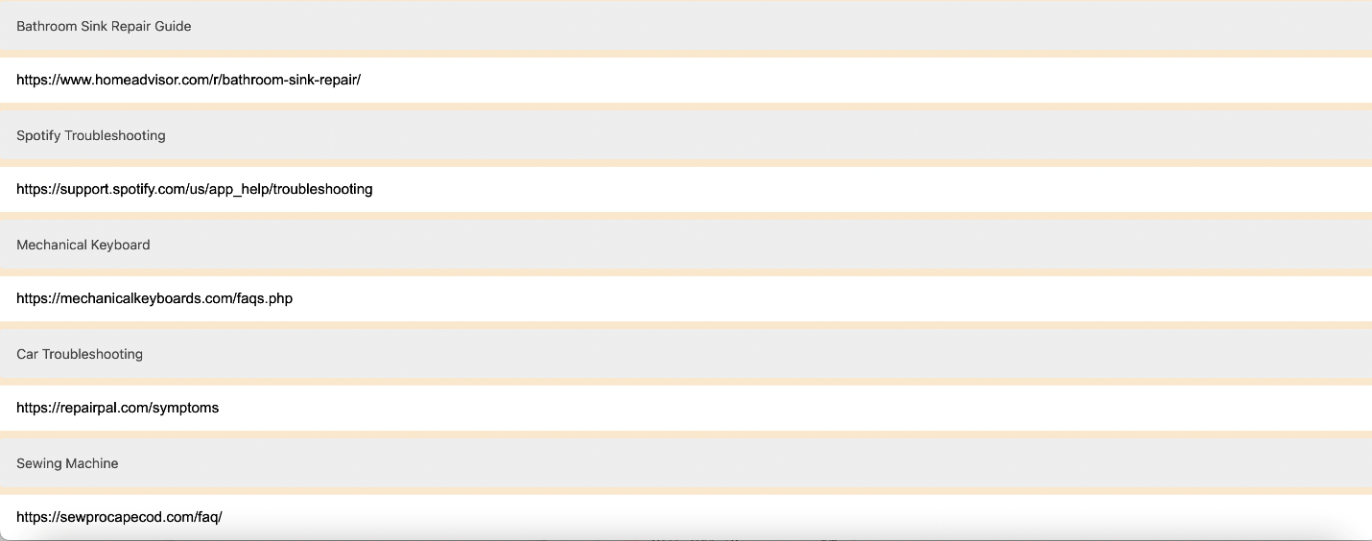

## 1.5 Customer Directory

* Links- FAQs page, Comments, and Create a Ticket form under “Can’t find what you’re looking for?”
* Search bar
* Chat box

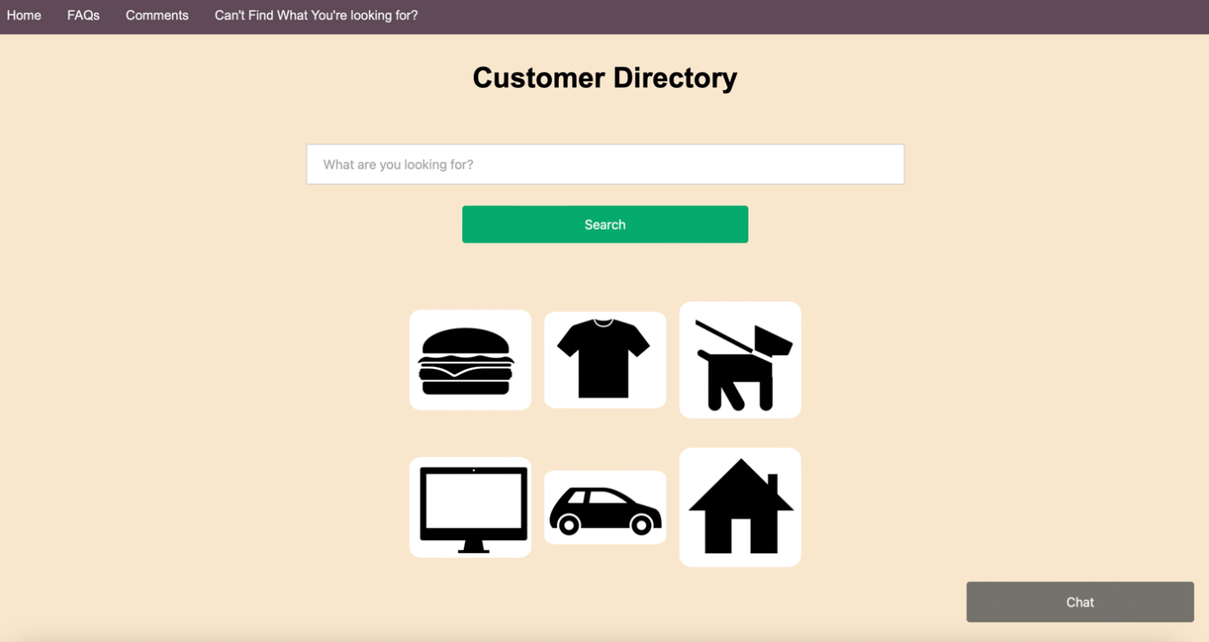

Customer Directory with Chat Box Open

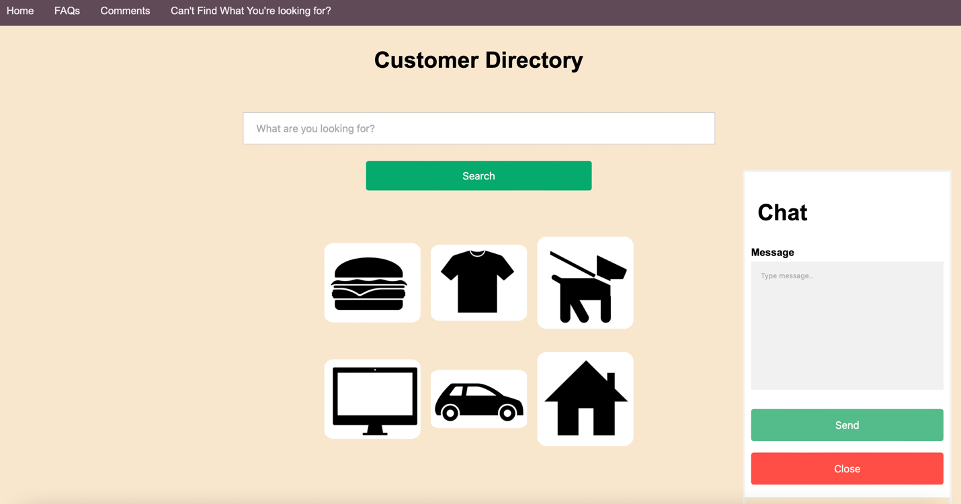

## 1.6 Comments Page

* Allows user to leave comments/reviews

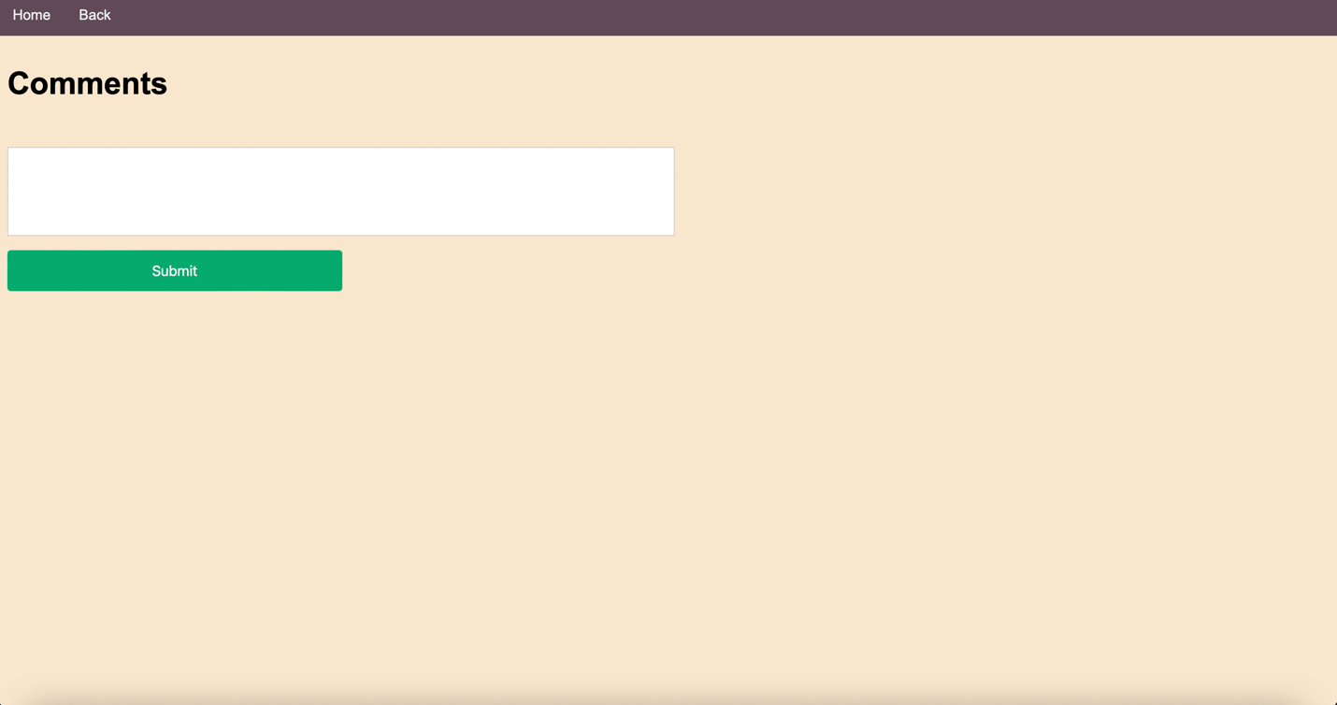

## 1.7 Create a Ticket Page

* Allows user to create a ticket if they can’t find what they are looking for within the customer or business directory.

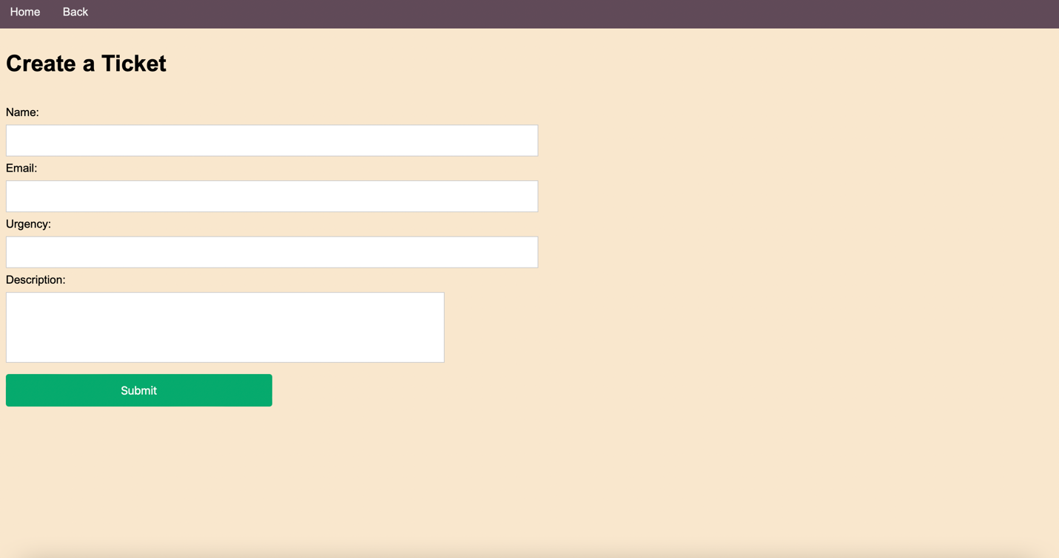

## 1.8 Business Directory Page

* Links – Comments Page and Create a Ticket Page

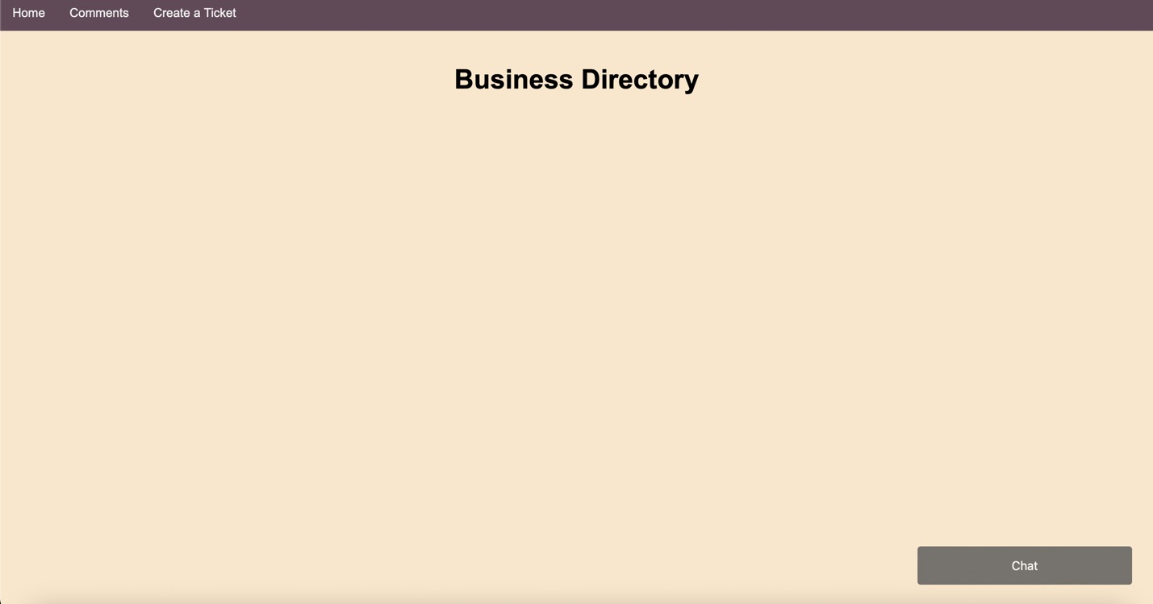

## 1.9 Business Directory with Chat Box Open

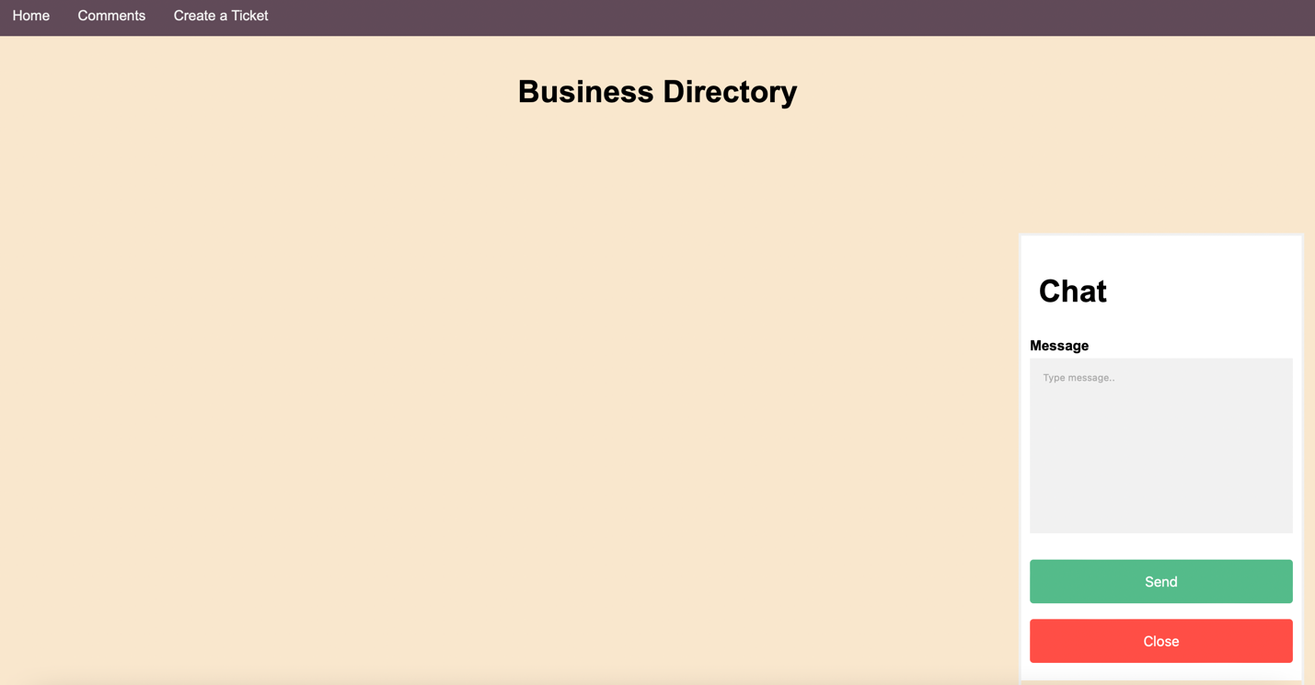

## 1.10 Comments Page

* Allows user to leave comments/reviews



## 1.11 Create a Ticket Page

* Allows business user to create a ticket, mark as complete or delete.

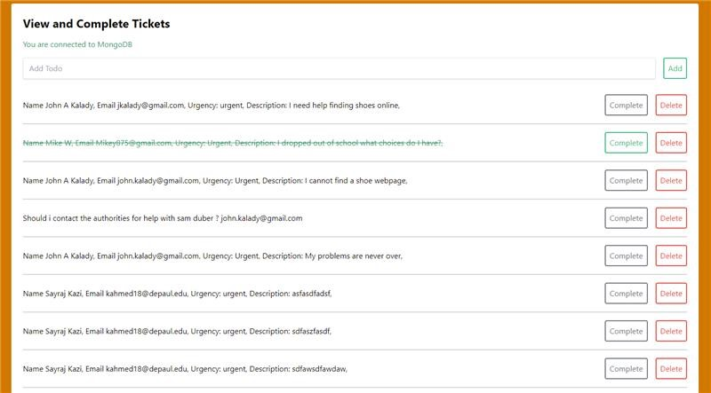

## 1.12 Chatbot

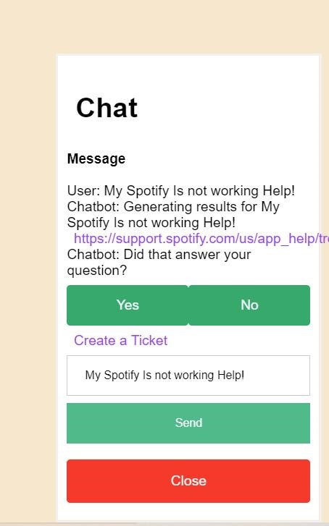

# Coding Documentation

# 1 Summary

In this Document you will find the mern-stack implementation for our front-end HTML code, which represents the visual format of the Graphical User Interface (GUI), alongside the back-end implementation written in JavaScript which handles the functionalities of our web application. We constructed our web application from the Node.js structure. This allowed us to have a series of four main components. The GUI, a react front end through API’s, an express backend application, and a MongoDB Atlas Live database all within a single runnable application. The forefront three are represented within the Node.js structure using Express, a module that handles routing to different handlebars layouts and API calls, the React module, which handles JavaScript methods using a module called mongoose to connect and grab data from our MongoDB Atlas database,  and handlebars, an html reading module which allows for static HTML to display as a GUI on a web Browser. This application is then run with Amazon Web Services (AWS) which uses instances and security groups to monitor connections to the application and allows users to link to our application through any web Browser.

## Google OAuth

Google allows for users to create and run a security check through their servers to maintain whether or not a User is who they say they are. For this Google requires a google strategy which envelopes processing the data from the user and sending the data to an instantiated link, which only accepts requests from our applications secret key. Within our applications react API we created a google strategy and User variable type which allows users to verify themselves with google before using our application. Upon signing into google our application provides a callback URL that redirects the User back to our main directories after Logging in.

# 2 Main Method

App.js a file that handles the users function requests and directs them to various pages.

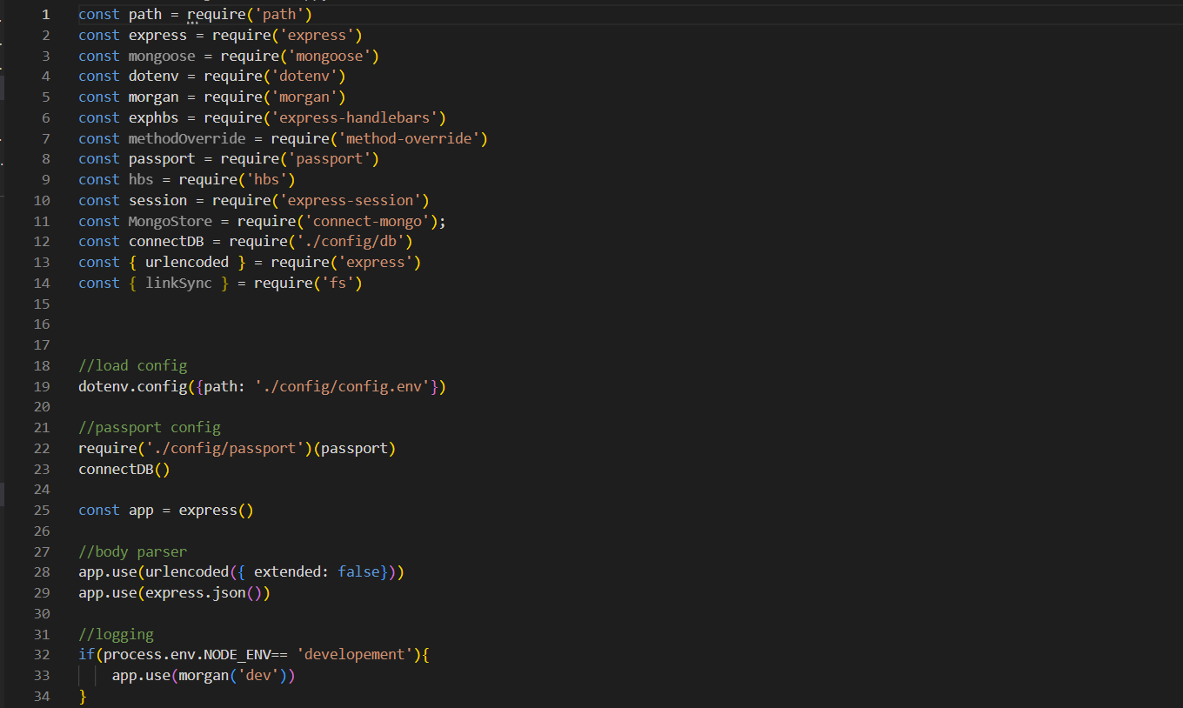

Above you will find the packages we included in our main application’s runnable file as well as the loading of configurations from our configuration files. Also we have instantiated a body parser to read information from html forms and a logging method which logs errors on the terminal that runs the application.

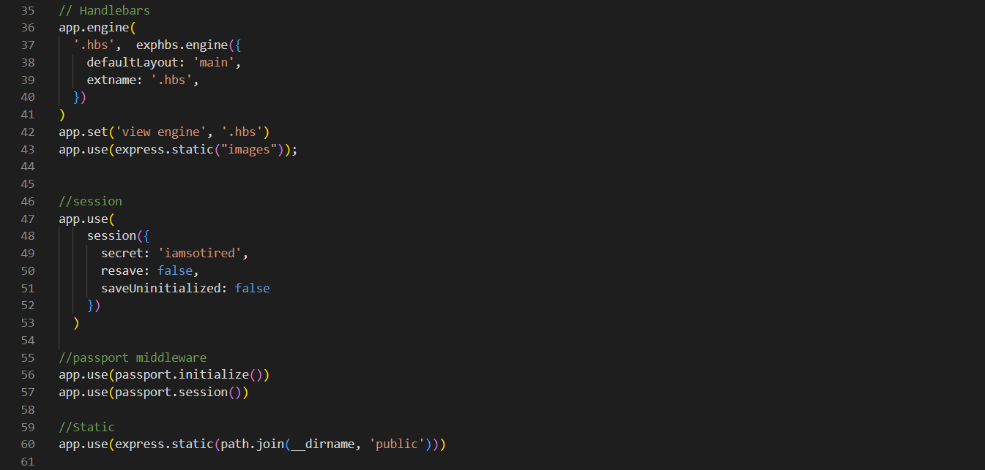

Above You will see the instantiation of handlebars and sessions. Handlebars creates a GUI that runs static HTML files in a dynamic way redirecting users to different pages without having to create new web pages for each page design. Sessions store the user that is logged in to handle user return requests from other web pages and keeps the user logged in until they log out.

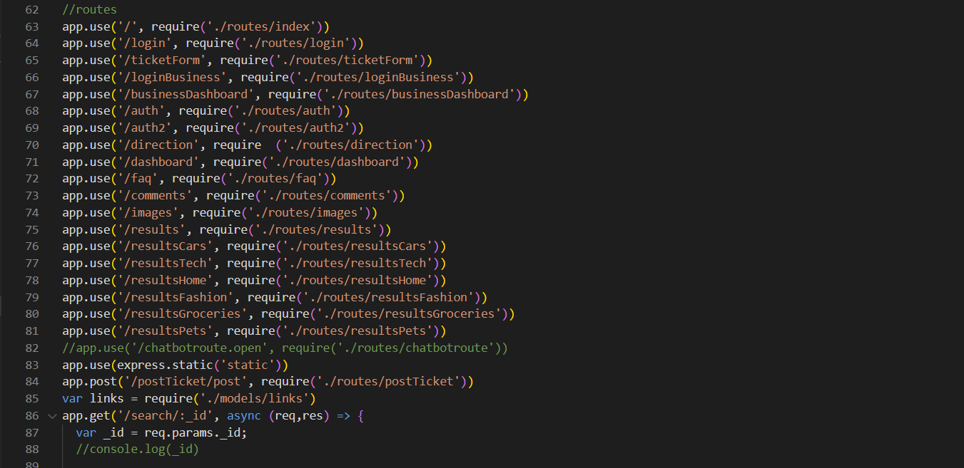

Above You will find the routes used to direct users to the different static HTML pages. In this form it creates variables that store the URL request composition and opens the correct pages upon request. Also seen on line 84, is the route to our post method for creating a new Ticket.

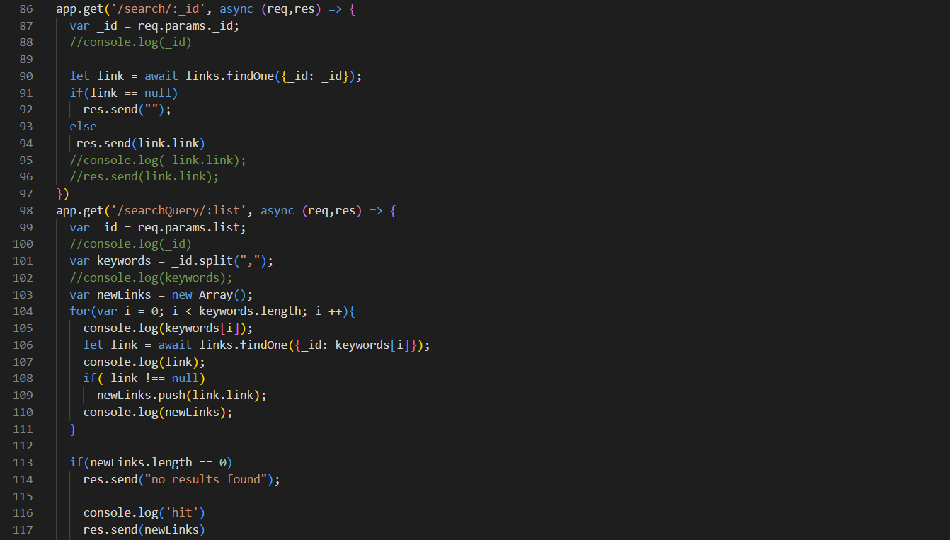

Above is the Get methods to retrieve links stored within our database that have been tied to key words pulled from user’s search queries.

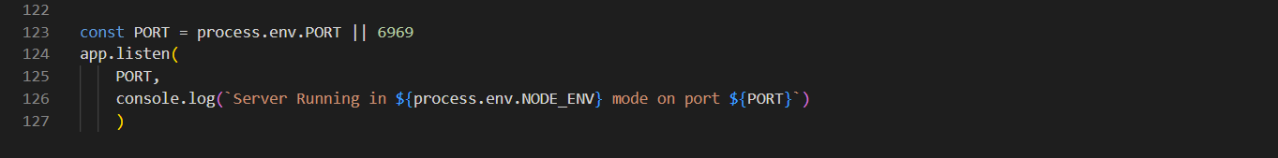

Lastly, we instantiate the Port in order to reference the application when it runs.

## 3 Configuration Files

In these files we find the various packages and modules which assist our program with handling functionality as well as storing connections and file locations.

First our package file

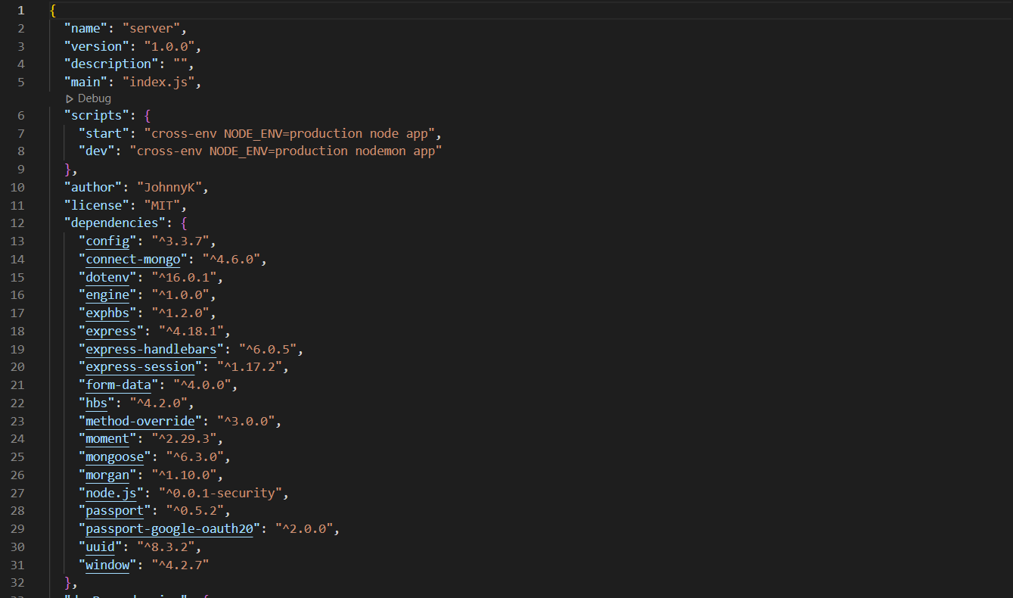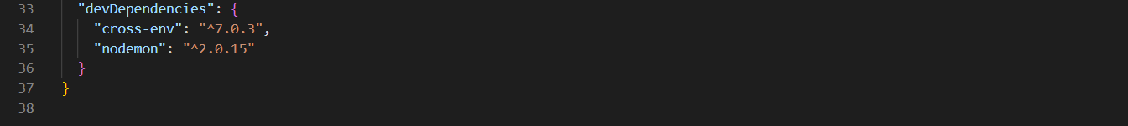

Second our environment config file

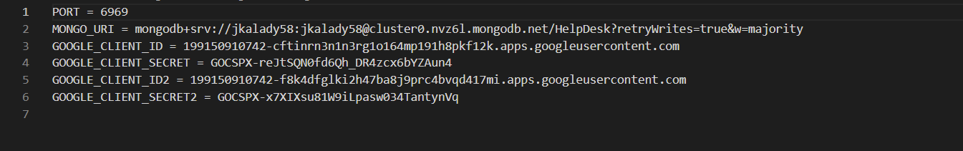

Third Our DB configuration and connection file

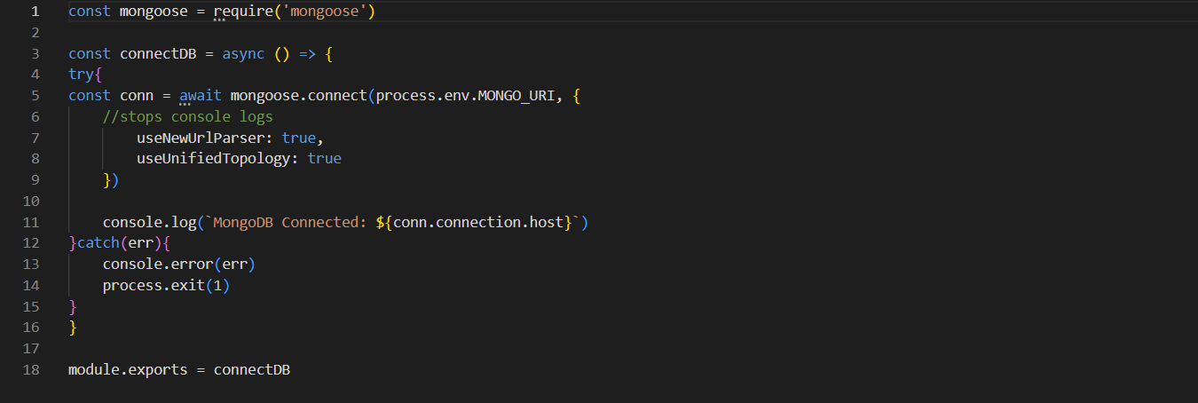

Lastly the google strategy file which allows communication with google logins

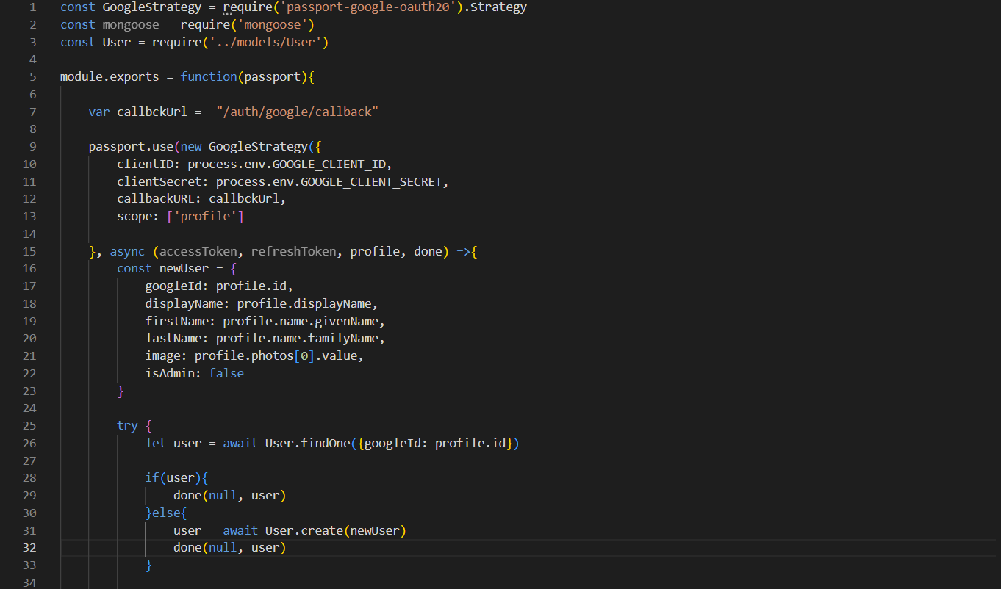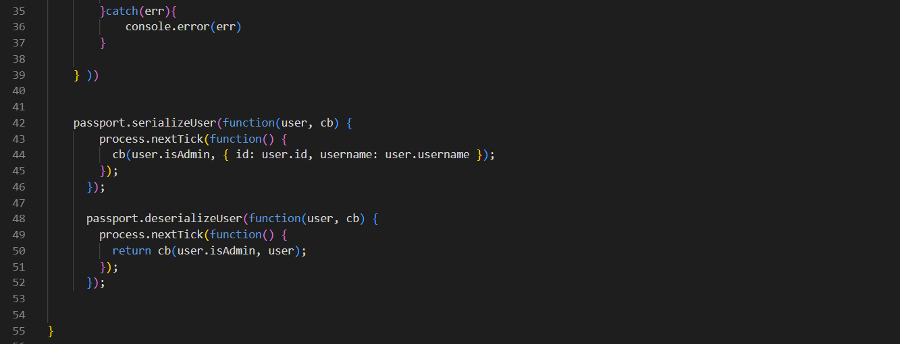

## Front End Code

Handlebars filetypes written in HTML for translation to a GUI

Business Dashboard

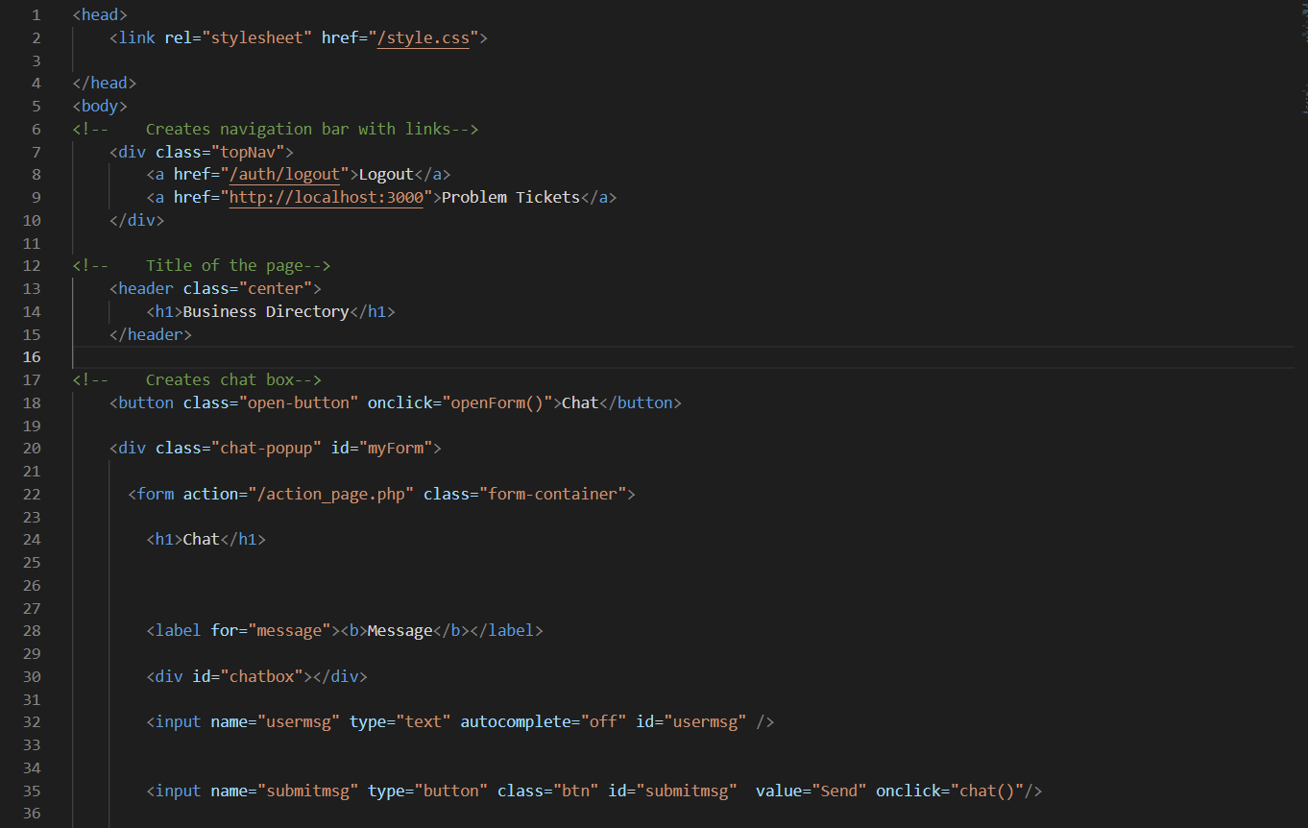

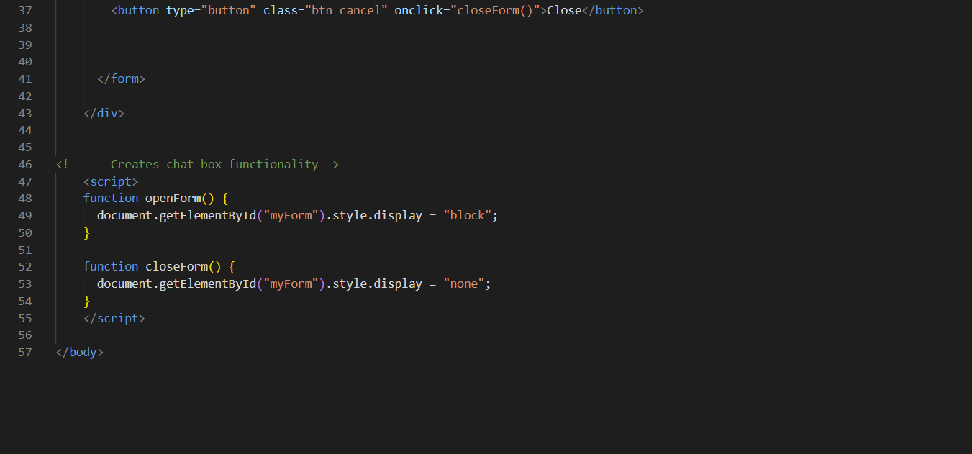

## /Comments

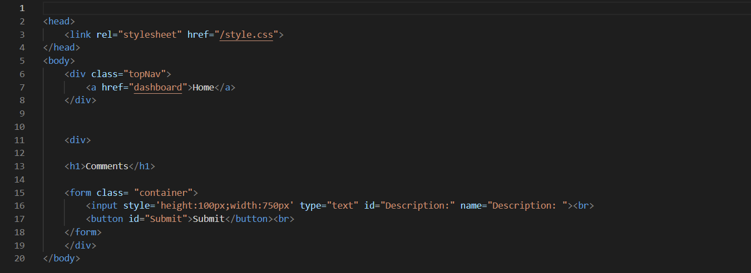

## /User Dash Board

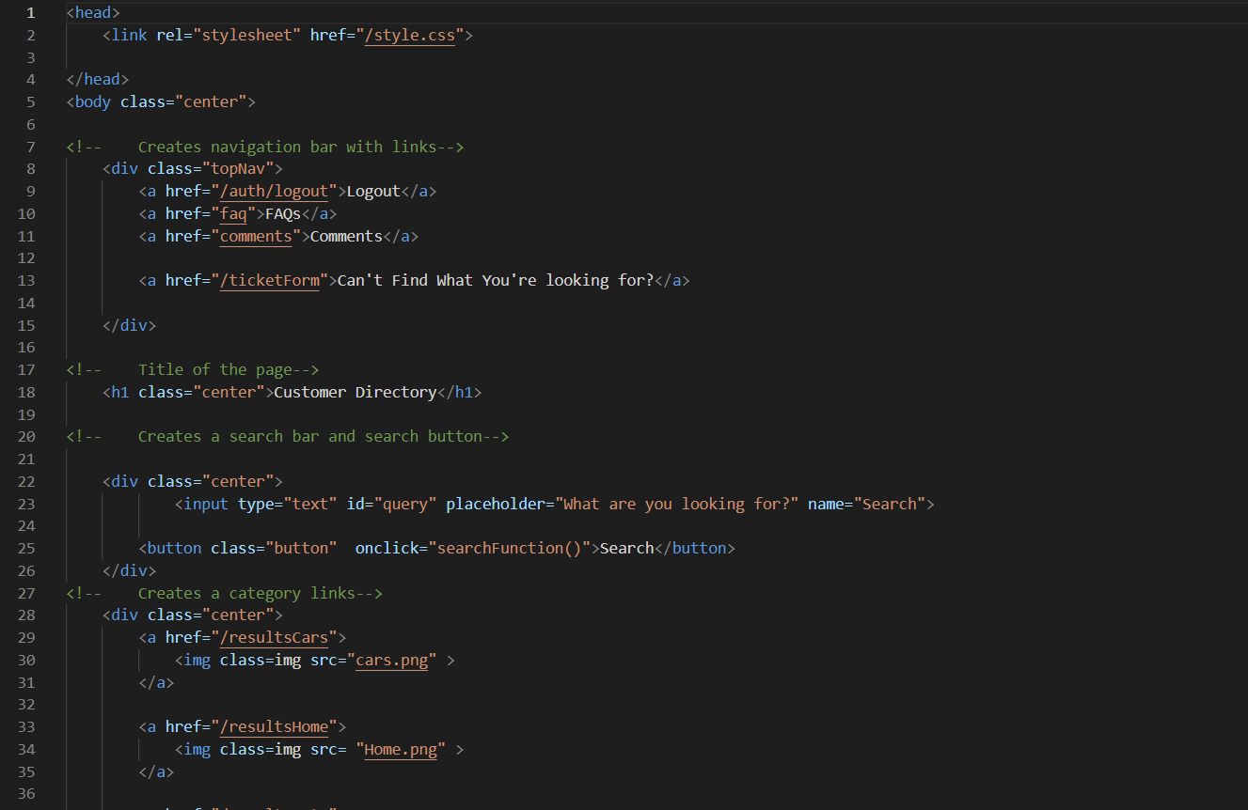

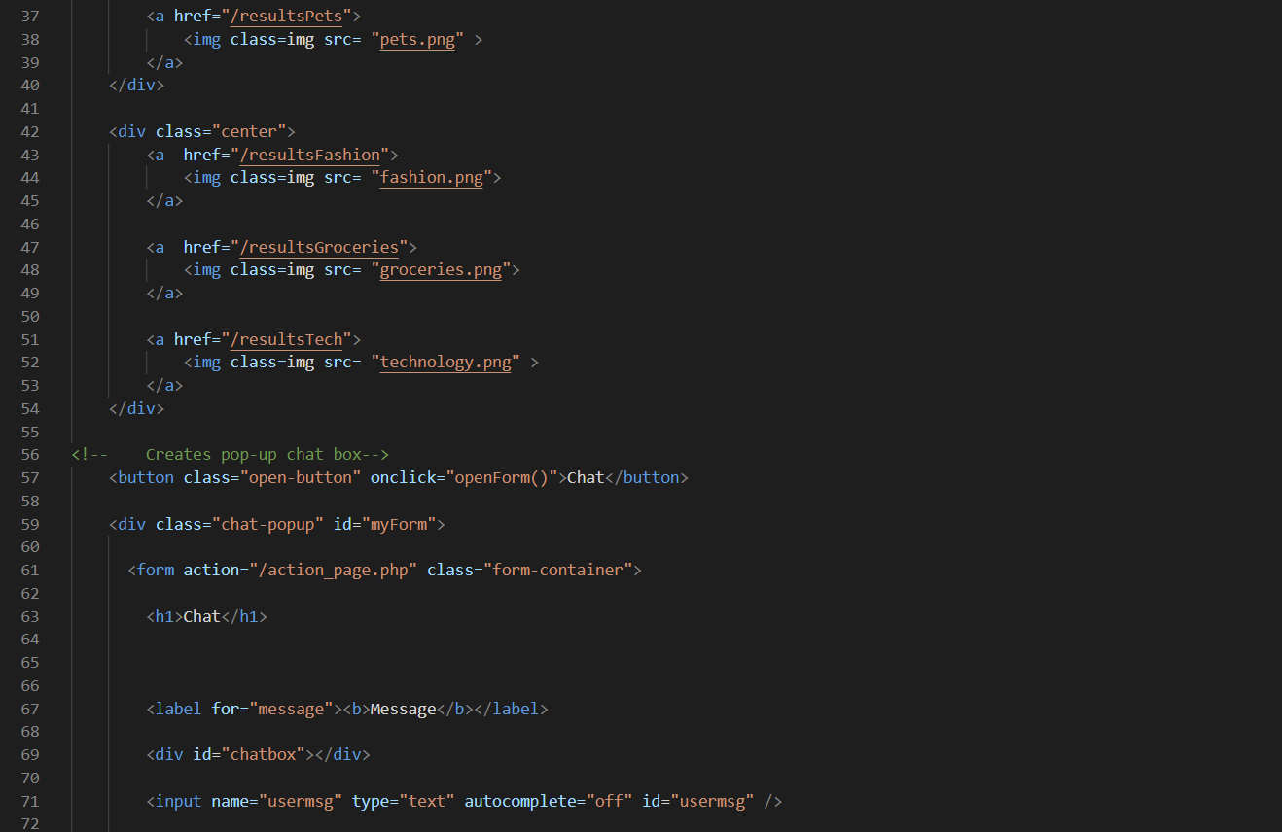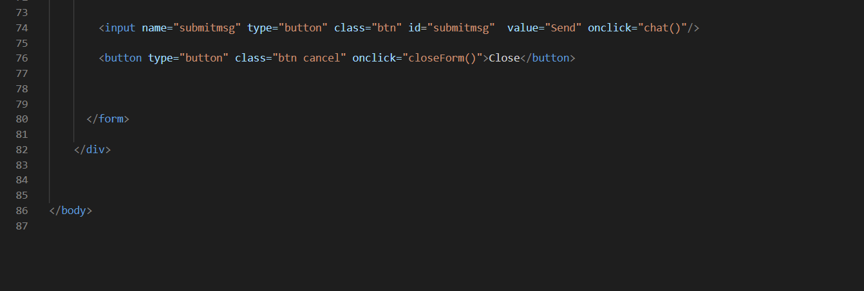

## /Landing page

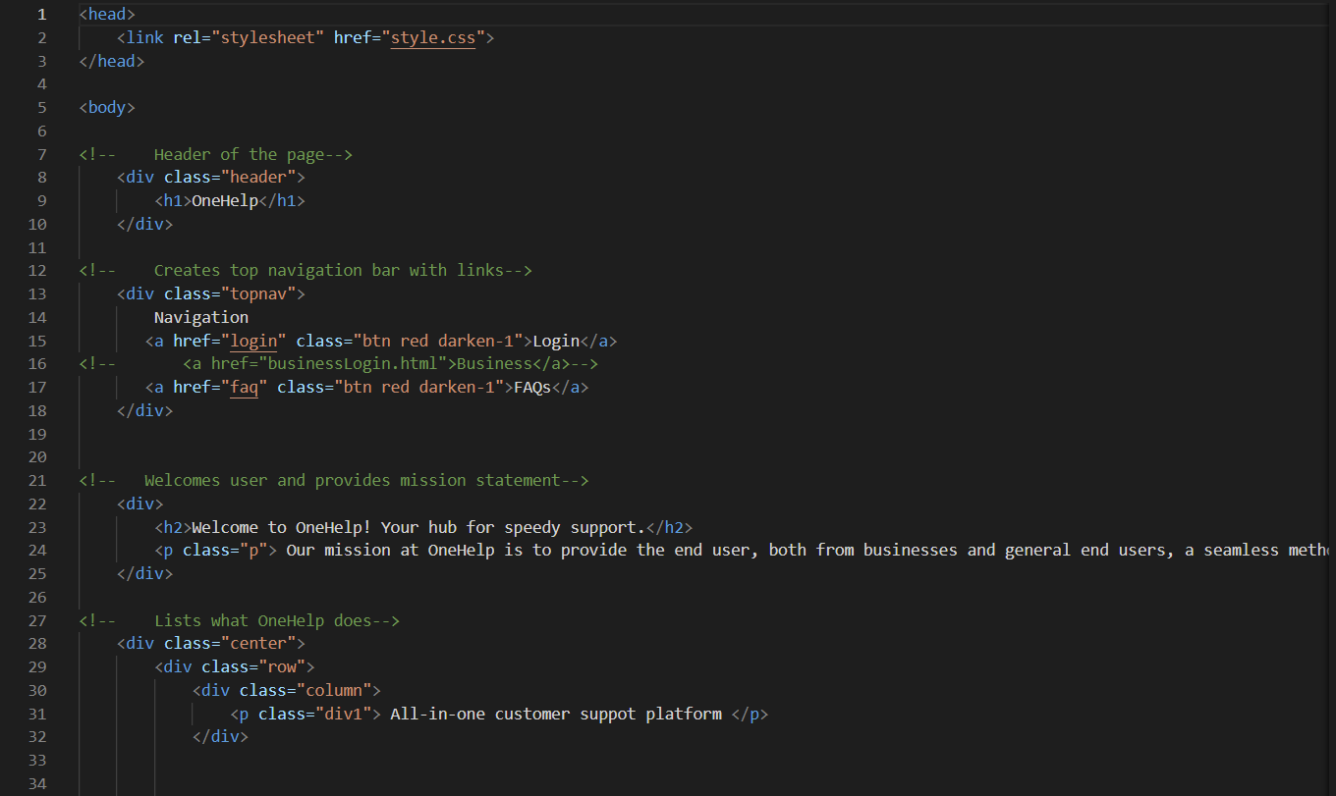

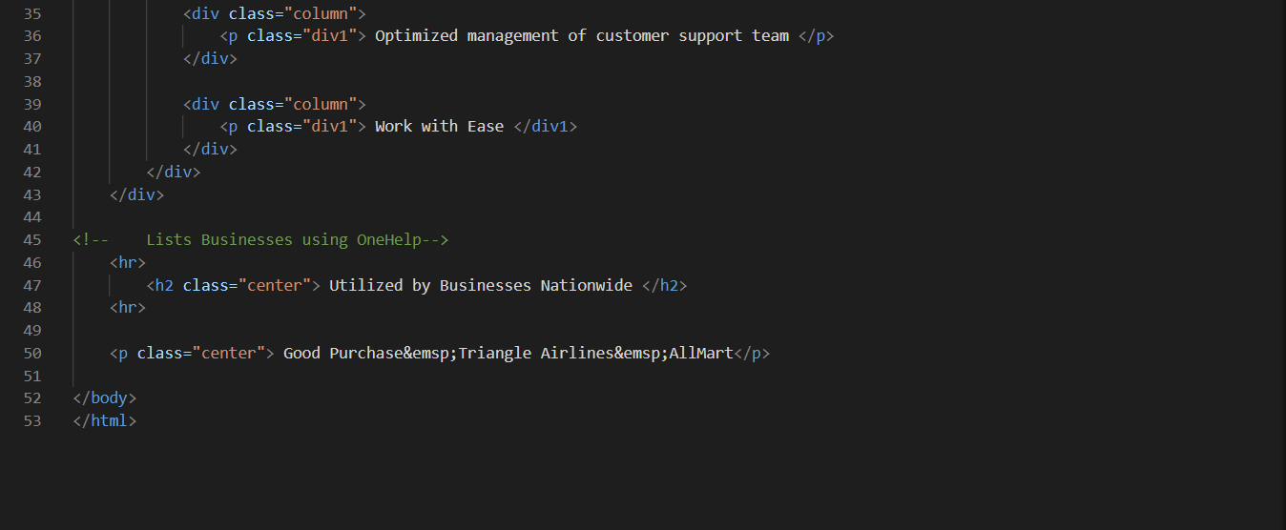

## / FAQ page

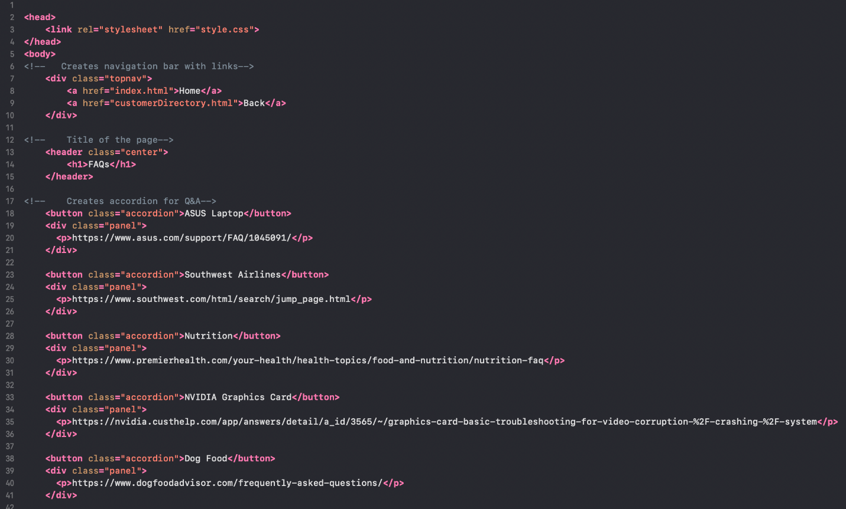

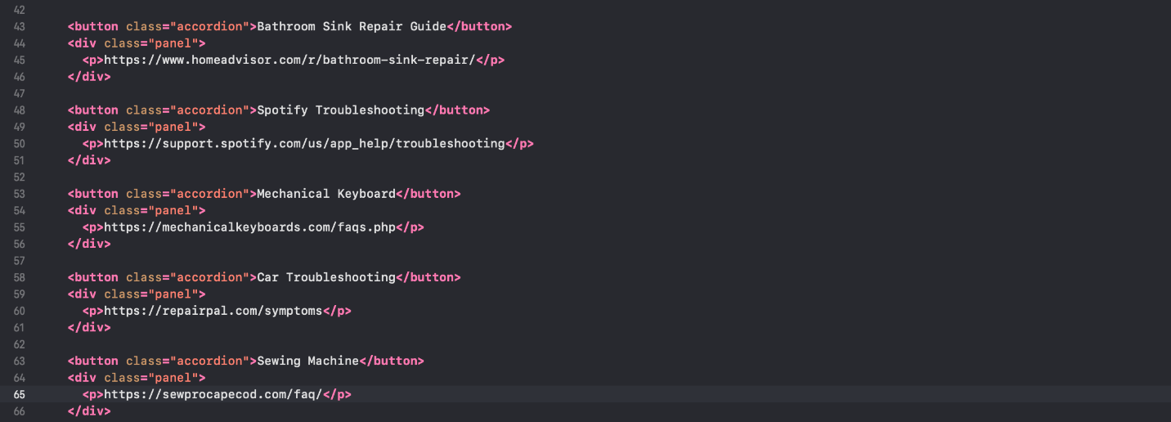

## /User Login

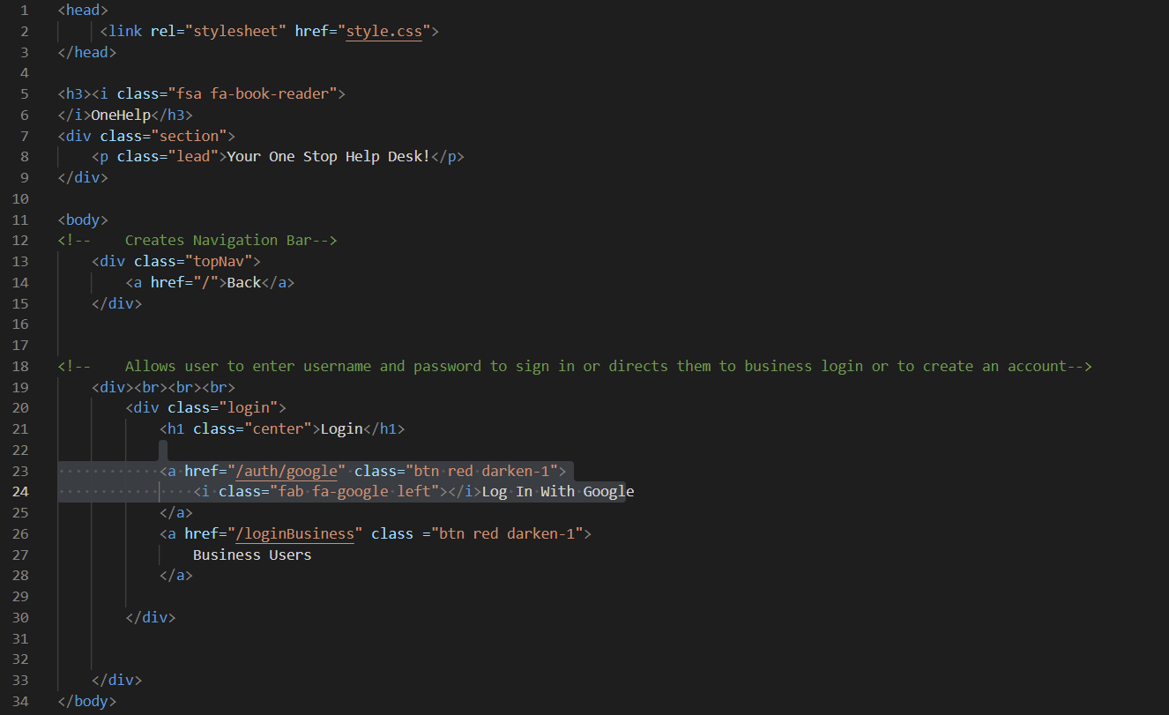

## /Business Login

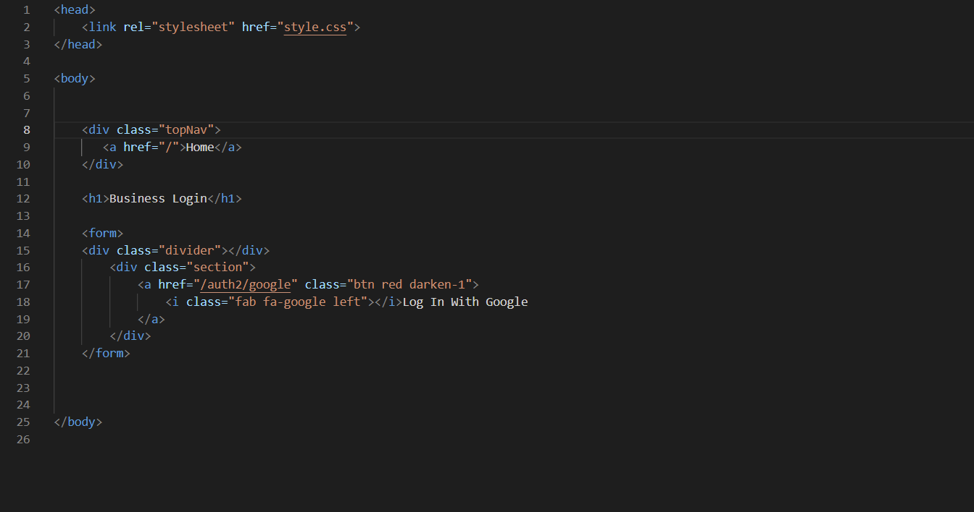

## /results page

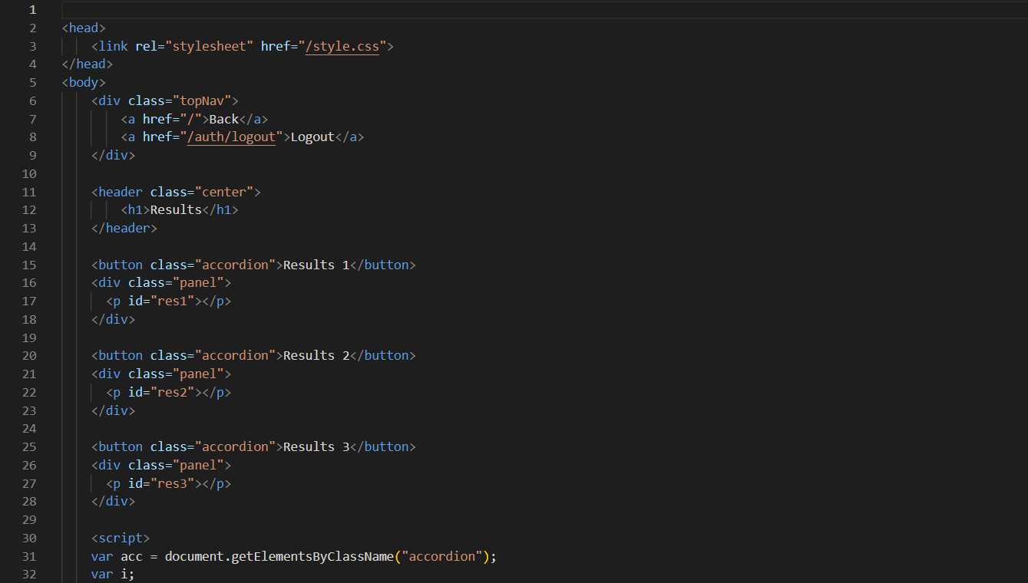

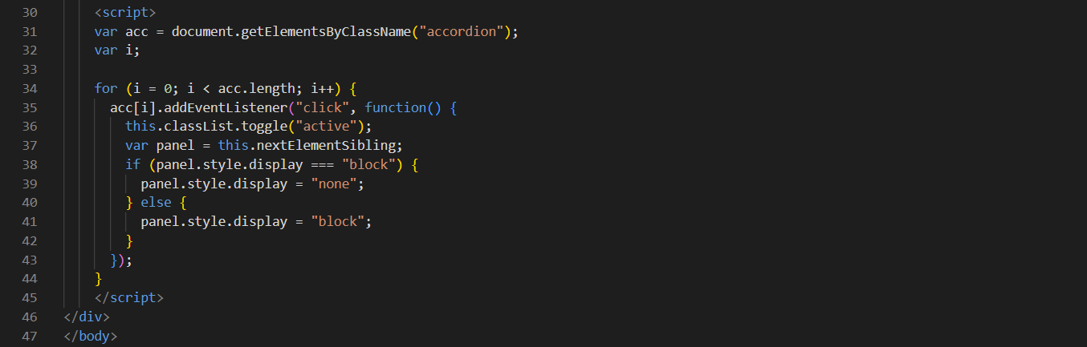

## /Submit a ticket Page

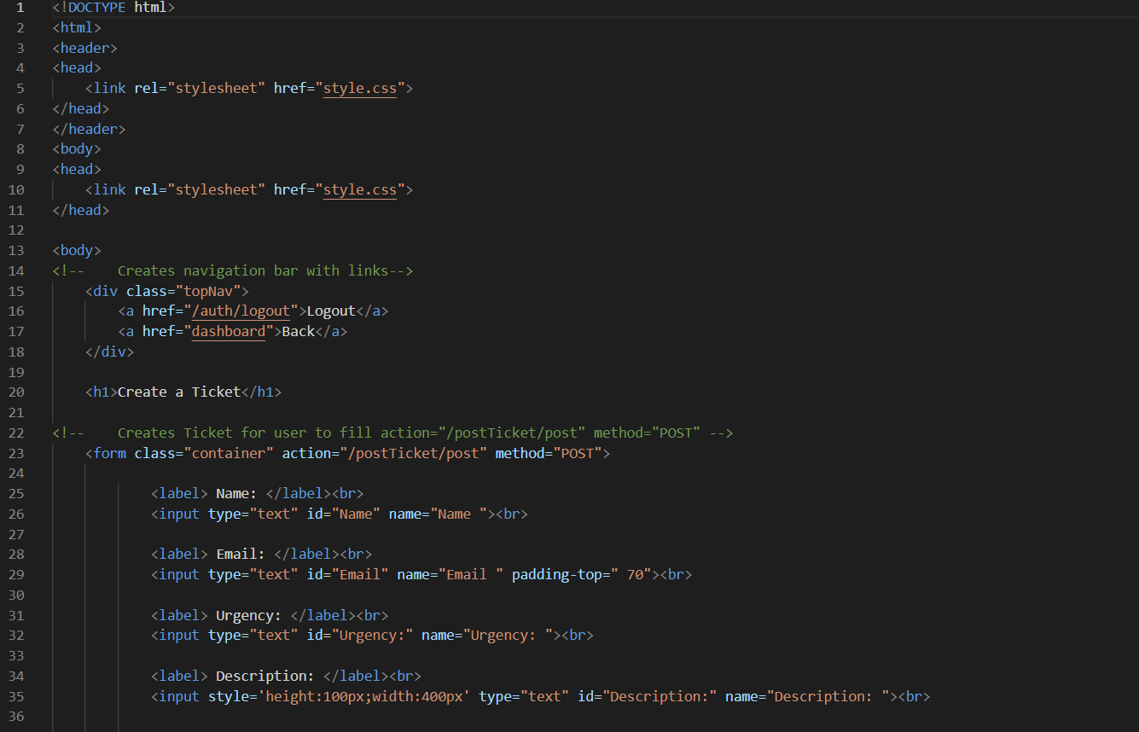

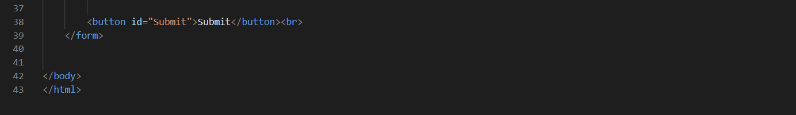

Next we have the layouts for the page which display the html within the GUI. There are three types one being the user dashboard, next the business dashboard and last the common structure

/layout user dashboard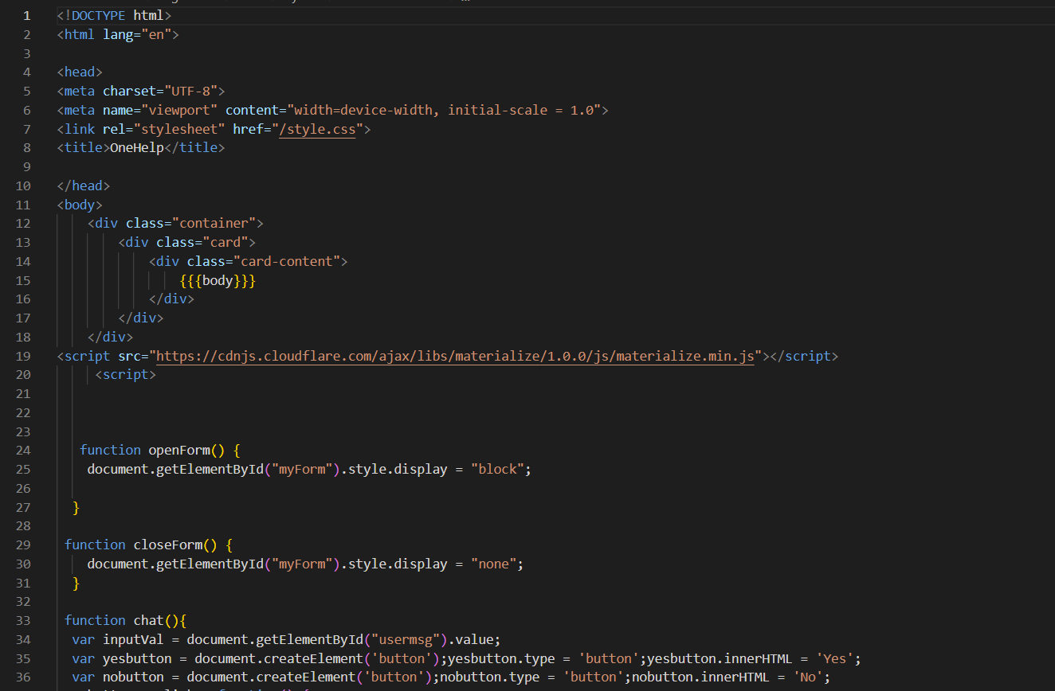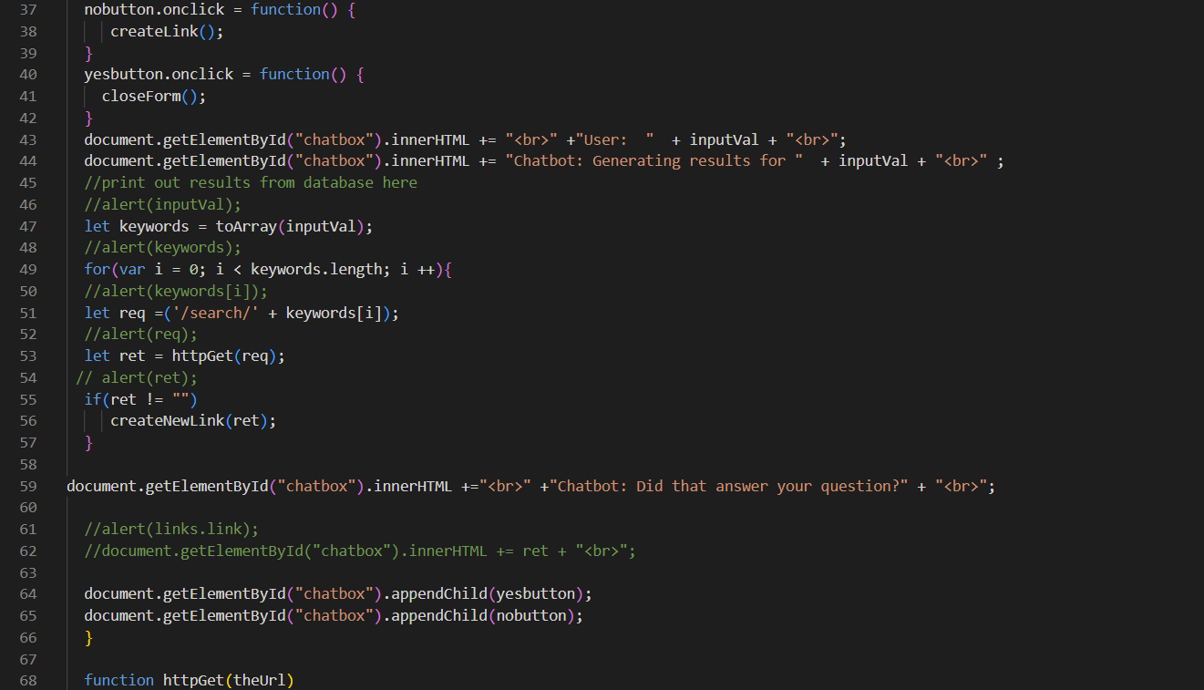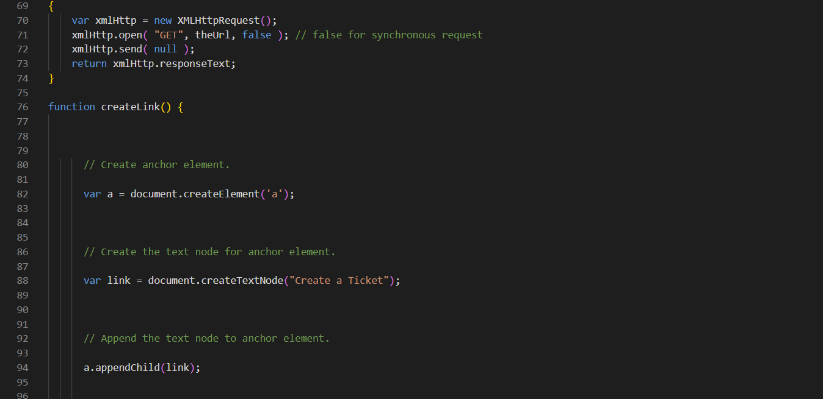

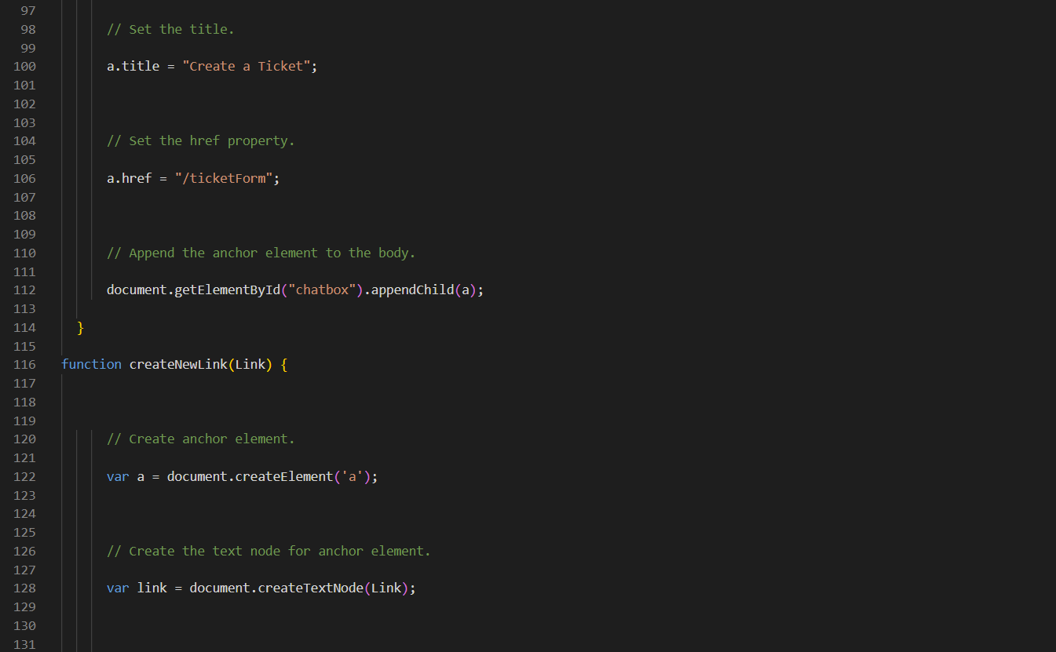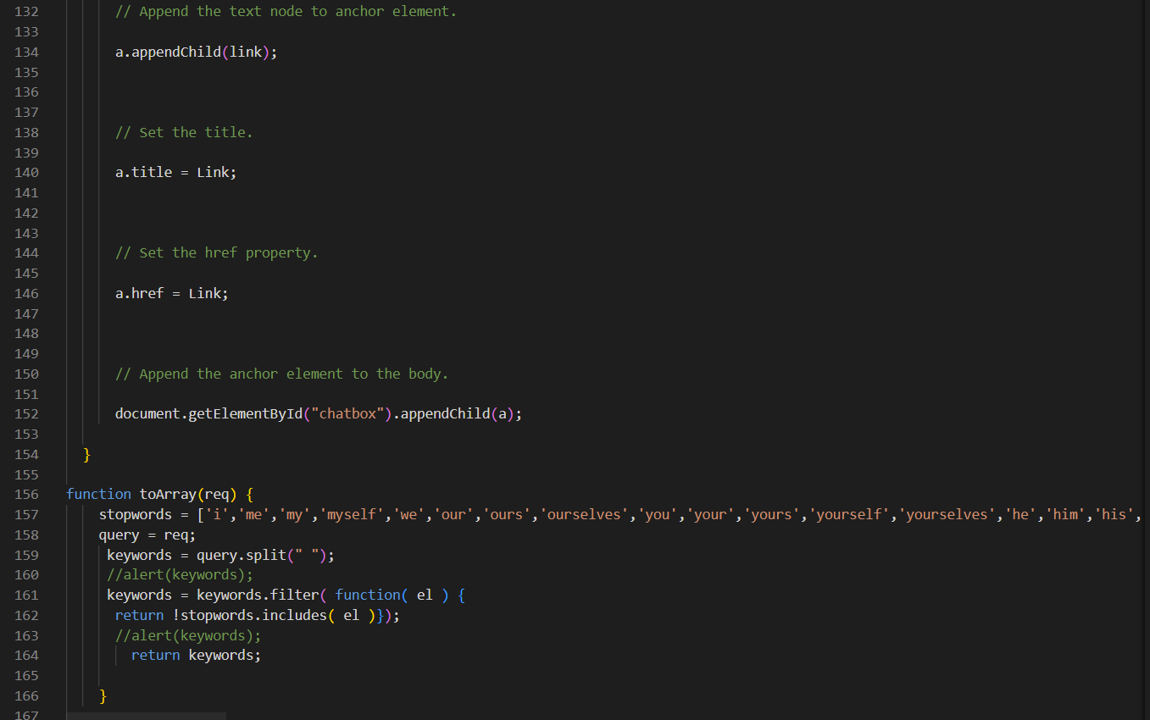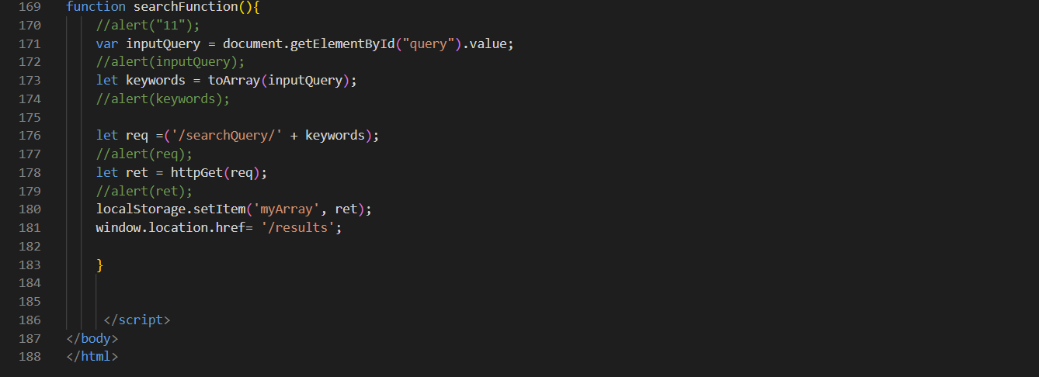

## layouts business dashboard

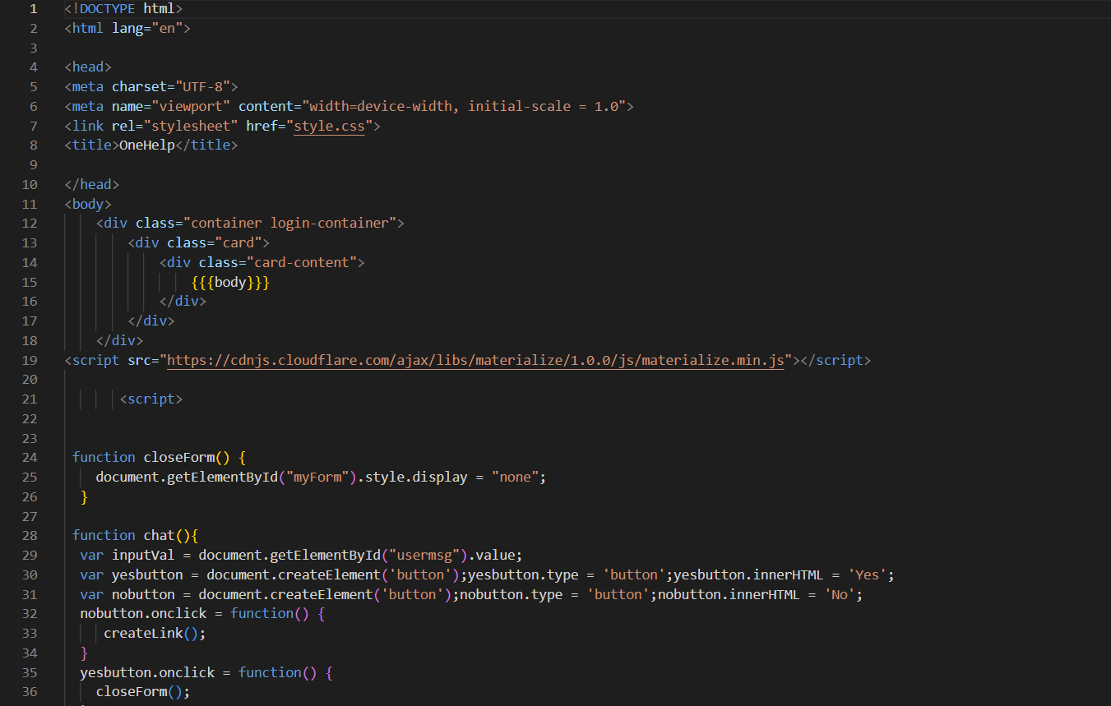

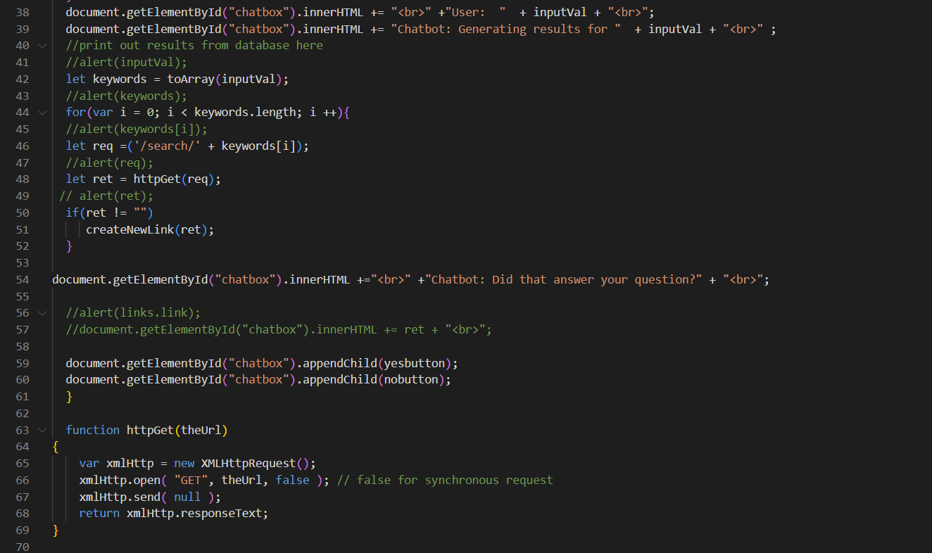

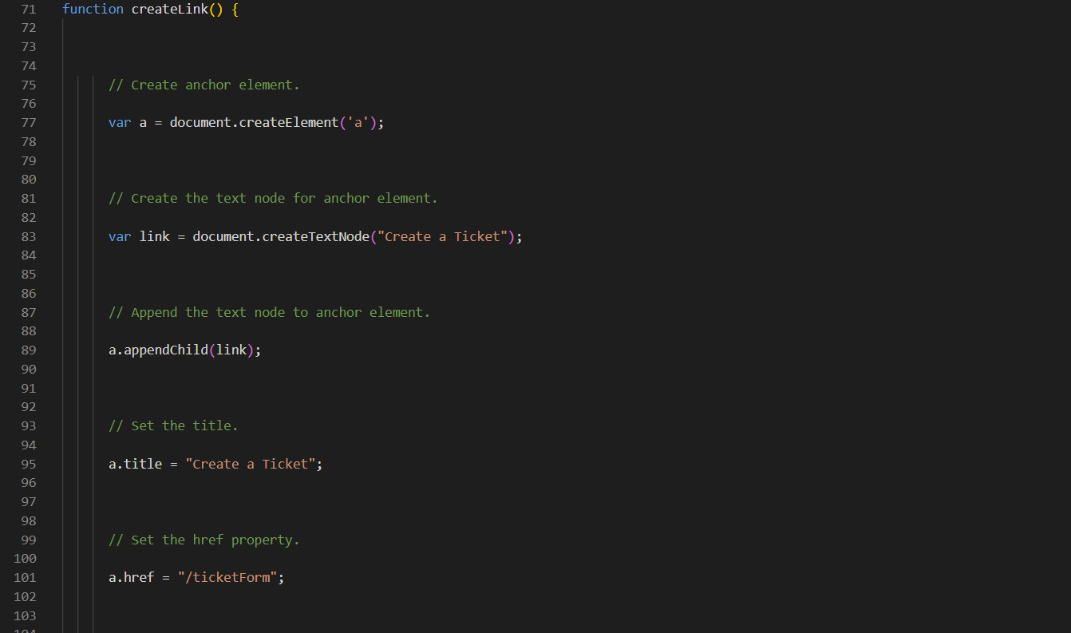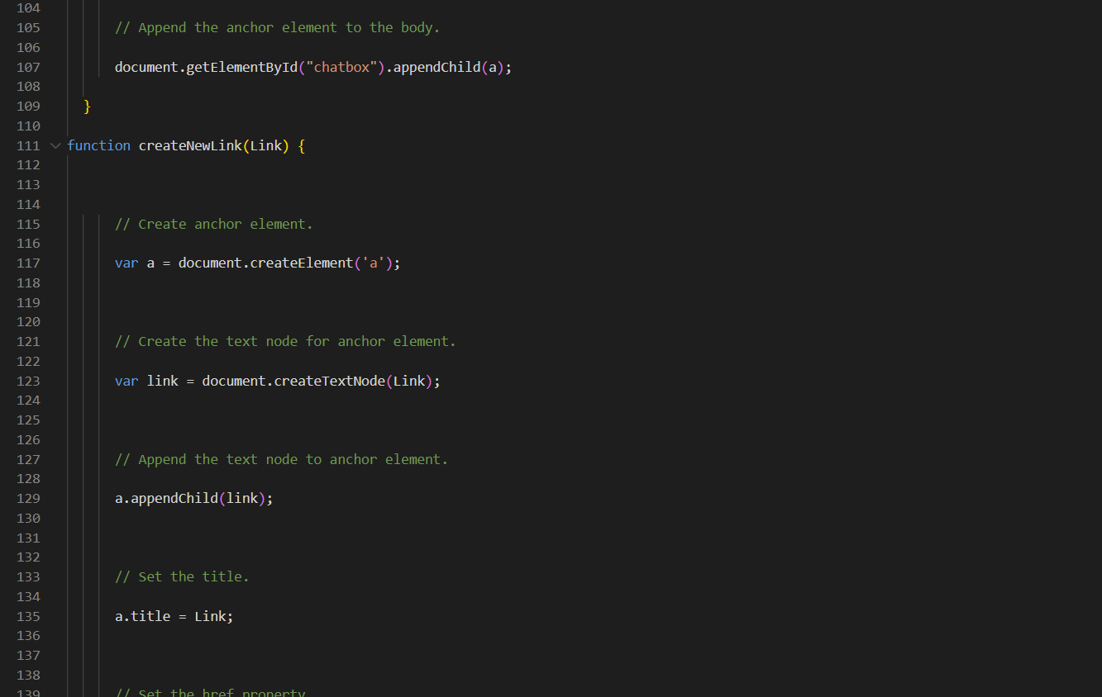

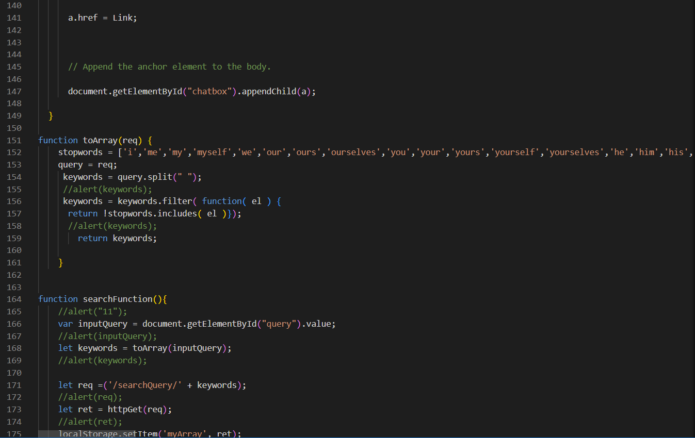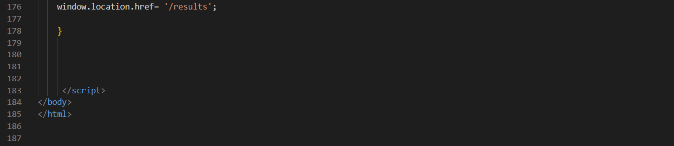

## / Standard

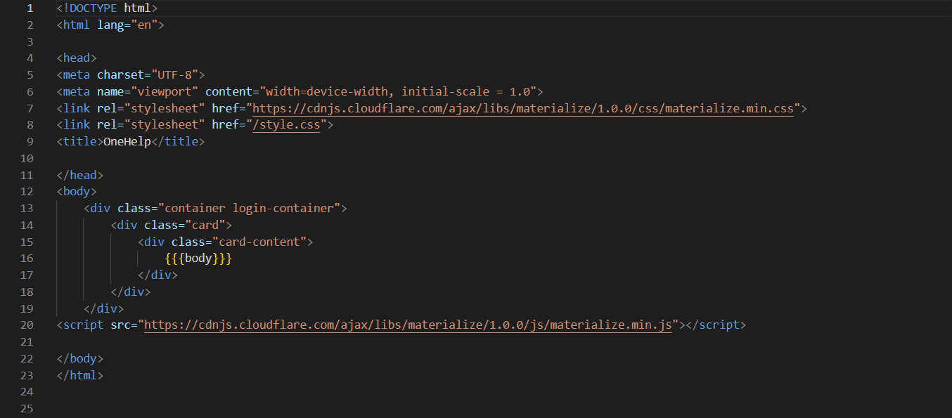

And lastly or style sheet for all front-end display

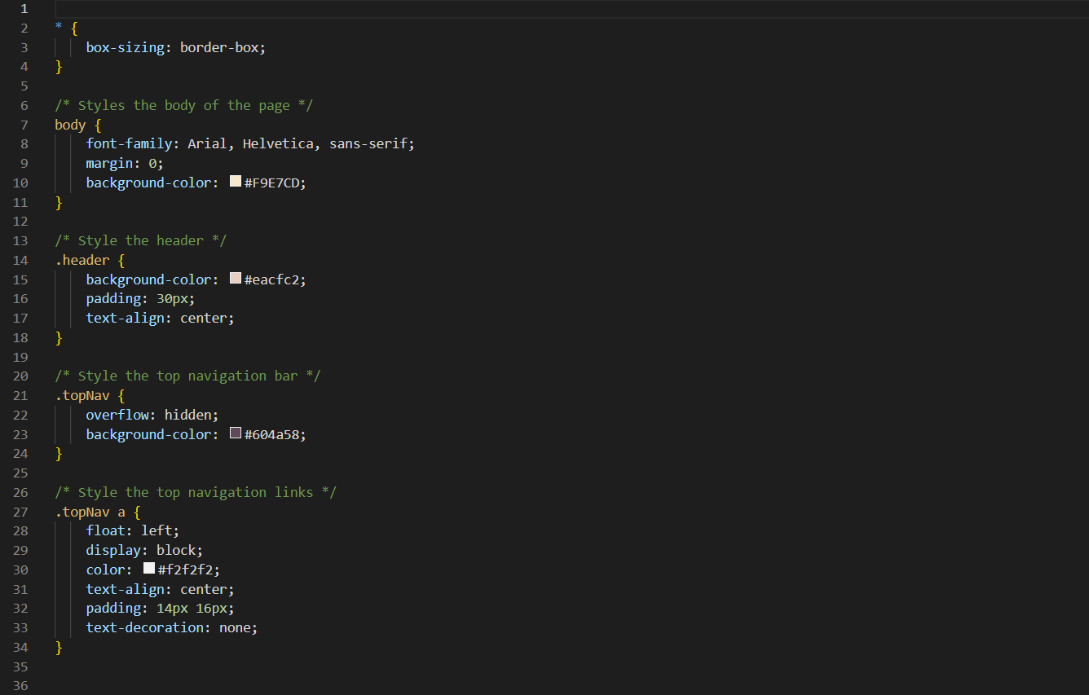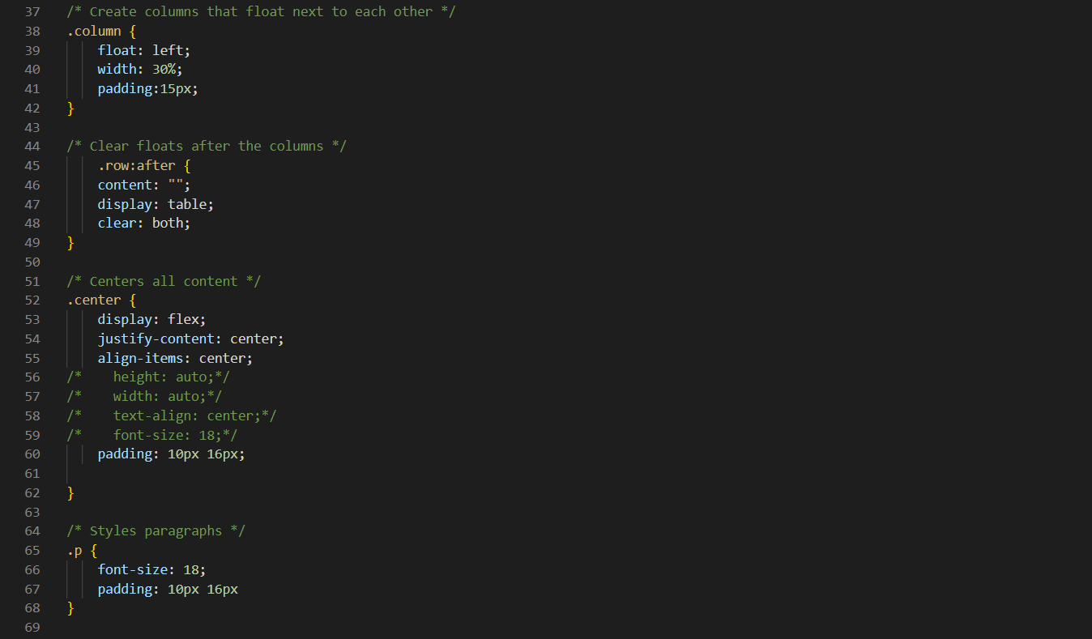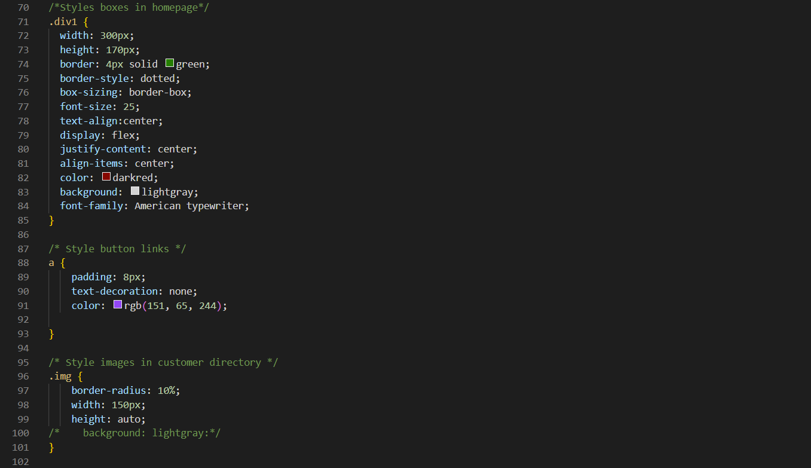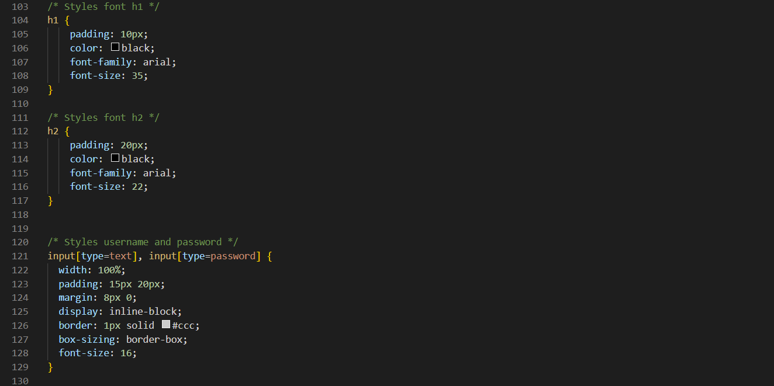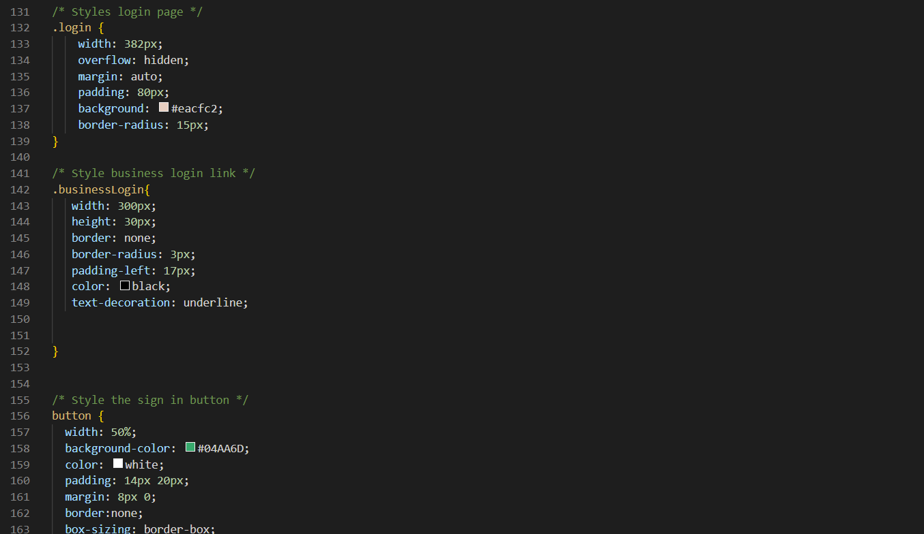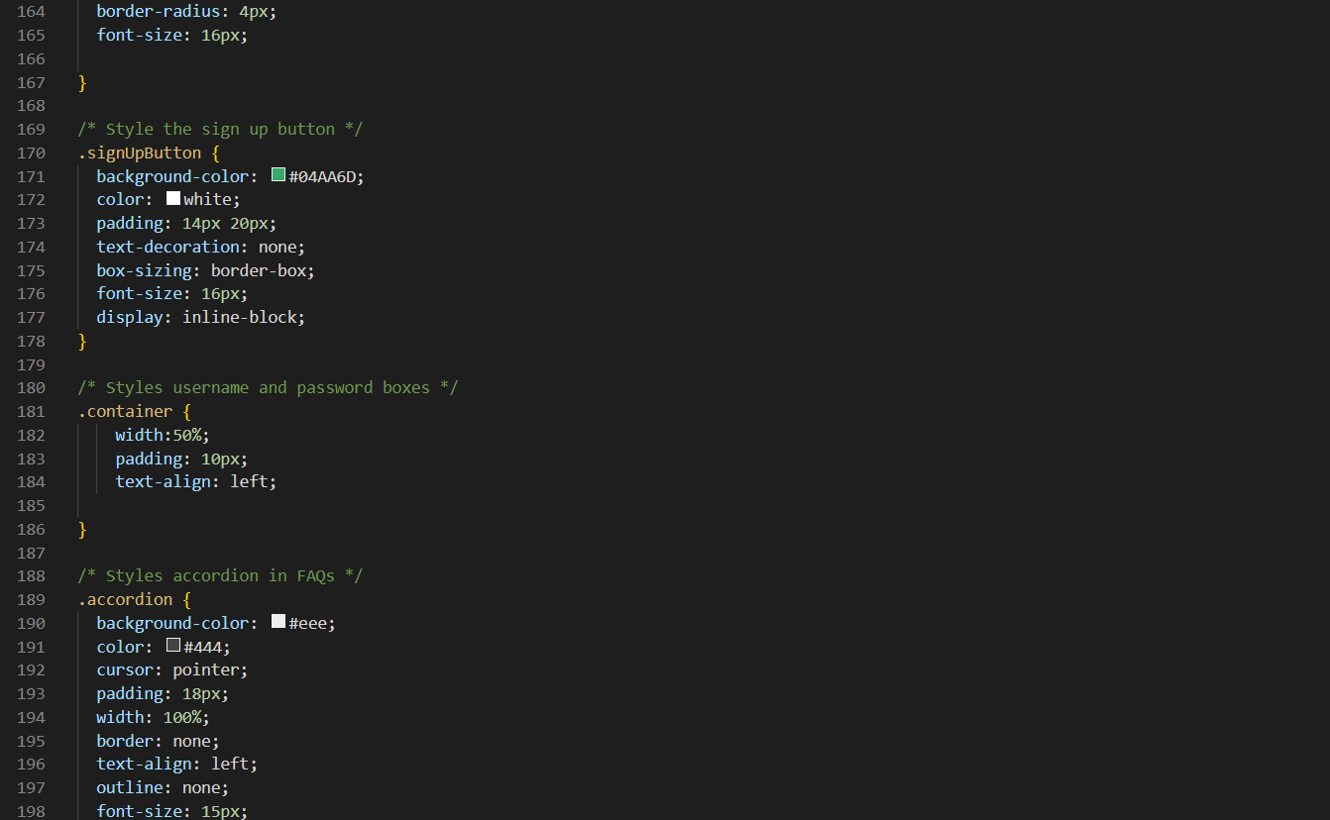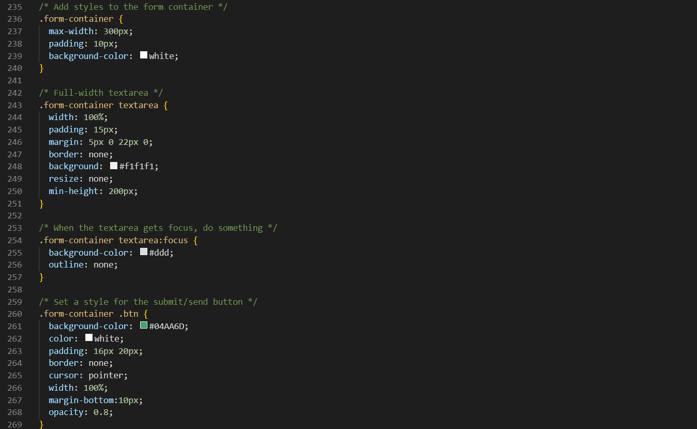

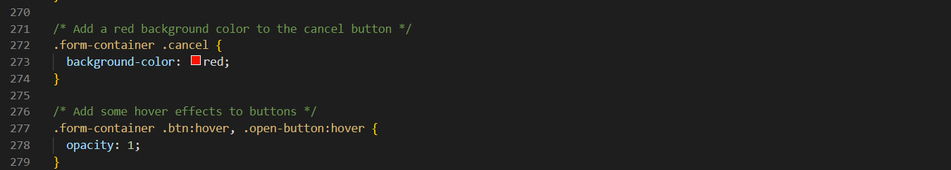

# 4 Routing

In these files we set up the routes to different pages or instantiate methods that can be called from dynamic sources

## /Google OAuth Route

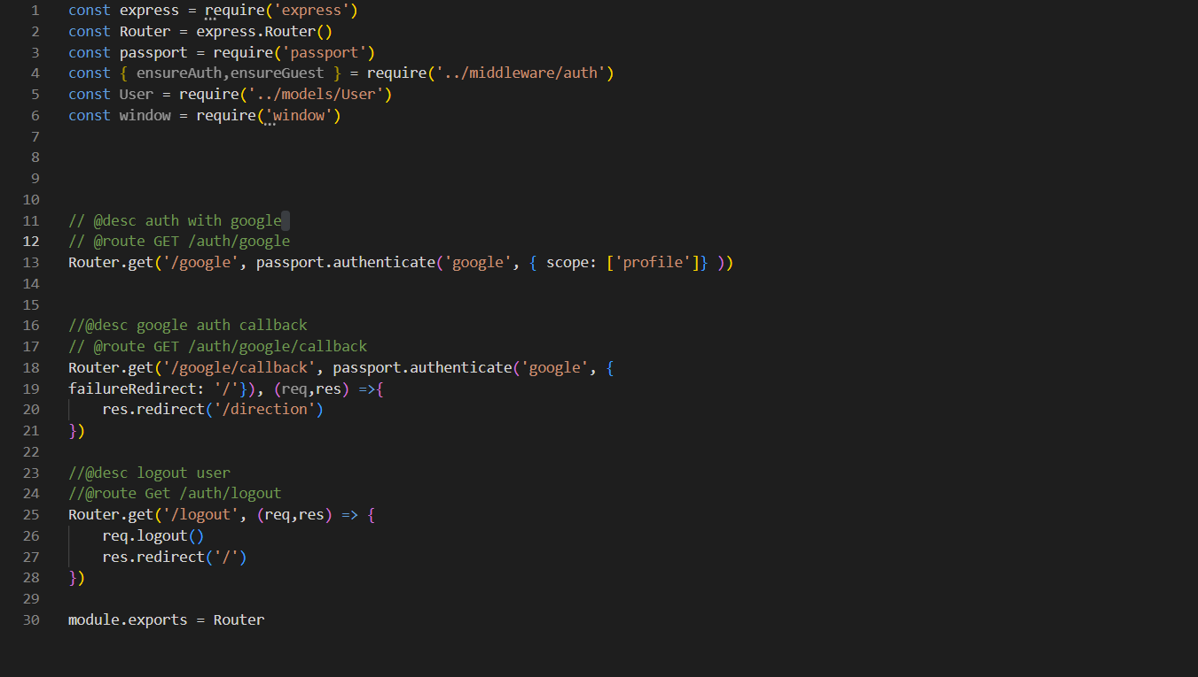

## /Comments Page Route

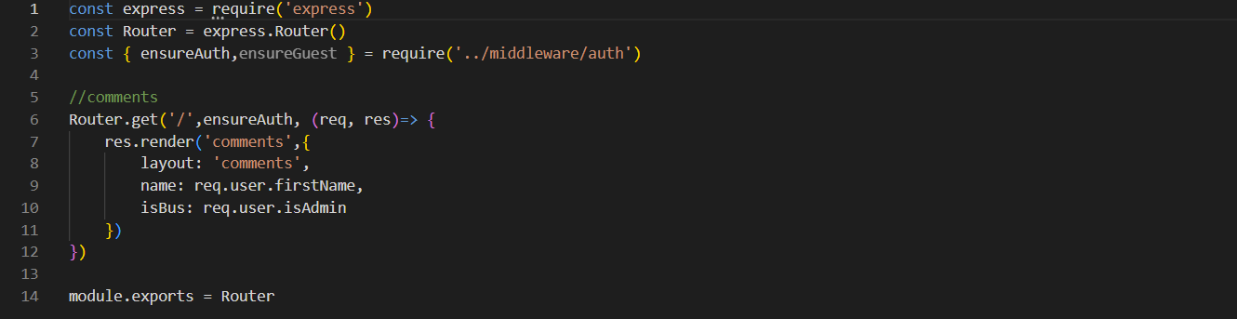

## /User Dashboard Route

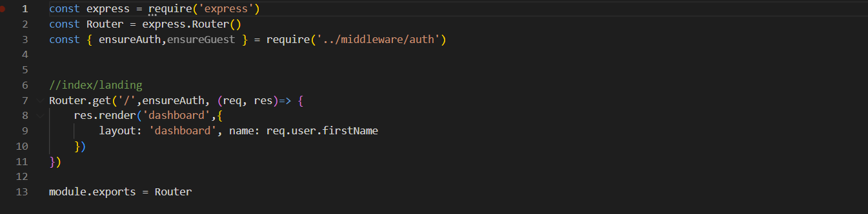

## /FAQ Page Route

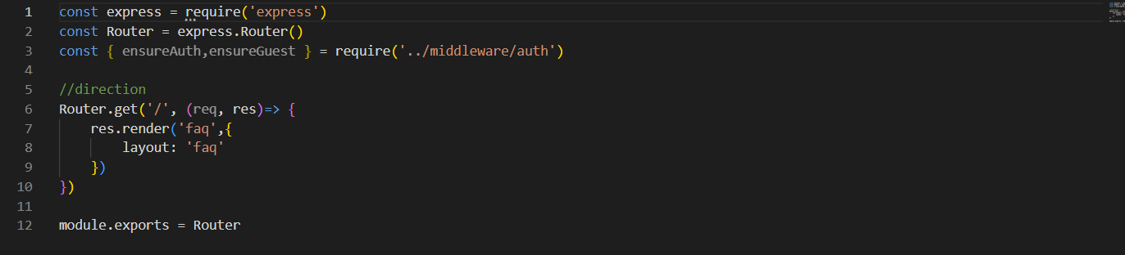

## /Landing Page Route

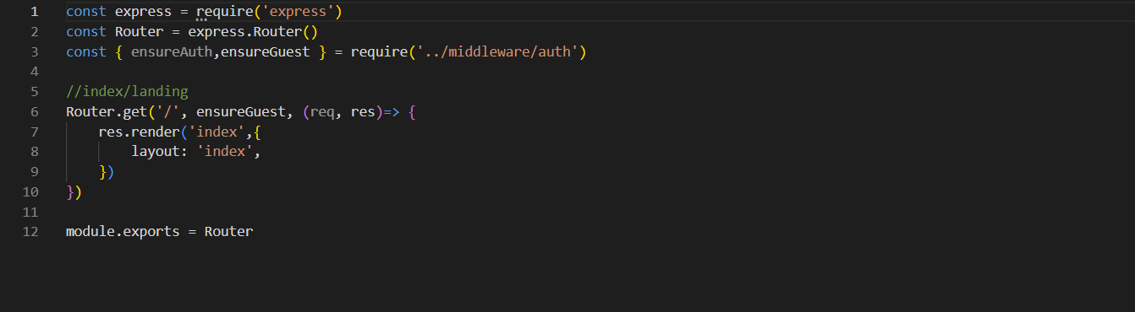

## /Login Page Route

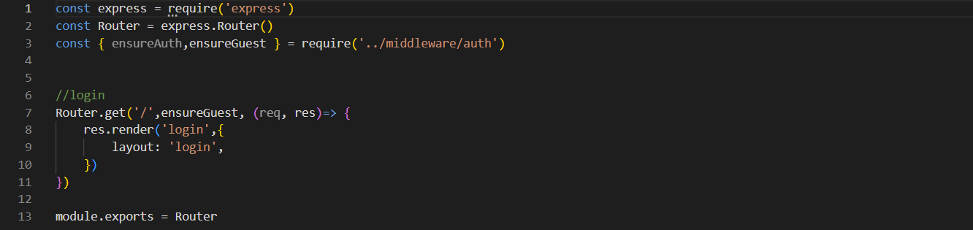

## /Business Login Route

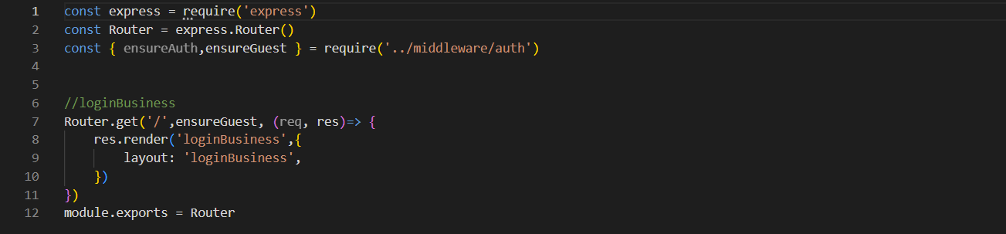

## /Post Ticket Method

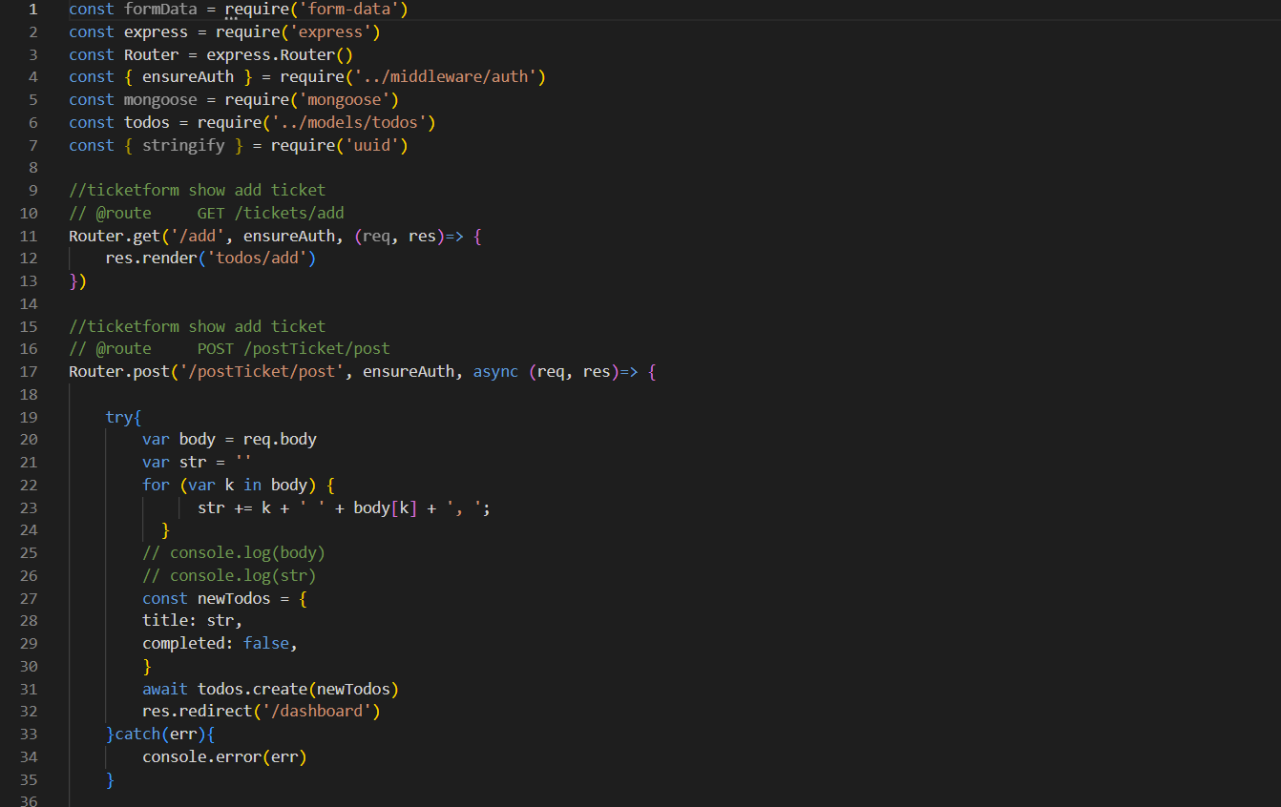



## /Results Page Route

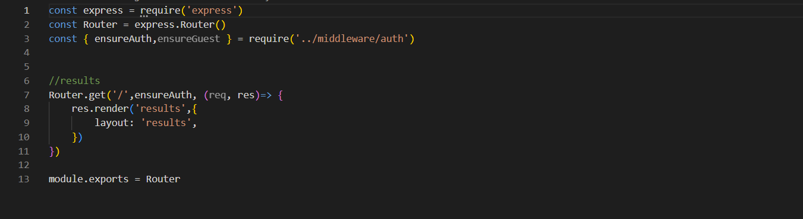

## /New Ticket Page Route

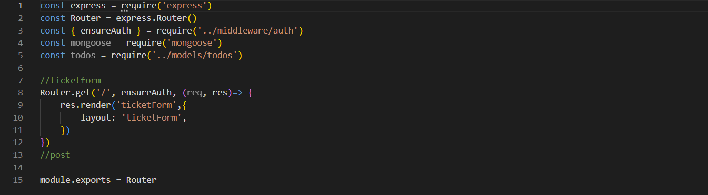

# 5 Models/MiddleWare

Using Models and Middleware we were able to create global variable types that could be read from any web page if needed and a way to communicate models to separate entities

/User

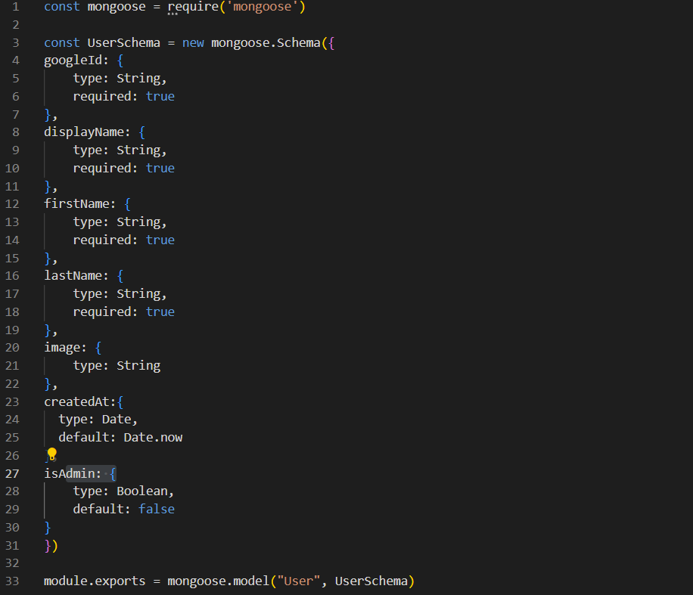

## /Ticket

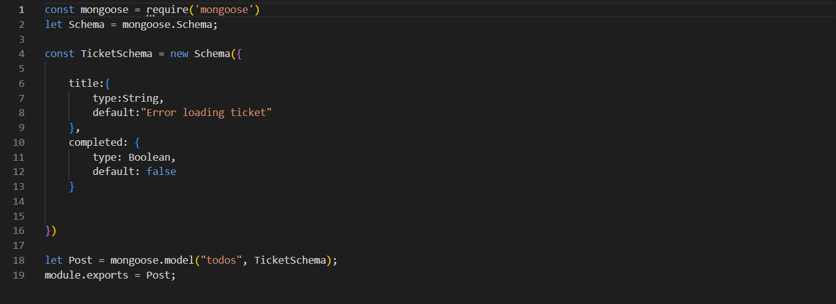

## /Links

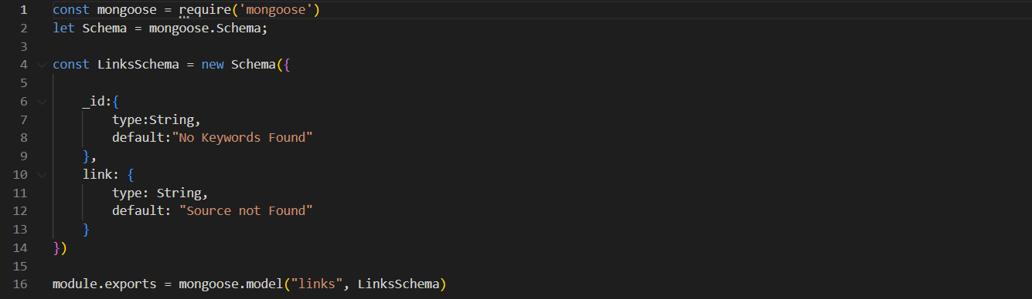

# 6 Ticket Manager Page

Once directing to the Ticket manager page one will see an orange background with tickets displayed on the screen. We set this manager up within a separate Node.js application to handle the large number of tickets without slowing down the main user end of the application.

## Packages used within Node.js

## The Manager’s ticket visualizer

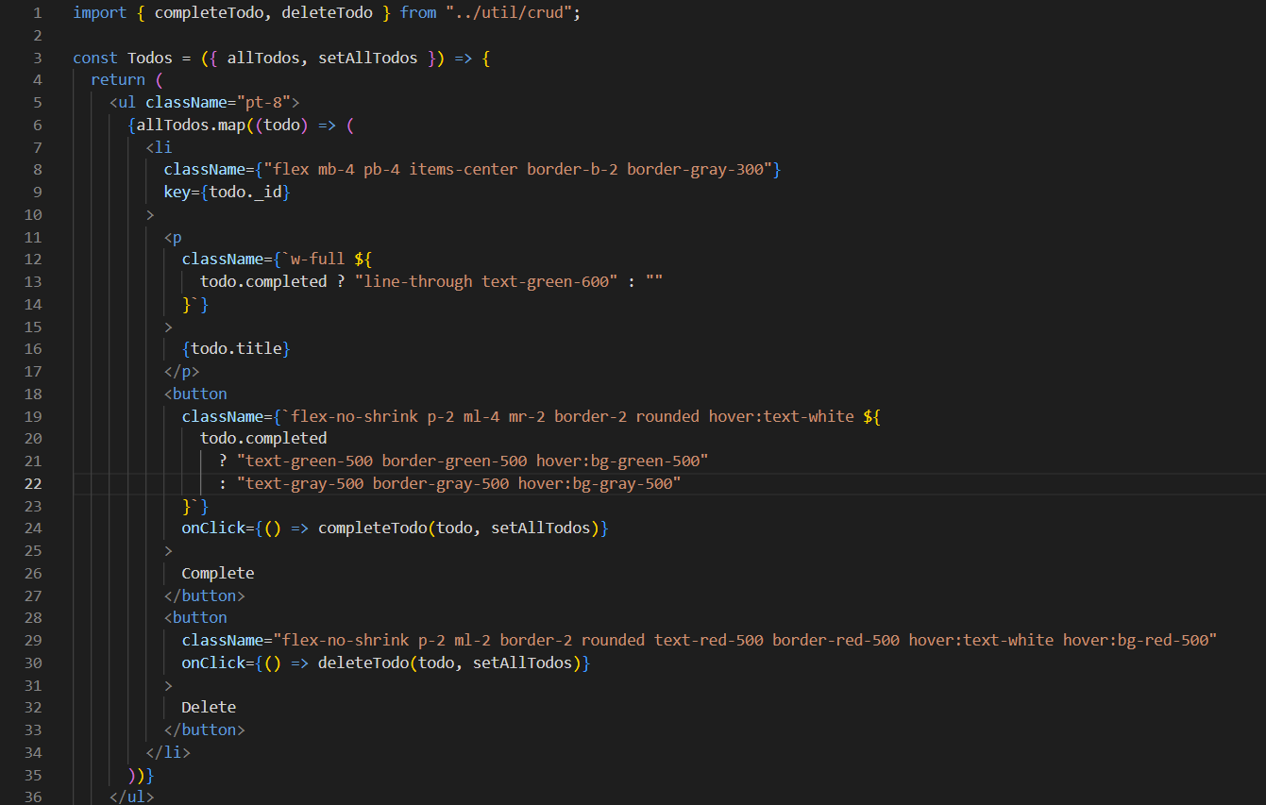

## The Crud Functionality for the page (for Display)

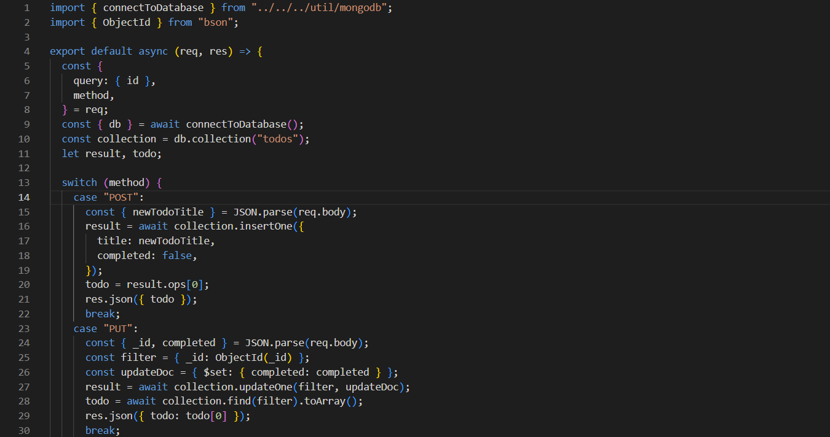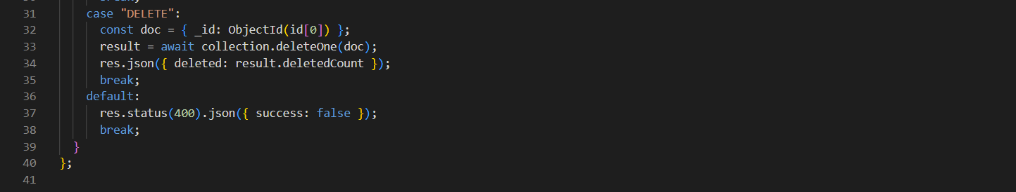

## Manager Crud Functionality(For Backend)

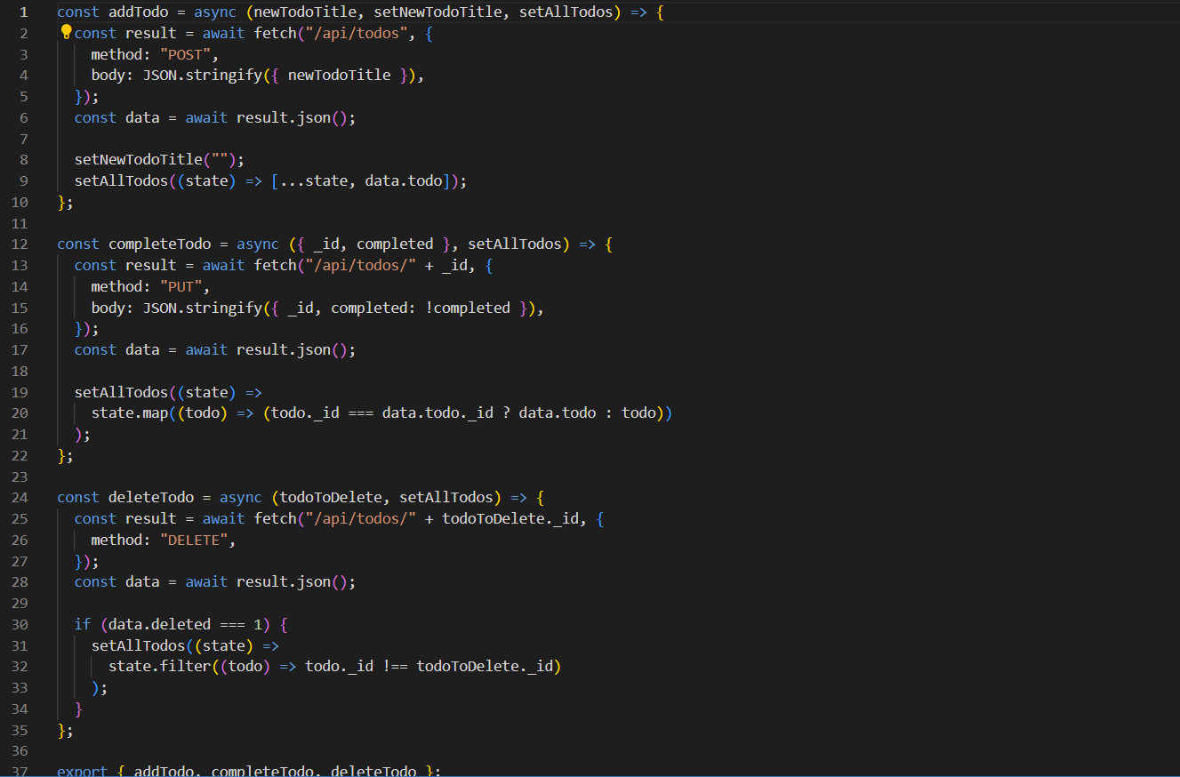

## To Visualize New Tickets

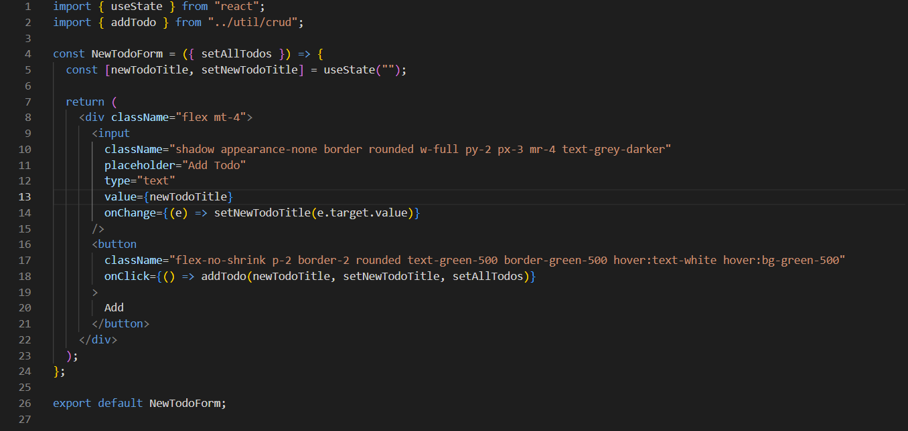

## Routing for the manager

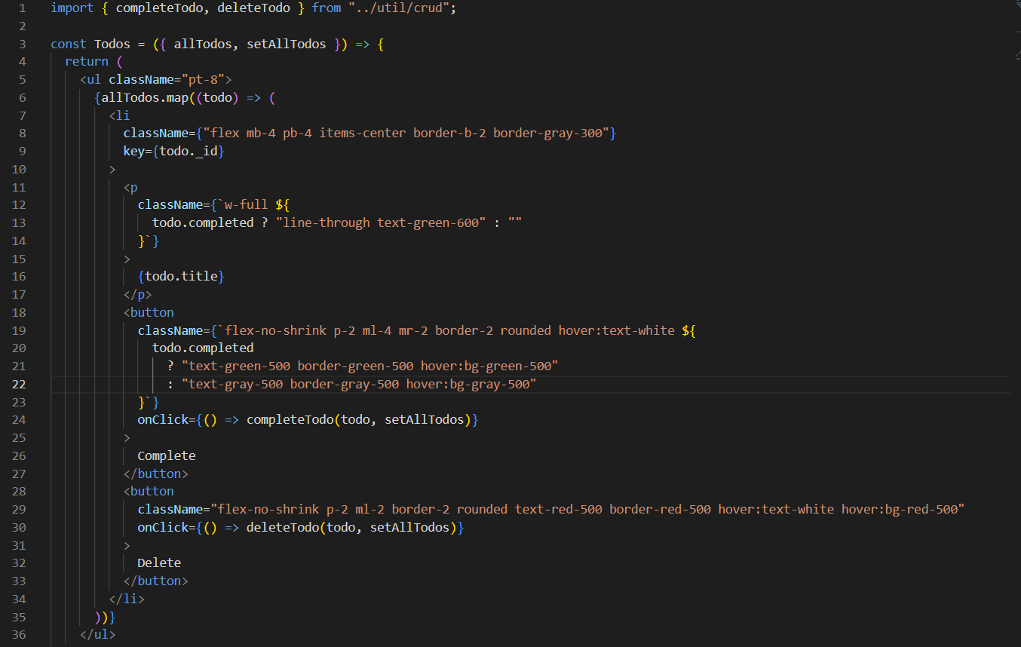

## Lastly For the connection to the Database

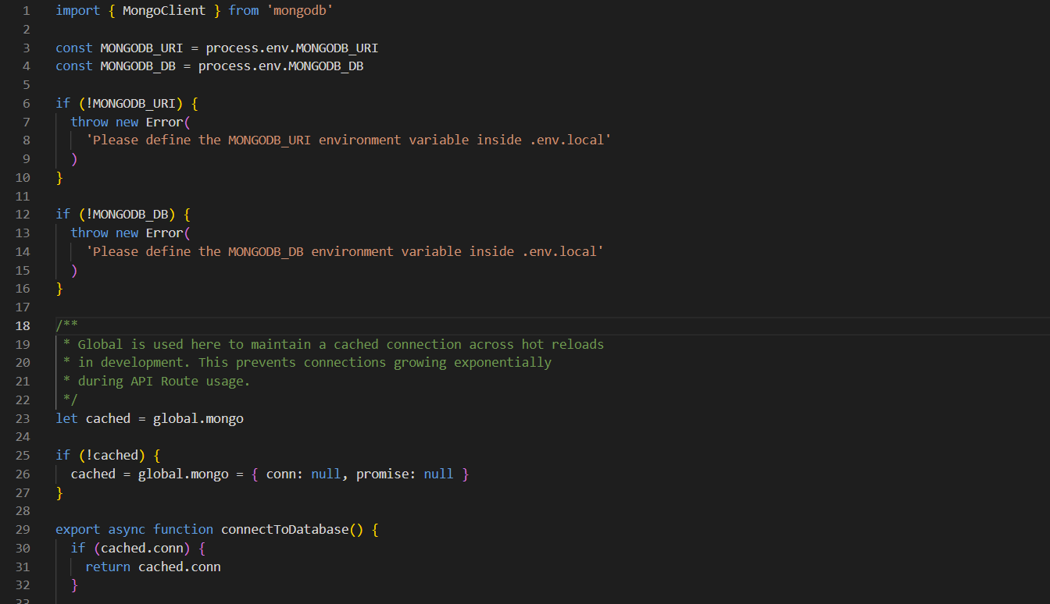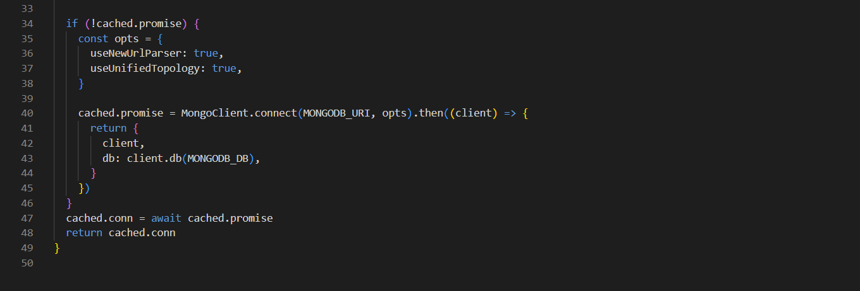

# Time logs

# Johnny Kalady

|  |  |  |  |
| --- | --- | --- | --- |
| **Name** | **Date** | **Hours** | **FULL description of the task in 3 sentences or fewer. (do not write 'met with group')** |
| Johnny Kalady | 3/30/2022 | 2 | First meeting, planned next meeting. Assigned roles. Accepted roles: Systems Programmer and Planner |
| Johnny Kalady | 3/31/2022 | 0.05 | Reserving room for second meeting-Planning. |
| Johnny Kalady | 3/31/2022 | 0.2 | Customized time sheet to display colors for individuals and inadequate information |
| Johnny Kalady | 3/31/2022 | 2.5 | Met with group and planned for demo due dates. set up dates in microsoft teams for due dates. |
| Johnny Kalady | 3/31/2022 | 0.5 | aws setup and github setup. also created temp files for html going to post to repo for general use |
| Johnny Kalady | 3/31/2022 | 2.5 | Set up basic html files and started linking aws server to github repo, blocker was aws had to create everything from scratch, hadn't done it in a while also helped kazi get caught up and explained some code problems to begin logged off at 2 |
| Johnny Kalady | 4/1/2022 | 1.5 | Worked on github repo with kazi and lorena no everyone has access to web html designs for demo |
| Johnny Kalady | 4/1/2022 | 0.6 | Met with andy and jay, set up github branches and had generel discourse on project whereabouts. Some complications with github for andy's login will check in tomorrow |
| Johnny Kalady | 4/2/2022 | 3 | set up mongo db and began creating simple crud app through npm in vscode, ready to explain all details |
| Johnny Kalady | 4/2/2022 | 6 | Added db ticket functionality to html pages, added javascript to front end api for login functionality |
| Johnny Kalady | 4/3/2022 | 0.75 | Met with Anna about code redesign and backend/frontend structure |
| Johnny Kalady | 4/4/2022 | 0.5 | Met with group members to help run program on their device and share connections to db |
| Johnny Kalady | 4/5/2022 | 1 | aws assignment for class running into permission problems |
| Johnny Kalady | 4/6/2022 | 2.5 | AWS assignment work/ work on website and database connection/ troubleshoot errors with John R. |
| Johnny Kalady | 4/6/2022 | 0.25 | Added reminders to Microsoft Teams for upcoing quizzes and next demo Due date |
| Johnny Kalady | 4/6/2022 | 1 | Weekly meeting 4-6 set up perm roles and planned on next actions |
| Johnny Kalady | 4/6/2022 | 0.2 | worked on discord channel with Anna |
| Johnny Kalady | 4/8/2022 | 1 | Setting up working web link, working on db connection |
| Johnny Kalady | 4/8/2022 | **0.5** | Group update meeting, scheduling and general dsicourse |
| Johnny Kalady | 4/10/2022 | **1.5** | Worked on AWS assignment/ setting up server for project with John Ress, had one last bug to fix before login was enabled |
| Johnny Kalady | 4/10/2022 | **1** | Implementation meeting / design overview with team, |
| Johnny Kalady | 4/11/2022 | **1.5** | Group psuedo implementation meeting. |
| Johnny Kalady | 4/12/2022 | **2** | Meeting with anna to set up databases, also connecting to aws server, helped andy with github |
| Johnny Kalady | 4/13/2022 | 0.5 | Created data flow diagram, very basic needs revision. |
| Johnny Kalady | 4/13/2022 | 0.5 | Meeting with Clark Elliot before group meeting |
| Johnny Kalady | 4/13/2022 | 1.2 | Met with group and talked about planning and requirements demo |
| Johnny Kalady | 4/14/2022 | 2 | Generated documentation for overview of testing based on initial requirements doc |
| Johnny Kalady | 4/17/2022 | 1 | Revision of implementation doc, still neeeds work. met with john ress |
| Johnny Kalady | 4/18/2022 | **0.25** | Watched video on oauth implementation for login functionality |
| Johnny Kalady | 4/19/2022 | **1** | Met with John and Zunair to go over security matrix for rdp demo |
| Johnny kalady | 4/19/2022 | **1** | Met with group to diiscuss rdp demo and went over task functionality within teams |
| Johnny Kalady | 4/20/2022 | **3** | Writing code for the login screen backend with oauth implementation, used tutorial to explain node.js login functionality |
| Johnny Kalady | 4/20/2022 | **1.5** | Class meeting with professor elliot and group meeting going over rdp demo and necessary tasks for this weekend |
| Johnny Kalady | 4/20/2022 | **1** | requirements documentation finalizing and discussion con zunair anna denise and our captian john ress |
| Johnny Kalady | 4/21/2022 | 1.25 | Met with Lorena, and Jay for github merges working on uploading to aws and implementing login and chatbot scud |
| Johnny Kalady | 4/21/2022 | 1 | working onTesting Document to be implemented in Requirements doc |
| Johnny Kalady | 4/21/2022 | **1** | Met with Zunair and John Ress, Formalizing requirement docs and assessing feasabillity of reuisites. follow up meeting tomorrow |
| Johnny Kalady | 4/22/2022 | **1** | code setup for rdp demo screenshots and code snippets |
| Johnny Kalady | 4/22/2022 | **1** | Finalizing matrix in req doc with john ress |
| Johnny Kalady | 4/22/2022 | **0.5** | Production meeting planning with production team, general discourse on plan and walkthrough given by anna |
| Johnny Kalady | 4/23/2022 | **2** | worked on Presentation for Design manager and prepped video explanation of dfd |
| Johnny Kalady | 4/24/2022 | **0.5** | worked on Presentation for Design manager and prepped video explanation of dfd, first one was too long and had to reinvolve new powerpoint |
| Johnny Kalady | 4/27/2022 | 1 | Met with group mates to discuss planning for our |
| Johnny Kalady | 4/28/2022 | 2 | began Node.Js script for running login page |
| Johnny Kalady | 4/29/2022 | 2 | Continued to add express backend for node.js front end login, db connection established. |
| Johnny Kalady | 4/30/2022 | 1 | Began implementing google keys to ensure security when logging in and navigating pages |
| Johnny Kalady | 5/4/2022 | 1 | Weekly meeting with group for demo and timeline instructions |
| johnny Kalady | 5/5/2022 | 1 | Worked on oauth implementation for login |
| johnny kalady | 5/6/2022 | 2 | Researched implementation of node.js for navigation security and implemented pages for already constructed html files |
| johnny Kalady | 5/8/2022 | 3 | Worked on express connection to dtabase to ensure database recieved login info correctly. |
| Johnny Kalady | 5/11/2022 | 1 | Class meeting with Professor, met with groupmates afterward going over current implementation of app |
| Johnny Kalady | 5/11/2022 | 0.5 | Met with John Ress about issues |
| Johnny Kalady | 5/11/2022 | **0.7** | Met with dev team going over necessary work for demo |
| Johnny Kalady | 5/12/2022 | **4** | Worked on routes for webpages allowing for app to navigate to different functionalities |
| Johnny Kalady | 5/13/2022 | **5** | Updated node.js file to current release for use of passport module to communicate with google for authentication |
| johnny Kalady | 5/14/2022 | **4** | Fixed issues with node.js communicating with DB for problem tickets |
| Johnny Kalady | 5/15/2022 | **4** | worked on presentation with anna and denise for finalization and recording |
| Johnny kalady | 5/17/2022 | **2** | worked on routing issues through aws with Kazi |
| Johnny Kalady | 5/18/2022 | 0.5 | group met to go over final todos |
| Johnny Kalady | 5/19/2022 | 1 | worked on cllback error with john ress ~1pm |
| Johnny Kalady | 5/19/2022 | **1** | Worked on routing issues for files and images for node.js application with john ress |
| Johnny Kalady | 5/19/2022 | **3** | Worked on routing/implementation of designed code and formatting for db for post method for tickets with dev team |
| Johnny Kalady | 5/19/2022 | **3** | worked on get method for chatbot with dev team for implementation of links on front end |
| johnny kalady | 5/20/2022 | **2** | worked on routing issues and formatting of variables for returns and cross application use with dev team |
| Johnny Kalady | 5/20/2022 | **0.25** | reviewed elliots notes from prior week |
| johnny kalady | 5/20/2022 | **3** | worked on finalizing application for presentation recordings with dev team |
| johnny kalady | 5/20/2022 | **0.5** | spent thirty minutes watching blue rhinos demo for preparation for demo |
| johnny kalady | 5/20/2022 | **0.2** | spent ten minutes choosing apparel and getting dressed for demo presentation |
| johnny kalady | 5/20/2022 | **2** | setting up application and recording backend poortion of demo for final demo |
| johnny kalady | 5/21/2022 | **1** | re recorded demo portion of backend per request of group members |
| Johnny Kalady | 5/22/2022 | **2** | added comments to code for documentation |
| Johnny kalady | 5/24/2022 | **3** | began work on document for code base, took screen shots of code |
| Johnny kalady | 5/24/2022 | **1** | updated time logs for previous work spent on project |
| Johnny Kalady | 5/25/2022 | 0.5 | spent thirty minutes reviewing code for testing documentation to ensure tests were met |
| Johnny Kalady | 5/25/2022 | 1 | updated testing documentation for project manual |
| Johnny kalady | 5/25/2022 | 0.5 | spent thirty minutes in class with elliot to go over final demos and further work needed for project manuals |
| Johnny Kalady | 5/25/2022 | 1 | group meeting going over manual for final project manual everyone attended, asked about testing cuts based on axed portion of implementation |
| Johnny kalady | 5/25/2022 | 2 | Continued work on code document added section explaining merstack and google passport |
| Johnny kalady | 5/26/2022 | **0.4** | spent roughly 25 minutes coordinating with Lorena and Kazi for project manual images and code |
| Johnny Kalady | 5/26/2022 | **3** | three hours finishing coding documentation for project manual submitted at ~4:17 pm |
|  | Total | 119.8 |  |

# Sayraj Kazi

|  |  |  |  |  |
| --- | --- | --- | --- | --- |
| Sayraj Kazi | 3/30/2022 | 2 | First meeting we figured roles. | |
| Sayraj Kazi | 3/31/2022 | 1 | discussed setting up the code and aws server with JohnK. | |
| Sayraj Kazi | 4/1/2022 | 2 | Set up the database with JohnK and try to connectt aws or any other server | |
| Sayraj Kazi | 4/2/2022 | 3 | worked on html pages, meeting with group members on demo videos. Code rundown with JohnK to prepare for demo | |
| Sayraj Kazi | 4/3/2012 | **1** | online quiz | |
| Sayraj Kazi | 4/6/2022 | 1 | meeting with group members.- | |
| Sayraj Kazi | 4/8/2022 | 0.43 | group meeting. | |
| Sayraj Kazi | 4/10/2022 | 2 | group meeting. Going over the design planning. | |
| Sayraj Kazi | 4/11/2022 | 1 | Group psuedo implementation meeting. | |
| Sayraj Kazi | 4/12/2022 | **2** | meet with members to talk about search algorithm and planning design. Then meet with zunair and discuss and review requirement doc. Also take/retake online class quiz | |
| Sayraj Kazi | 4/13/2022 | 3 | worked with search algorithm search bar(front end) with lorena for little. Then team group meeting. then again follow up meeting with project manager. | |
| Sayraj Kazi | 4/14/2022 | 1 | watched req and design planning doc and discussed implementation tasks and roles with members | |
| Sayraj Kazi | 4/15/2022 | 1 | worked on implementation doc and talked to members to understand the work flow and suitable assignment for tasks related to modules. | |
| Sayraj Kazi | 4/17/2022 | 0.3 | meeting with project manager | |
| Sayraj Kazi | 4/18/2022 | **1** | online class quiz | |
| Sayraj Kazi | 4/20/2022 | 0.75 | watched the meeting video regarding req doc. | |
| Sayraj Kazi | 4/20/2022 | 1 | weekly group meeting discuss finalizations for RDP and presented for planning | |
| Sayraj Kazi | 4/20/2022 | 0.5 | met with jay to talk about chatbot implementation | |
| Sayraj Kazi | 4/27/2022 | 1.5 | mandatory weekly group meeting discussing improvements after RDP submission and future planning. | |
| Sayraj Kazi | 5/4/2022 | 1.5 | Weekly meeting discussing plans for preview demo and going over tasks | |
| Sayraj Kazi | 5/6/2022 | 1 | online quiz on Basic Group Dynamics. | |
| Sayraj Kazi | 5/8/2022 | 1 | Sunday group to discuss tasks and modules. | |
| Sayraj Kazi | 5/11/2022 | 1.5 | mandatory group meeting. discussed future plans and expectations with group members. | |
| Sayraj Kazi | 5/17/2022 | 2 | Worked on routing issues with JohnK. | |
| Sayraj Kazi | 5/18/2022 | 1 | met with group manager to discuss tasks and final demo plans. | |
| Sayraj Kazi | 5/19/2022 | 4 | Helped dev teams on debugging issues related to ticket and login system. | |
| Sayraj Kazi | 5/20/2022 | 4.5 | continued to work on the ticket system and chatbot functionality with dev team., | |
| Sayraj Kazi | 5/20/2022 | 2 | presentation and recording final demo videos. | |
| Sayraj Kazi | 5/22/2022 | **1.35** | recorded the videos after meeting with the team. | |
|  | Total | 45.33 |  |  |

# Zunair Khan

|  |  |  |  |  |  |  |
| --- | --- | --- | --- | --- | --- | --- |
| Zunair Khan | 3/30/2022 | 2 | Present and Participated. Accepted role as Requirements Manager | | | |
| Zunair Khan | 3/31/2022 | 1.5 | Met with group to discuss conept demo. Come up with idea for project and assign tasks | | | |
| Zunair Khan | 4/1/2022 | 0.5 | Met with Johnny to discuss requirements for frontend and backend features. Discussed setting up React and using a package manager. | | | |
| Zunair Khan | 4/2/2022 | 1.5 | Reviewed ITIL and Requirements. Created preliminary Requirements Doc | | | |
| Zunair Khan | 4/2/2022 | 1.4 | Met with the team to discuss remaining tasks for concept demo and reviewed requirements. | | | |
| Zunair Khan | 4/2/2022 | 0.75 | Created Swimlane diagrams for Customer and Business Sign up | | | |
| Zunair Khan | 4/6/2022 | 1 | Met with Group to finalize roles, Discuss plan for RDP demo | | | |
| Zunair Khan | 4/8/2022 | 0.5 | Met with group finalize teams, solidify plans and deadlines | | | |
| Zunair Khan | 4/10/2022 | 0.8 | Met with team to review rdp demo | | | |
| Zunair Khan | 4/11/2022 | 0.8 | Met with implementation team to go over tasks for implementation | | | |
| Zunair Khan | 4/12/2022 | 3 | Started working on the requirement | | | |
| Zunair Khan | 4/13/2022 | 3 | Continued working on requirements document | | | |
| Zunair Khan | 4/17/2022 | 1 | Worked on Requirments document | | | |
| Zunair Khan | 4/17/2022 | 1 | Met with group to discuss plan for RDP demo and requirements document | | | |
| Zunair Khan | 4/19/2022 | 2 | Worked on Requirements document creating technical requirements matrix | | | |
| Zunair Khan | 4//19/2022 | 1.5 | Met with group members to create security matrix. Had another meeting with grouo members to go over requirements document. | | | |
| Zunair Khan | 4/20/2022 | 1 | Weekly Group meeting to discuss RDP progress reports and plan for finalization. | | | |
| Zunair Khan | 4/20/2022 | 1.5 | Met with Project Manager, designer, Systems programmer and planner to discuss Group management requirements, technical scope requirements and scope change management requirements | | | |
| Zunair Khan | 4/21/2022 | 1 | Worked on requirements document: added risk management table, client/developer management | | | |
| Zunair Khan | 4/21/2022 | 3 | Met with planner, project manager and systems programmer to work on planning requirements, technical requirements and group management requirements | | | |
| Zunair Khan | 4/22/2022 | 6 | Completed and Finalized Requirements Document; added missing content and formatted the document | | | |
| Zunair Khan | 4/22/2022 | 0.5 | Met with presentation manager/designer, systems programmer, documentation manager and planner/ video manager to go ove presentation outline | | | |
| Zunair Khan | 4/27/2022 | 1 | Manadatory group meeting to discuss future plan and RDP demo review | | | |
| Zunair Khan | 5/4/2022 | 1 | Mandatory group meeting to discuss assignment of tasks and status updates for preview demo | | | |
| Zunair Khan | 5/11/2022 | 1 | Group meeting to discuss plan for final demo | | | |
| Zunair Khan | 5/12/2022 | 1.5 | Worked on Business Overview | | | |
| Zunair Khan | 5/18/2022 | 1 | Met with group to discuss final demo presentation and implementation | | | |
| Zunair Khan | 5/20/2022 | 1.5 | worked on business overview presentation | | | |
| Zunair Khan | 5/25/2022 | 1 | Met with group to plan for project manual, updated group on tasks | | | |
|  | Total | 43.25 |  |  |  |  |

# John Rees

|  |  |  |  |  |  |  |  |  |  |  |  |  |
| --- | --- | --- | --- | --- | --- | --- | --- | --- | --- | --- | --- | --- |
| John Ress | 3/30/2022 | 2 | Discussed roles and assignments. Group discussion and introductions. Project planning - discuss meetings and follow ups. | | | | | | | | | |
| John Ress | 3/31/2022 | 1 | Created Teams meeting and updated discussion board. Updated Teams posts and reviewed project guidelines. | | | | | | | | | |
| John Ress | 3/31/2022 | 5.75 | Teams meeting - discussed ideas for proof of concept. Discuss tasks and deadlines with group members. Provided update summary. | | | | | | | | | |
| John Ress | 4/1/2022 | 1 | Work on ticket flowchart. Review posts/ code/ communicate with group members. | | | | | | | | | |
| John Ress | 4/2/2022 | 1 | Complete flowchart design. Communicate and check-in with team and coordinate afternoon meeting. Review website and documents. | | | | | | | | | |
| John Ress | 4/2/2022 | 10 | Work with group members/ host check-in meetings. Provide meeting updates. Worked on flowcharts and proposal document with Anna and Jay. | | | | | | | | | |
| John Ress | 4/3/2022 | 3 | Meet with group members to follow up on code and proposal document. Set timeline for submission and communicate with group members. | | | | | | | | | |
| John Ress | 4/4/2022 | 1.5 | Host meetings/ discuss presentation recording with group. | | | | | | | | | |
| John Ress | 4/5/2022 | 2 | Provide group with meeting and project updates in MS Teams. Create Teams Survey for responsibilities and availability. | | | | | | | | | |
| John Ress | 4/6/2022 | 2 | Communicate with group members/ follow up for availability and role delegation. Review project guidelines. Worked with John K on AWS assignment. | | | | | | | | | |
| John Ress | 4/6/2022 | 5 | Follow up with group for availability and role delegation. Worked with John K on AWS assignment and consolidated MS Teams Channels and files. Group meeting and meet with planner and group members to discuss roles and planning. | | | | | | | | | |
| John Ress | 4/7/2022 | 2 | Review meeting notes and plan with Denise on Teams call. Discussed using Planner tasks manager in Teams for delegating tasks. | | | | | | | | | |
| John Ress | 4/8/2022 | 1 | Create and assign planner tasks. Post updates to group. | | | | | | | | | |
| John Ress | 4/8/2022 | 1 | Group meeting to discuss tasks and roles. Following up with Team members on call(s). | | | | | | | | | |
| John Ress | 4/10/2022 | 2.5 | Meet with John to work on AWS Server. Meet with group members to follow up on tasks. Attend Implementation group meeting and create update post with meeting recording. | | | | | | | | | |
| John Ress | 4/11/2022 | 3 | Meet with Denise to cover planning items and deadlines. Email Correspondance/ behind the scenes conflict resolution. | | | | | | | | | |
| John Ress | 4/12/2022 | 3 | Follow up with group members on communications/ Email Correspondance/ behind the scenes conflict resolution. Follow up with Denise to schedule time to discuss Week 3 plan and agenda. | | | | | | | | | |
| John Ress | 4/13/2022 | 1.5 | Weekly Group meeting. | | | | | | | | | |
| John Ress | 4/13/2022 | 2 | Meet/ follow up with Implementation team to cover implementation requirements/ tasks/ RDP content. Delegate tasks. | | | | | | | | | |
| John Ress | 4/14/2022 | 1 | Follow up with Designer and Implementation manager. Update planner tasks. | | | | | | | | | |
| John Ress | 4/15/2022 | 1.5 | Follow up with team to discuss design and implementation. Meet with HCI manager, designer, and Implementation manager to cover design/ Implementation and next steps. Update Planner tasks | | | | | | | | | |
| John Ress | 4/16/2022 | 1 | Follow up with group members/ planner tasks. Create talking points for group meeting on 4/17. | | | | | | | | | |
| John Ress | 4/17/2022 | 8 | Follow up with group members on tasks. Work on/ complete Implementation document with designer and programmer. Update planner tasks/ upload Implementation documentation for group. | | | | | | | | | |
| John Ress | 4/18/2022 | 1 | Work on Bad client attacks and revisions in requirements document with Anna. | | | | | | | | | |
| John Ress | 4/19/2022 | 5.5 | Work on Bad client attacks and revisions in requirements document with Anna. Follow up with group members. Attend Security Requirements and general requirements meeting and delegate tasks. | | | | | | | | | |
| John Ress | 4/20/2022 | 2 | Email discussion re. problem resolution and Individual coordination with a group member. | | | | | | | | | |
| John Ress | 4/19/2022 | 2 | Email discussion re. problem resolution and Individual coordination. | | | | | | | | | |
| John Ress | 4/20/2022 | 6 | Work on Requirements document - bad client/ dev attacks, add requirements and format structure of document. Follow up with group members to coordinate and delegate tasks. Meet with Requirements team to work on Requirements document | | | | | | | | | |
| John Ress | 4/21/2022 | 6 | Complete Functional Requirements sections in Requirements document. Follow up with Planner and group members on tasks and deadlines. Meet with Planner, Requirements manager, and Programmer to work on requirements document - planning and technical requirements. | | | | | | | | | |
| John Ress | 4/22/2022 | 5 | Review Functional requirements and Testing documentation. Complete Chatbot and Anonymous user search workflow diagrams. Complete technical requirements and follow up with group members on tasks. | | | | | | | | | |
| John Ress | 4/23/2022 | 1.5 | Consolidate General and Business user workflow charts and upload to Microsoft Teams/ send to Presentation manager for updates. Follow up with group members/ check in on RDP demo status. | | | | | | | | | |
| John Ress | 4/24/2022 | 2 | Follow up with group members. Submit RDP Demo Presentation. | | | | | | | | | |
| John Ress | 4/27/2022 | 2 | Group Meeting. Follow up with Planner to schedule Preview Demo meeting for Sunday. Create Teams update post for group - listed follow up post on meeting talking points. | | | | | | | | | |
| John Ress | 4/29/2022 | 1 | Communicate with Group members. Review Preview Demo and post update to Microsoft teams. | | | | | | | | | |
| John Ress | 5/1/2022 | 1.5 | Review Preview demo requirements and communicate with Denise and group in Teams - planning and meeting update. Group Meeting to discuss Preview Demo tasks. Follow up with group members. | | | | | | | | | |
| John Ress | 5/2/2022 | 1 | Review Task chart and assign tasks in Teams. Follow up with Planner to designate next steps and preparation for task assignments. | | | | | | | | | |
| John Ress | 5/3/2022 | 1 | Follow up with Planner and send update post communication to group. Communicate with group members to discuss fallback option for planning schedule. | | | | | | | | | |
| John Ress | 5/4/2022 | 3 | Follow up with planner on gantt chart deliverable and communicate tasks to team through direct message and group update post. Class & Group meeting. Follow up with group members to discuss tasks and status of project including Preview Demo expectations. | | | | | | | | | |
| John Ress | 5/5/2022 | 0.5 | Follow up with group members/ Denise on tasks. | | | | | | | | | |
| John Ress | 5/7/2022 | 2.5 | Follow up with Designer, Programmer, Webmaster, Planner on tasks and scheduling meetings. Meet with Dev Team members to discuss website structure and modules. Provide Teams update post to group. | | | | | | | | | |
| John Ress | 5/8/2022 | 2.5 | Group meeting to discuss task/ module updates - set follow up meetings with group members and planner & discuss preivew demo content. Follow up meeting with Zunair to discuss business overview and with Andy to discuss planner task item(s). | | | | | | | | | |
| John Ress | 5/9/2022 | 1.5 | Follow up with group members on obtaining a domain for website. Update Business overview document. Meet w/ Anna/ Designer to discuss website appearance. | | | | | | | | | |
| John Ress | 5/10/2022 | 1 | Follow up with Denise, Lorena, and John K on planner tasks. Discuss group meeting agenda with Denise. | | | | | | | | | |
| John Ress | 5/11/2022 | 2 | Meet w/ Denise to work on creating weekly group meeting agenda and discuss tasks. Weekly group meeting. | | | | | | | | | |
| John Ress | 5/14/2022 | 1 | Follow up with Designer and programmer on remaining deliverable items/ project status. | | | | | | | | | |
| John Ress | 5/15/2022 | 0.5 | Follow up with planner and designer to inquire about project status and remaining deliverable items. | | | | | | | | | |
| John Ress | 5/16/2022 | 2 | Review feedback for Preview Demo. Follow up with group members to discuss Preview Demo. Create group posts to set up time to discuss final demo deliverable. | | | | | | | | | |
| John Ress | 5/17/2022 | 3 | Discuss Preview demo with group members/ discuss remaining project planning. Communication correspondance/ conflict resolution. | | | | | | | | | |
| John Ress | 5/18/2022 | 5.5 | Meet w/ Denise to plan final demo schedule and discuss objectives and tasks/ work on planning documentation. Review Preview Demo presentations. Group meeting and group member follow ups, Submit attendence on Final Demo deliverables, coordinate planning and deliverables with Denise. | | | | | | | | | |
| John Ress | 5/19/2022 | 9.5 | Work with John K, Kazi, Lorena, and Jay to verify website code functionality. Meet with Anna and Kazi to review presentation scheme for design and follow up with group members/ provide Teams post for udpates to scheme. Update user workflows. | | | | | | | | | |
| John Ress | 5/20/2022 | 7.25 | Work with John K, Kazi, Lorena, and Jay to update and verify website code functionaltiy. Follow up with Denise/ Planner and Team on project updates. Update user workflows, prepare script, and record workflow presentation section. | | | | | | | | | |
| John Ress | 5/21/2022 | 4.5 | Update PowerPoint, prepare script, and record intro and outro to presentation/ upload to Teams. Follow up with Denise and Team on presentation and review backend section recording & provide feedback for updates. Group meeting to review/ discuss final demo recording and provide Teams update post to group regarding follow up items and deadline schedule. | | | | | | | | | |
| John Ress | 5/22/2022 | 1.5 | Teams update post to recognize Team efforts and update on planner tasks. Follow up with group members and submit final demo to D2L. Create schedule for Project Manual submission. | | | | | | | | | |
| John Ress | 5/23/2022 | 1.5 | Follow up with Denise/ Planner on Project Manual schedule. Provide Teams update post/ schedule for completing Project Manual and assign tasks. Review group time logs and review group time sheet. | | | | | | | | | |
| John Ress | 5/24/2022 | 4 | Create Project Manual folder/ directory for uploading documentation. Create Teams post for udpates and request status updates on tasks. Follow up with group members on documentation tasks and deadlines and consolidate meeting agenda. Conflict resolution/ communication correspondance. | | | | | | | | | |
| John Ress | 5/25/2022 | 5.75 | Follow up with group members on tasks & Provide Teams update post regarding meeting agenda and alpha listing assignment. Follow up email inquiry with Elliot regarding alpha listing and time logs & create group meeting to review and finalize project manual. Meet w/ John K and Jay to discuss security documentation and meet with Jay to discuss remaining Project manual deliverables. Group meeting, post Teams update post, submit alpha listing and group attendence form. Discuss requirements & deliverable items with Denise/ Planner. | | | | | | | | | |
| John Ress | 5/26/2022 | 6 | Follow up with Jay regarding updates to Project Manual/ review inclusive Project Manual documentation and create Teams post. Conflict Resolution/ email correspondence. Review Project Manual document/ Provide Feedback on document. | | | | | | | | | |
| John Ress | 5/27/2022 | 6 | Email correspondance. Review and Update Project Manual document | | | | | | | | | |
|  | Total | 170.25 |  |  |  |  |  |  |  |  |  |  |

# Andy Reyes

|  |  |  |  |  |  |  |
| --- | --- | --- | --- | --- | --- | --- |
| Andy Reyes | 3/30/2022 | 2 | Volunteered to take the Interface manager role. Participated in todays 2 hour meeting. | | | |
| Andy Reyes | 3/31/2022 | 1.3 | Met wtih group to discuss project overview. | | | |
| Andy Reyes | 4/1/2022 | 1 | Met with Johnny K to set up github branches. Also discussed future plans for our project. | | | |
| Andy Reyes | 4/3/2022 | 0.2 | Got on a late evening call with project manager to discuss concerns about our team project moving forward and scheduling. | | | |
| Andy Reyes | 4/4/2022 | 1 | Met with team to confirm final submission for our project that was due that same week. | | | |
| Andy Reyes | 4/6/2022 | 2 | Had our second weekly group meeting. Reassinged and confrmed our roles moving forward. Also discussed availability. | | | |
| Andy Reyes | 4/6/2022 | 0.15 | Got on a phone call with project manager to confirm availability and team role moving forward. | | | |
| Andy Reyes | 4/8/2022 | 1 | Late evening group meeting to discuss next steps for our project. | | | |
| Andy Reyes | 4/10/2022 | 0.4 | Met with group for a bit to plan out design and prototype for our project. | | | |
| Andy Reyes | 4/11/2022 | 1.5 | Met with the respective group members for this part of the project to clarify design, layout, and prototype of our project. | | | |
| Andy Reyes | 4/12/2022 | 0.3 | Met with John K and Anna to set up my GitHub. GitHub was not connecting to the server which was the reason the three of us met. | | | |
| Andy Reyes | 4/13/2022 | 2 | Weekly group meeting. Continued discussing the next steps for our project. | | | |
| Andy Reyes | 4/15/2022 | 1.5 | Late evening meeting with John (Project Manger), Anna, and Kazi. Clarified concerns we had for our project and the next steps each individual should take. | | | |
| Andy Reyes | 4/17/2022 | 1 | Met with Denise and Lorena to discuss flowchart and documentation on the human aspect of the project. | | | |
| Andy Reyes | 4/17/2022 | 1 | Late evening group meeting that consisted of following up with everyone and seeing where everyone is at with the project. I stayed towards the end of the group meeting to ask GitHub related concerns. | | | |
| Andy Reyes | 4/20/2022 | 1 | Weekly group meeting. Continued discussing the next steps for our project. Also discussed deadlines for each person. | | | |
| Andy Reyes | 4/21/2022 | 2 | Worked on projected on user and business workflow charts overnight. | | | |
| Andy Reyes | 4/22/2022 | 0.5 | Met with project manager via call to further discuss plan on my assigned workflow charts and meeting deadlines. | | | |
| Andy Reyes | 4/22/2022 | 1 | Continued to work on the workflow charts specificially the business workflow chart since the user workflow cahrt was already completed. Made some more edits on the user workflow chart. | | | |
| Andy Reyes | 4/27/2022 | 1 | Weekly group meeting. Continued discussing the next steps for our project. Also discussed deadlines for each person. | | | |
| Andy Reyes | 4/29/2022 | 1 | Reviewed assigned deliverables. Included previewing the workflow charts . | | | |
| Andy Reyes | 5/4/2022 | 1 | Reviewed assigned deliverables. Stayed up-to-date on our microsoft teams group chat. I also continued to preview the workflow charts before our deadline. | | | |
| Andy Reyes | 5/11/2022 | 1 | Weekly group meeting. Continued discussing the next steps for our project. Also discussed deadlines for each person. | | | |
| Andy Reyes | 5/18/2022 | 1 | Weekly group meeting. Continued discussing the next steps for our project. Also discussed deadlines for each person. | | | |
| Andy Reyes | 5/25/2022 | 1 | Weekly group meeting. Continued discussing the next steps for our project. Also discussed deadlines for each person. | | | |
|  | Total | 26.85 |  |  |  |  |

# Denise Maldia

|  |  |  |  |
| --- | --- | --- | --- |
| Denise Maldia | 3/30/2022 | 2 | Present and participate in the meeting, figured out roles, and discussed next steps. |
| Denise Maldia | 3/31/2022 | 1.4 | Met with group discussing what to do for project and plan for future |
| Denise Maldia | 4/2/2022 | 1.4 | Met with team for updates and reviewed tasks |
| Denise Maldia | 4/4/2022 | 1 | Worked on editing concept video, uploaded the video on Youtube as backup and uploaded the final video on OneDrive |
| Denise Maldia | 4/6/2022 | 2.1 | Reassigned roles and I have taken up the role of planner manager. Stayed after to meet with project manager to discuss planning for second deliverable. |
| Denise Maldia | 4/7/2022 | 1.2 | Created an agenda for following meeting. Took notes on deadlines and started to develop an outline for a plan. |
| Denise Maldia | 4/7/2022 | 2.1 | Met with project manager to discuss about next meeting's agenda and get started on planning for the next portions of the class. |
| Denise Maldia | 4/8/2022 | 0.35 | Met with team to discuss next steps and discuss plans for future meetings and roles |
| Denise Maldia | 4/8/2022 | 0.1 | Met with project manager to discuss a good time to schedule a meeting for implementation group |
| Denise Maldia | 4/10/2022 | 0.03 | Met with project manager to disucss planning and meeting requirements |
| Denise Maldia | 4/10/2022 | 1.3 | Worked on an outline for future planning and organized schedules and tasks |
| Denise Maldia | 4/11/2022 | 3 | Met with project manager discussing plan of plan outline and agenda for next group meeting |
| Denise Maldia | 4/12/2022 | 0.3 | Created an evaluation survey for group and agenda for wednesday's meeting |
| Denise Maldia | 4/13/2022 | 2 | required group meeting and briefly met with project manager to discuss planning outlines and deadlines |
| Denise Maldia | 4/14/2022 | 0.3 | met with project manager to show gantt chart outline and updates on design plan |
| Denise Maldia | 4/14/2022 | 3 | created gantt chart outline and started working on figuring out individual tasks and making start and end dates as well as progress |
| Denise Maldia | 4/17/2022 | 3 | discussed with project manager for updates, seperate meeting with Lorena and Andy about front-end desgin, and created agenda/talking points for 4/17 meeting |
| Denise Maldia | 4/19/2022 | 0.3 | met with project manager to discuss plans needed for this week |
| Denise Maldia | 4/19/2022 | 0.4 | group meeting for requirements |
| Denise Maldia | 4/20/2022 | 1 | weekly group meeting discuss finalizations for RDP and presented for planning |
| Denise Maldia | 4/20/2022 | 1.3 | met with RDP managers to dicuss necessary information for requirements document |
| Denise Maldia | 4/20/2022 | 1.3 | meeting with project manager regarding tasks concerns and what will be needed for RDP demo |
| Denise Maldia | 4/21/2022 | 2 | completed future task document |
| Denise Maldia | 4/21/2022 | 2 | meeting with requirements manager to complete planning requirements and meeting with project manager for project management requirements |
| Denise Maldia | 4/22/2022 | 1 | met with webmaster to discuss indivuidual task outline for front-end |
| Denise Maldia | 4/22/2022 | 2 | met with designer to discuss presentation plan, met with documentation manager, programmer and designer to finalize RDP & ensure all documents are completed |
| Denise Maldia | 4/22/2022 | 5 | finished Gantt chart and finished individual tasks chart |
| Denise Maldia | 4/24/2022 | 1.3 | worked with presentation manager to finalize RDP demo presentation |
| Denise Maldia | 4/27/2022 | 1.3 | mandatory weekly group meeting discussing improvements after RDP submission, met with project manager to discuss future planning |
| Denise Maldia | 5/4/2022 | 1 | Weekly meeting discussing plans for preview demo and going over tasks and Gantt chart |
| Denise Maldia | 5/5/2022 | 1 | Re edited Gantt Chart accordingly and updated tasks on teams |
| Denise Maldia | 5/7/2022 | 0.3 | Discussed with various members of the group via Teams to figure out future meetings and delegating tasks |
| Denise Maldia | 5/8/2022 | 1 | Sunday group meeting discussing what tasks need to be done for the week and delegating tasks |
| Denise Maldia | 5/10/2022 | 0.5 | Met with presentation manager to plan for preview demo presentation and created a presentation planning outline |
| Denise Maldia | 5/11/2022 | 1 | met with project manager to go over 5/11 agenda and ensuring everything is on track to have tasks finished by Thursday night |
| Denise Maldia | 5/11/2022 | 0.2 | created 5/11 meeting agenda |
| Denise Maldia | 5/12/2022 | 1.3 | met with systems programmer and webmaster to work on code functionalities and debugging |
| Denise Maldia | 5/15/2022 | 2 | worked with presentation manager to finalize preview demo video, edited preview demo video, and uploaded to Panopto, Youtube and D2L |
| Denise Maldia | 5/18/2022 | 1 | Met with project manager to discuss agenda for group meeting and tasks needed for final demo |
| Denise Maldia | 5/18/2022 | 2 | Created 5/18 agenda and final demo presentation outline |
| Denise Maldia | 5/19/2022 | 2 | Group meeting discussing improvements for final demo and deliverables. Created meetings necessary before sunday deadline |
| Denise Maldia | 5/20/2022 | 2 | recorded planning portion for final demo |
| Denise Maldia | 5/21/2022 | 5 | edited and produced final demo |
| Denise Maldia | 5/21/2022 | 1.4 | group meeting for a screening for final demo video and discussing suggestion for edits |
| Denise Maldia | 5/21/2022 | 2 | re edited according to group feedback from screening and reuploaded to teams for group to take another look |
| Denise Maldia | 5/22/2022 | 2 | did final touches to final demo video and uploaded the video to panopto and youtube, sent the links to project manger |
| Denise Maldia | 5/22/2022 | 2 | mediation |
| Denise Maldia | 5/24/2022 | 2 | created 5/25 meeting agenda and ensured all delieverables are in order for meeting |
| Denise Maldia | 5/25/2022 | 1 | group meeting regarding tasks for project manual and update on group tasks |
| Denise Maldia | 5/25/2022 | 1 | thinking about how to condense all agendas and figuring out what needs to be fixed for the gantt chart/individual task chart |
| Denise Maldia | 5/16/2022 | 1 | Conflict/Mediation |
| Denise Maldia | 5/26/2022 | 3 | updated gantt chart and individual task chart |
| Denise Maldia | 5/26/2022 | 1.3 | took screenshots of necessary items needed for planning document, condensed agenda into one document, uploaded all documents and screenshots on teams |
| Denise Maldia | 5/26/2022 | 1.3 | took another look at the gantt chart and individual chart and communicated through teams regarding questions |
| Denise Maldia | 5/27/2022 | 1.3 | attempted to fnish the planning portions, conflict - email |

# Jay Miller

|  |  |  |  |  |
| --- | --- | --- | --- | --- |
| Jay Miller | 3/30/2022 | 2 | Participated in initial meeting, discussed roles, framework for working on demo, and set next meeting. | |
| Jay Miller | 3/31/2022 | 1.15 | Met with group to determine basic functionality necesary for project | |
| Jay Miller | 4/1/2022 | 0.75 | Met with Johnny for basic scrum and github refresher, did some HTML/Javascript refresher | |
| Jay Miller | 4/1/2022 | 1.5 | Set up basic chat functionality | |
| Jay Miller | 4/2/2022 | 0.5 | Added a small bot reply function | |
| Jay Miller | 4/2/2022 | 2.25 | Met with members of team to go over Chatbot functionality and helped Johnny with login HTML | |
| Jay Miller | 4/2/2022 | 1.75 | Met with Johnny and Anna to discuss high level design going forward and design of documentation | |
| Jay Miller | 4/3/2022 | 0.75 | Wrote an overview of site functionalities, prepared a writeup of chatbot to send to Presentation Manager | |
| Jay Miller | 4/6/2022 | 1 | Met with group for recap of concept demo and initial planning of RDP Demo | |
| Jay Miller | 4/6/2022 | 0.5 | Met with group for setup of deadlines and future plans concerning RDP Demo | |
| Jay Miller | 4/10/2022 | 0.5 | Looked over examples on D2L and RDP requirements to understand what is needed for a start of documentation | |
| Jay Miller | 4/10/2022 | 1.25 | Met with implamentation team to go over Anna's plan document. | |
| Jay Miller | 4/13/2022 | 1 | Edited Documentation made during Concept Demo for scalability to RDP Documentation | |
| Jay Miller | 4/13/2022 | 1.5 | Looked at existing help chatbots and prepared talking points for meeting regarding chatbot | |
| Jay Miller | 4/13/2022 | 1.5 | Required meeting for week. Covered design/requirements documents as well as group evaluations | |
| Jay Miller | 4/17/2022 | 0.75 | Read up on security concerns for applications in MERN Stack | |
| Jay Miller | 4/17/2022 | 0.25 | Met with project manager to discuss where I am and what I will do going forward | |
| Jay Miller | 4/20/2022 | 1.5 | Updated chatbot functionality to fit with current requirements document | |
| Jay Miller | 4/20/2022 | 1.25 | Reviewed meetings I missed concerning security requirements, looked over security matrix and current writing in security documents | |
| Jay Miller | 4/20/2022 | 1 | Required Group Meeting, Stand-Up on current tasks and planning for completion of RDP Demo | |
| Jay Miller | 4/21/2022 | 1.15 | met with John and Lorena to discuss chatbot implementation wanted for RDP demo, worked on implementation | |
| Jay Miller | 4/21/2022 | 0.83 | Moved chatbot functionality over to chat box on directory page | |
| Jay Miller | 4/22/2022 | 0.5 | Moved chat function to js file, added bot functionality to all instances of chat | |
| Jay Miller | 4/22/2022 | **1** | Met with makers of RDP documents and planned on consolidating | |
| Jay Miller | 4/27/2022 | 1 | Mandatory group meeting, post mortem on RDP demo, discussed what we will do going forward | |
| Jay Miller | 5/1/2022 | 0.5 | Meeting to go over tasks ahead of preview demo | |
| Jay Miller | 5/4/2022 | 1 | Weekly meeting with team to discuss tasks and workload for preview demo | |
| Jay Miller | 5/4/2022 | 0.25 | Planned ways to complete tasks for chatbot | |
| Jay Miller | 5/5/2022 | 0.25 | Looked at other tasks to see what I have the knowledge to help with | |
| Jay Miller | 5/7/2022 | 1.25 | Met with programming team minus Johnny to discuss tasks we can take off his hands, how to do them, and general website design | |
| Jay Miller | 5/8/2022 | 0.66 | Added js function to put search query in an array and remove stopwords | |
| Jay Miller | 5/10/2022 | 0.06 | Retrieved FAQs from internet for data entry tests | |
| Jay Miller | 5/11/2022 | 0.6 | Added functions to chatbot which create link to ticket page and clear chatbox so users can ask another question | |
| Jay Miller | 5/11/2022 | 1 | Mandatory project meeting, discussed what needed to get done ahead of preview deadline | |
| Jay Miller | 5/11/2022 | 0.5 | Met with dev team to discuss tasks that could be broken up before preview demo | |
| Jay Miller | 5/13/2022 | 2 | Helped John K with regular/buisness user redirect on JavaScript | |
| Jay Miller | 5/18/2022 | 0.5 | Added time total and individual totals to front of group time logs | |
| Jay Miller | 5/18/2022 | 1 | Mandatory group meeting, preview demo post mortem and plans for finishing work and doing final demo | |
| Jay Miller | 5/19/2022 | 2.75 | Helped dev team try and solve problems with ticket and login system | |
| Jay Miller | 5/19/2022 | 3 | Helped dev team repair chatbot, talked through routing problems on search bad | |
| Jay Miller | 5/20/2022 | 0.25 | Reviewed sample documentation on D2L to make sure I am prepared for creation of Project Manual | |
| Jay Miller | 5/20/2022 | 1.75 | Helped Johnny get chatbot to propigate links from database, set up infrastructure for search algo to do the same | |
| Jay Miller | 5/20/2022 | 3 | Dev team completed chat bot and search modules | |
| Jay Miller | 5/20/2022 | 0.75 | Checked time logs and created a sheet that has them in the format they will go onto the project manual in | |
| Jay Miller | 5/21/2022 | 1.4 | Final video review with entire group | |
| Jay Miller | 5/24/2022 | 0.5 | Looked over existing security documentation + security documentation in other project manuals, figured out what would be needed for our manual | |
| Jay Miller | 5/25/2022 | 1 | Talked with John K about what is needed for code screenshots in documentation, as well as what we need for security documentation | |
| Jay Miller | 5/25/2022 | 1 | Discussed with project manager what deliverables are needed for complete project manual that do not already exist | |
| Jay Miller | 5/25/2022 | 1 | Group meeting, discussed final demo, what we need to prepare for project manual | |
| Jay Miller | 5/25/2022 | 3 | Added all already prepared documents into project manual, added table of contents, changed formatting to conform to singular thing, wrote brief descriptions of all modules for design section | |
| Jay Miller | 5/26/2022 | 0.25 | Following up with people on documentation created for project manual | |
| Jay Miller | 5/26/2022 | 0.41 | Reviewed time log totals at group members request, added documentation that was completed yesterday to project manual | |
| Jay Miller | 5/26/2022 | 1.5 | Followed up with everyone who created new material for Project Manual, added it all to Project Manual, reformatted it. Did one last sweep of teams to ensure all documentation was included in | |
| Jay Miller | 5/27/2022 | 0.5 | Looked over Project Maunal one last time, helped with formatting, fixed issue with security section of requirements | |
| Jay Miller | 5/27/2022 | 0.5 | added time logs to project manual | |
|  | Total | 59.26 |  |  |

# Lorena Rojas

|  |  |  |  |  |  |  |  |  |  |  |  |  |  |  |
| --- | --- | --- | --- | --- | --- | --- | --- | --- | --- | --- | --- | --- | --- | --- |
| Lorena Rojas | 3/30/2022 | 2 | Participated in the initial meeting, we assigned roles, and set the next meeting. | | | | | |  |  |  |  |  |  |
| Lorena Rojas | 3/31/2022 | 2 | Met with group and brainstormed. We came up with a project idea and layout for concept demo. | | | | | |  |  |  |  |  |  |
| Lorena Rojas | 4/1/2022 | 4.5 | Completed basic HTML files with working links to html pages we'll need in the future. | | | | | |  |  |  |  |  |  |
| Lorena Rojas | 4/1/2022 | 1.5 | Discussed html designs with Johnny and Kazi and uploaded files to github. | | | | | |  |  |  |  |  |  |
| Lorena Rojas | 4/2/2022 | 1.5 | Met with the team to discuss remaining tasks for concept demo and discussed format. | | | | | |  |  |  |  |  |  |
| Lorena Rojas | 4/2/2022 | 1.5 | Met with Kazi and Johnny to discuss some of the code and uploaded two files to github. One, images folder, containing the images used in our customer directory and a second file, style.css, containing the format of our html files. | | | | | |  |  |  |  |  |  |
| Lorena Rojas | 4/4/2022 | 1 | Met with John and Johnny to discuss code and proposal documents. | | | | | |  |  |  |  |  |  |
| Lorena Rojas | 4/4/2022 | 1.75 | Met with the team to discuss final concept demo, created a google form to figure out the teams availability to meet during the week and organized the time log by team member | | | | | |  |  |  |  |  |  |
| Lorena Rojas | 4/6/2022 | 1 | Week 2 meeting, set permanent roles for each team member and talked about next actions based on responsibilities. | | | | | |  |  |  |  |  |  |
| Lorena Rojas | 4/8/2022 | 0.5 | Met with team and discussed plan for RDP and teams individual deadlines. | | | | | |  |  |  |  |  |  |
| Lorena Rojas | 4/10/2022 | 1.25 | Implementetation/design meeting with the team/discussed Anna's plan document. | | | | | |  |  |  |  |  |  |
| Lorena Rojas | 4/11/2022 | 1 | Implemetation meeting with the team. | | | | | |  |  |  |  |  |  |
| Lorena Rojas | 4/13/2022 | 3 | Updated html files and design. Implemented search bar in the customer directory. | | | | | |  |  |  |  |  |  |
| Lorena Rojas | 4/13/2022 | 1 | Met with Kazi to discuss web application design and discuss future changes. | | | | | |  |  |  |  |  |  |
| Lorena Rojas | 4/13/2022 | 1.75 | Met with Anna to discuss web page layouts and designs/discussed color schemes. | | | | | |  |  |  |  |  |  |
| Lorena Rojas | 4/15/2022 | 4.5 | Updated the layout of the following html pages: Customer Login, Business Login, FAQs, Comments, Ticket Form, Customer Directory, Business Directory, History, Create an Account, and style sheet. | | | | | |  |  |  |  |  |  |
| Lorena Rojas | 4/17/2022 | 0.85 | Watched Lecture on Requirements Development | | | | | |  |  |  |  |  |  |
| Lorena Rojas | 4/17/2022 | 1.5 | Implemented chat box to both customer and business directory. | | | | | |  |  |  |  |  |  |
| Lorena Rojas | 4/17/2022 | 1 | Met with Denise and Andy to discuss overall design of the website as well as chat box. | | | | | |  |  |  |  |  |  |
| Lorena Rojas | 4/17/2022 | 1 | Met with group to discuss implementation document and flow chart for customer directory. Updated github html files. | | | | | |  |  |  |  |  |  |
| Lorena Rojas | 4/20/2022 | 0.5 | Met with Denise to go discuss website updates and planning. | | | | | |  |  |  |  |  |  |
| Lorena Rojas | 4/20/2022 | 1 | Weekly meeting with the team. Discussed RDP demo and remaining tasks. | | | | | |  |  |  |  |  |  |
| Lorena Rojas | 4/21/2022 | 1.25 | Met with Kalady and Jay to upload updated files, for RDP demo, to github. Implemented search bar in Business Directory | | | | | |  |  |  |  |  |  |
| Lorena Rojas | 4/22/2022 | 1 | Met with Denise to discuss individual tasks for front end implementation. | | | | | |  |  |  |  |  |  |
| Lorena Rojas | 4/27/2022 | 1 | Weekly mandatory meeting. Discussed future planning for preview demo. | | | | | | | | | | | |
| Lorena Rojas | 5/1/2022 | 0.5 | Group meeting to discuss future tasks for preview demo. | | | | | | | | | | | |
| Lorena Rojas | 5/4/2022 | 1 | Weekly meeting with team to discuss current tasks for preview demo. | | | | | | | | | | | |
| Lorena Rojas | 5/7/2022 | 2 | Followed up with John Ress to discuss website formatting/functionality. Met with devekopment team to discuss changes that need to be made to website and split tasks. | | | | | | | | | | | |
| Lorena Rojas | 5/8/2022 | 0.5 | Met with the group to discuss updates on tasks and remaining tasks for preview demo. | | | | | | | | | | | |
| Lorena Rojas | 5/9/2022 | 1 | Met with Anna to discuss design of Main Page, Customer Login, and Business Login. | | | | | | | | | | | |
| Lorena Rojas | 5/9/2022 | 0.5 | Researched how to implement Anna's ideas/designs using CSS, such as creating boxes to add text in our main page and creating a more aesthetic login page. | | | | | | | | | | | |
| Lorena Rojas | 5/9/2022 | 4.5 | Updated the CSS and comments of following website pages based on Anna's designs: Main Page, Customer Login and Business Login. As well as, customer directory, business directory, Create Account, FAQ, Ticket form and comments/reviews. Added necessary links to pages in order to be able to navigate through the site easier. | | | | | | | | | | | |
| Lorena Rojas | 5/9/2022 | 0.5 | Met with Anna and John Kalady to show them the updates done on the website and uploaded all 10 html files to github under third commit. | | | | | | | | | | | |
| Lorena Rojas | 5/10/2022 | 0.5 | Met with John Kalady to discuss the CSS and login functionality of the site. Updated business directory by adding the comments link on navigation bar. Uploaded to github under third commit update. | | | | | | | | | | | |
| Lorena Rojas | 5/11/2022 | 1 | Mandatory group meeting: discussed remaining tasks for preview demo. | | | | | | |  |  |  |  |  |
| Lorena Rojas | 5/11/2022 | 0.5 | Met with development team to discuss tasks remaining for preview demo. | | | | | | |  |  |  |  |  |
| Lorena Rojas | 5/13/2022 | 3 | Met with John K and Denise to see if we could redirect logins to customer or business directories. Both logins were redirecting to customer dashboard. | | | | | | |  |  |  |  |  |
| lorena Rojas | 5/17/2022 | 2 | Met with PM to discuss preview demo feedback and discussed changes needed for final demo. | | | | | | |  |  |  |  |  |
| Lorena Rojas | 5/18/2022 | 1 | Mandatory week meeting, discussed feedback on preview demo and tasks for final demo. | | | | | | |  |  |  |  |  |
| Lorena Rojas | 5/19/2022 | 4.5 | Met with dev team to help solve back-end code issues: ticketing, login chatbot,routing and search bar. | | | | | | |  |  |  |  |  |
| Lorena Rojas | 5/20/2022 | 3 | Met with dev team to try to help with chat bot and search bar functionality. | | | | | | |  |  |  |  |  |
| Lorena Rojas | 5/21/2022 | 1.5 | Met with team to review final demo presentation and discussed changes. | | | | | | |  |  |  |  |  |
| Lorena Rojas | 5/25/2022 | 1 | Weekly group meeting. Discussed tasks for project manual. | | | | | | |  |  |  |  |  |
| Lorena Rojas | 5/26/2022 | 1.5 | Gathered website screenshots for project manual and wrote brief descriptions for each website page. Modified FAQs html page by adding topics and links. | | | | | | |  |  |  |  |  |
| Lorena Rojas | 5/26/2022 | 2 | Met with Kazi to review website documentation for project manual, Added login screen shots and chat bot screenshot provided by Johnny. | | | | | | |  |  |  |  |  |
|  | Total | 70.85 |  |  |  |  |  |  |  |  |  |  |  |  |

# Anna Terzian

|  |  |  |  |  |  |  |  |  |  |
| --- | --- | --- | --- | --- | --- | --- | --- | --- | --- |
| Anna Terzian | 3/30/2022 | 2 | Assigned role of Designer and Remote Collaborator | | | | | | |
| Anna Terzian | 3/31/2022 | 5.75 | Teams meeting to discuss concept demo. Assigned tasks and plans for future. | | | | | | |
| Anna Terzian | 4/2/2022 | 1.7 | Reviewed design of chat and database. Cleared up possible confusion on frontend and backend framework | | | | | | |
| Anna Terzian | 4/3/2022 | 1.5 | Follow up meeting with group members on code, proposal, and presentation. | | | | | | |
| Anna Terzian | 4/3/2022 | 0.75 | Met with Johhny about code redesign and backend/frontend structure | | | | | | |
| Anna Terzian | 4/3/2022 | 0.5 | Met with Project Manager and discussed project roles | | | | | | |
| Anna Terzian | 4/2/2022 | 1 | Met with John (Prj Man) about group communication and redefined role responsibility | | | | | | |
| Anna Terzian | 4/6/2022 | 1 | Second meeting with group. Reassigned certain roles within group, am now responsible for presentation manager (instead of remote collab) | | | | | | |
| Anna Terzian | 4/8/2022 | 0.5 | Full group meeting to discuss upcoming deadlines and tasks | | | | | | |
| Anna Terzian | 4/9/2022 | 2 | Researching and setting up design document for the upcoming meeting with implementation group | | | | | | |
| Anna Terzian | 4/10/2022 | 0.5 | Met with Project Manager to overview demo doc and its presentation to implementation group. MERN stack and Typescript research | | | | | | |
| Anna Terzian | 4/10/2022 | 1 | Presented design demo doc to implementation group. Answered questions and noted specific details that cannot be projected at this time | | | | | | |
| Anna Terzian | 4/10/2022 | 0.5 | Contacted Implementation Manager to schedule meeting pertaining to the applications major modules. Contacted John Kalady for assistance with DFD level 0-2. Created basic outline for PPT. | | | | | | |
| Anna Terzian | 4/12/2022 | 3 | In-person research and development with John Kalady. Detailed design framework and future work (security, extra features) | | | | | | |
| Anna Terzian | 4/13/2022 | 2.5 | Worked and finished on comprehensive design document | | | | | | |
| Anna Terzian | 4/13/2022 | 0.5 | Met with Implementation Manager (Kazi) and gave brief overview of design document | | | | | | |
| Anna Terzian | 4/13/2022 | 1.75 | Met with Webmaster (Lorena) and gave brief overview of design document. Specified web design elements such as layout, icons, logos | | | | | | |
| Anna Terzian | 4/13/2022 | 1.5 | Weekly group meeting. Presented design document to group and answered any questions regarding feasibility, functionality, and overall comprehension | | | | | | |
| Anna Terzian | 4/14/2022 | 1.5 | Search algorithm research | | | | | | |
| Anna Terzian | 4/15/2022 | 1 | Met with PM (John), Implementation Manager (Kazi), and Interface Manager (Andy) about translating design to implementation. Explained idealized roles and responsibilities in undertaking proposed design | | | | | | |
| Anna Terzian | 4/17/2022 | 1 | Group meeting. Discussed requirements and implementations followed by helping team members with github and various IDEs | | | | | | |
| Anna Terzian | 4/17/2022 | 2 | Implementation meeting, clearing up | | | | | | |
| Anna Terzian | 4/18/2022 | 1 | Met with John (PM) for bad dev/bad client attack on requirements document | | | | | | |
| Anna Terzian | 4/19/2022 | 1 | Met with John (PM) for bad dev/bad client attack on requirements document and formatting for presentation | | | | | | |
| Anna Terzian | 4/20/2022 | 1 | General group meeting | | | | | | |
| Anna Terzian | 4/20/2022 | 1 | Resource management meeting with John (PM), John (Programmer), Denise, and Zunair. Determined logistics of project | | | | | | |
| Anna Terzian | 4/21/2022 | 2 | Worked on requirement document with John Ress | | | | | | |
| Anna Terzian | 4/21/2022 | 1 | Revised requirement document | | | | | | |
| Anna Terzian | 4/22/2022 | 1 | Met with Denise about RDP plan and possible presentation layout | | | | | | |
| Anna Terzian | 4/22/2022 | 1 | RDP meeting with Denise, John Kalady, Jay, Zunair. Outlined presentation format and designated voice recording responsibilities | | | | | | |
| Anna Terzian | 4/23/2022 | **1** | Meeting with team members, recieved presentation materials and revised such. Suggested video revisions for Johnny Kalady | | | | | | |
| Anna Terzian | 4/23/2022 | 4 | Created and worked on demo presentation powerpoint, added neccesary materials and talking point notes | | | | | | |
| Anna Terzian | 4/24/2022 | 3 | Finished and revised demo presentation powerpoint, reviewed appearance and content with PM, Programmer, Video Manager | | | | | | |
| Anna Terzian | 4/24/2022 | 5 | Recorded video clips without script, redid clips with imperfections or mistakes | | | | | | |
| Anna Terzian | 4/24/2022 | 1 | Edited and uploaded rdp demo video | | | | | | |
| Anna Terzian | 4/27/2022 | 1 | General group meeting. Review of the completed RDP demo and what to work on | | | | | | |
| Anna Terzian | 4/28/2022 | 2 | Brainstormed logo and icon design for frontend webpage | | | | | | |
| Anna Terzian | 4/28/2022 | 1 | Preview demo overview with group, designated specific tasks and set up meetings for tasks and responsibilities, outlined a refined presentation plan | | | | | | |
| Anna Terzian | 4/30/2022 | 2 | Set up preliminary outline for preview powerpoint, worked on design elements | | | | | | |
| Anna Terzian | 5/1/2022 | 0.5 | Meeting to finalize task assignments and role responsibilities. Addressed the needed communications between various managers (frontend, backend, presentation) | | | | | | |
| Anna Terzian | 5/2/2022 | 1 | Idealized web design, reviewed codebase | | | | | | |
| Anna Terzian | 5/4/2022 | 1 | Weekly meeting with group to discuss current requirements and tasks for preview demo | | | | | | |
| Anna Terzian | 5/7/2022 | 2 | Meeting with dev group, overview of website functionality and format. Development discussion for future changes and finalized requirements for frontend | | | | | | |
| Anna Terzian | 5/8/2022 | 1 | Meeting with entire group for updates and task delegation; reviewed required tasks, code, design, ect needed for preview demo at the end of this week | | | | | | |
|  | Total | 67.95 |  |  |  |  |  |  |  |